**School of Electrical**

**and Electronic Engineering**



**Robot Orchestra**

**Final Report**

**Group 11**

|  |  |  |
| --- | --- | --- |
| Group Members: | Buruiana, Andrei | 9478411 |
|  | Chanda, Joyanto | 9015629 |
|  | Dimou, Theodoros | 9126435 |
|  | Fumagalli, Francesco | 9017237 |
|  | Petrovs, Antons | 9474345 |
|  | Simpson, Joshua | 8929879 |

Tutors: Prof. Danielle George and Dr. William McGenn

Date: 15 May 2018

# Executive Summary

This report presents the work undertaken by MEng Team 11 on the “New core infrastructure for the Robot Orchestra” project. The project combines engineering with music and art into a single application that can appeal to a wide audience and advertises engineering to people who might not normally consider it. This final year project was motivated by the rising public and industrial interest in the existing Robot Orchestra which, when expanded with the new core, will have greater flexibility, reliability and showcase industrial-standard equipment in an exciting non-traditional way.

The aim of the project was to increase the existing orchestra’s capabilities and allow for a wider selection of musical styles to be played while also allowing for the new instruments to be used as a standalone band. The objectives of the project were to select, design, manufacture and integrate four new instruments, as well as an electronic conductor, and assemble them into a core orchestra that can play together at least two recognisable songs. The instruments that have been developed for this project are: a keyboard, stepper motors, Tesla coils, all using a Teensy board as a controller and a novel xylophone that uses National Instruments’ MyRIO. The electronic conductor is based on a Raspberry Pi that sends all the necessary information to each instrument via WiFi. The instruments can play both individually as well as jointly songs such as *Californication* by the *Red Hot Chilli Peppers, Eye of The Tiger* by *Survivor* and the *Game of Thrones Main Theme*. The system has been designed with expandability in mind, allowing for future songs and instruments to be easily added. Additionally, it has been designed to allow for easy transportation and set up, making it suitable for use in many different locations and venues.

The project showcases the operation of multiple embedded systems to perform a shared task and it has a dual commercial applicability. First, the orchestra can be used at trade shows and other expo events by technology companies such as National Instruments (MyRIO), ARM (Teensy Board) or Broadcom (Raspberry Pi) to showcase their products that are being used in this atypical application. Secondly, as the project can raise the profile of engineering, it can support corporate social responsibility agendas as well as the government’s STEM initiatives.

The report concludes that the project has been completed successfully, having met all the requirements set in the beginning. The instruments can play two recognisable songs, are easy to transport and set up and the designed conductor ensures that future additions of instruments can be made. In terms of future work, the orchestra could be enhanced with a higher number of instruments and adapting the orchestra to play other recognisable songs could prove beneficial as it would increase its’ visibility and potential to draw a crowd at industry-related events.

Table of Contents

[1. Executive Summary 2](#_Toc513544485)

[2. Introduction 6](#_Toc513544486)

[2.1. Motivation 6](#_Toc513544487)

[2.2. Aims and Objectives 6](#_Toc513544488)

[2.2.1. Aims 6](#_Toc513544489)

[2.2.2. Objectives 6](#_Toc513544490)

[2.3. Literature Review 7](#_Toc513544491)

[2.3.1. Conductor 7](#_Toc513544492)

[2.3.2. Keyboard 9](#_Toc513544493)

[2.3.3. Xylophone 10](#_Toc513544494)

[2.3.4. Stepper Motors 10](#_Toc513544495)

[2.3.5. Tesla Coil 11](#_Toc513544496)

[2.3.6. Panpipes 12](#_Toc513544497)

[2.4. Decision on instruments 13](#_Toc513544498)

[2.5. Project Roles 14](#_Toc513544499)

[2.6. Required Skills 14](#_Toc513544500)

[2.7. Interdependencies 15](#_Toc513544501)

[2.8. Report Structure 17](#_Toc513544502)

[3. Technical Chapters 17](#_Toc513544503)

[3.1. Conductor Overview 17](#_Toc513544504)

[3.1.1. SDManager 17](#_Toc513544505)

[3.1.2. Bithoven 18](#_Toc513544506)

[3.1.3. Wireless Network 18](#_Toc513544507)

[3.1.4. Summary 19](#_Toc513544508)

[3.2. Instrument Software Overview 19](#_Toc513544509)

[3.2.1. Initial setup 19](#_Toc513544510)

[3.2.2. WiFi module 20](#_Toc513544511)

[3.2.3. playTrack 20](#_Toc513544512)

[3.2.4. Playing a track 20](#_Toc513544513)

[3.2.5. listTrack 21](#_Toc513544514)

[3.3. Keyboard 21](#_Toc513544515)

[3.3.1. Overall design description 21](#_Toc513544516)

[3.3.2. Solenoid Selection 22](#_Toc513544517)

[3.3.3. Supporting the Solenoids 23](#_Toc513544518)

[3.3.4. Solenoid PCB design 24](#_Toc513544519)

[3.3.5. Supporting the Bosch Bar 24](#_Toc513544520)

[3.3.6. PCB Support Plate 26](#_Toc513544521)

[3.3.7. Keyboard Software 26](#_Toc513544522)

[3.3.8. SN74HC595 Shift Registers 27](#_Toc513544523)

[3.3.9. Structure of the program 27](#_Toc513544524)

[3.3.10. Keyboard Testing 29](#_Toc513544525)

[3.3.11. Summary 29](#_Toc513544526)

[3.4. Xylophone 29](#_Toc513544527)

[3.4.1. Xylophone Software 29](#_Toc513544528)

[3.4.2. Structure of the program 29](#_Toc513544529)

[3.4.3. Piezo Sensors 31](#_Toc513544530)

[3.4.4. Xylophone Testing 34](#_Toc513544531)

[3.4.5. Summary 34](#_Toc513544532)

[3.5. Stepper Motors 35](#_Toc513544533)

[3.5.1. Stepper Motor Hardware 35](#_Toc513544534)

[3.5.2. Acoustic box 35](#_Toc513544535)

[3.5.3. Digital Signal Synthesizer 36](#_Toc513544536)

[3.5.4. Motor Driver Board 36](#_Toc513544537)

[3.5.5. Stepper Motor Software 37](#_Toc513544538)

[3.5.6. Stepper Motors Testing 38](#_Toc513544539)

[3.5.7. Summary 39](#_Toc513544540)

[3.6. Fourth Instrument Decision 39](#_Toc513544541)

[3.6.1. Panpipes 39](#_Toc513544542)

[3.6.2. Versions 39](#_Toc513544543)

[3.6.3. Research and testing for the tesla coil 40](#_Toc513544544)

[3.6.4. Issues found while testing 43](#_Toc513544545)

[3.6.5. Possible Solutions 43](#_Toc513544546)

[3.6.6. Summary 43](#_Toc513544547)

[3.6.7. Decision between Tesla coil and Panpipes 43](#_Toc513544548)

[3.7. Tesla Coil progress 43](#_Toc513544549)

[3.7.1. Heat sink calculations 43](#_Toc513544550)

[3.7.2. Component specification 44](#_Toc513544551)

[3.7.3. Testing PCBs 44](#_Toc513544552)

[3.7.4. Testing 45](#_Toc513544553)

[3.7.5. Summary 45](#_Toc513544554)

[4. References 45](#_Toc513544555)

[5. Appendices 45](#_Toc513544556)

[Appendix A 47](#_Toc513544557)

[Appendix B 52](#_Toc513544558)

[Appendix C 53](#_Toc513544559)

[6. Executive Summary 55](#_Toc513544560)

[7. Project vision 56](#_Toc513544561)

[7.1. Introduction 56](#_Toc513544562)

[7.1.1. Required Skills 56](#_Toc513544563)

[7.1.2. Project Roles 57](#_Toc513544564)

[7.2. Aims and Objectives 57](#_Toc513544565)

[7.2.1. Aims 57](#_Toc513544566)

[7.2.2. Objectives 58](#_Toc513544567)

[7.3. Motivation 58](#_Toc513544568)

[8. Literature Review 59](#_Toc513544569)

[3.1 Keyboard 59](#_Toc513544570)

[8.2. Xylophone 59](#_Toc513544571)

[8.3. String instruments 60](#_Toc513544572)

[8.4. Wind instruments 60](#_Toc513544573)

[8.5. Stepper motors 62](#_Toc513544574)

[8.6. Tesla Coils 63](#_Toc513544575)

[8.7. Embedded Systems 63](#_Toc513544576)

[8.7.1. Conductor 64](#_Toc513544577)

[8.7.2. Instrument Microcontrollers 64](#_Toc513544578)

[8.7.3. Wireless Link 65](#_Toc513544579)

[8.8. MIDI 65](#_Toc513544580)

[8.9. Music Background 67](#_Toc513544581)

[8.10. Anvil Studio Overview 68](#_Toc513544582)

[9. Technical Progress 68](#_Toc513544583)

[9.1. Conductor Design 68](#_Toc513544584)

[9.1.1. High Level Overview 68](#_Toc513544585)

[9.1.2. MIDI2Text 69](#_Toc513544586)

[9.2. Solenoids 70](#_Toc513544587)

[9.3. Keyboard 71](#_Toc513544588)

[9.4. Xylophone 73](#_Toc513544589)

[9.5. Panpipes 75](#_Toc513544590)

[9.6. Tesla Coils 77](#_Toc513544591)

[9.7. Stepper motors 77](#_Toc513544592)

[9.7.1. Hardware 77](#_Toc513544593)

[9.7.2. Software 78](#_Toc513544594)

[9.8. Guitar 79](#_Toc513544595)

[10. Progress and Planning 80](#_Toc513544596)

[10.1. Approach towards 2nd Semester 82](#_Toc513544597)

[10.2. Risk Management 83](#_Toc513544598)

[10.3. Minutes and agendas 84](#_Toc513544599)

[10.4. Logistics 84](#_Toc513544600)

[10.5. Procurement 85](#_Toc513544601)

[10.6. Conclusion 85](#_Toc513544602)

[11. References 86](#_Toc513544603)

[Appendix D 90](#_Toc513544604)

[Appendix E 91](#_Toc513544605)

[Appendix H 92](#_Toc513544606)

[Appendix I 93](#_Toc513544607)

[Appendix J 94](#_Toc513544608)

[Appendix K 95](#_Toc513544609)

[Appendix N 96](#_Toc513544610)

# Introduction

The University of Manchester Robot Orchestra was created in 2016 to celebrate Manchester becoming the European City of Science. Since it was created, the orchestra has gone on to feature in a popular BBC iPlayer documentary [1], played at the Museum of Science and Industry in Manchester and gained backing from Siemens, EPSRC, The Granada Foundation and National Instruments [2]. The objective behind the orchestra is to show that a range of technical engineering skills can be used to create something that is accessible to a mass audience, which hopefully inspires more young people to pursue a career in the technical sciences. So far, the orchestra has had a positive reception, so this project has been dedicated towards developing a new stand-alone core. Four new instruments will be constructed as well as a new conductor to improve the reliability and flexibility of the orchestra. The new standalone project has been accepted to appear at the competitive MOSI Maker Fest on May 26th.

## Motivation

The motivation behind this project is represented by the rising interest in the university’s existing Robot Orchestra as the orchestra has recently been part of an engineering tour sponsored by the Royal Academy of Engineering and it has also been part of a BBC programme [3]

Due to the fact that the existing orchestra has a narrow selection of songs it can play, increasing the orchestra’s capabilities by adding new instruments would allow for a wider selection of musical styles to be played and would lead to the orchestra appealing to a broader audience. In addition to its outreach aspect, the orchestra also showcases the operation of multiple embedded systems to perform a shared task, making use of platforms such as MyRIO, Raspberry Pi and Arduino to play recognisable songs.

As there is a high interest in attracting students to study STEM degrees and as it can be difficult to explain the benefits of such a degree to an audience of different backgrounds and age categories, the orchestra can serve as a good aid for universities to promote their courses and advertise engineering to people who normally would not consider it. Additionally, the orchestra can also be used by companies in the technology industry at trade fairs to illustrate the creative aspects of engineering and to showcase the applications of their products in an atypical project.

## Aims and Objectives

### Aims

According to the proposal given by the project tutors (Appendix A), the main goal is to develop 4 new robot instruments that will be controlled by a conductor. This should form a new standalone robot orchestra that can play at least 2 or more songs or melodies but should be flexible and allow for new additions of songs or instruments in the future. As the title implies, this is a robot orchestra and it should operate at a high level of autonomy.

The orchestra should stick to a certain engineering aesthetic as it is meant to promote STEM aspects and to appeal to audiences that are not traditionally associated with engineering.

Other goals outlined by the proposal are to make sure the orchestra is easily transportable in order to take it to different places and events.

### Objectives

The objectives of the project are as follows:

1. Select four new instruments:

* Look at different songs that could incorporate 4 robot instruments using Anvil Studio which looks at the MIDI file break down (Section 2.3.1)
* Pick two songs as well as the 4 instruments that will be playing those songs.

1. Design and construct the four instruments:

* Propose designs for the instruments as well as ideas for their communication with the conductor while considering transportation and modularity.
* Use CAD to design hardware and then produce prototypes.
* Design and test breadboard circuits and convert to PCBs.
* Print the PCBs make sure they work with the software like the breadboard circuits.
* Construct the hardware.
* Test the instruments and make sure they play all the notes that Anvil Studio shows they need to play and at the right tempo.

1. Design a conductor:

* Decide on an embedded system for the conductor.
* Design the conductor which will communicate with the instruments.
* Communicate with each instrument using the conductor.
* Receive “Play” and “Stop” from the GUI and send those commands to the instruments.

1. Synchronise the 4 instruments to play coherent music.

## Literature Review

During the first project block in Semester 1, the team was split into individual sub teams where each team was responsible for researching an instrument. Once the research period was over, another meeting was held to discuss potential instruments.

### Conductor

#### MIDI files

MIDI stands for Musical Instrument Digital Interface and is used to encode all the data required to replicate a song under a common format. MIDI files specify which note to play, for how long and with what velocity the instrument is to play the note [4] [5]. MIDI has become a standard interface used in the music industry and will be used in the project to acquire songs. MIDI files for a vast number of songs can be easily found online, allowing the team to easily choose any song available.

Each MIDI file consists of a *Header Chunk* and *Track Chunk*. The header chunk specifies various parameters needed to decode the rest of the file. It is constructed as follow [2][3][5]:

|  |  |  |  |  |  |
| --- | --- | --- | --- | --- | --- |
| **Length** | *4 bytes* | *4 bytes* | *6 bytes* | | |
| **Value** | *‘MThd’* | *Length (6bytes)* | *FF FF* | *NN NN* | *TT TT* |

Table 1 Header chunk

The top row in Table 1 indicates the size allocated to each section of the header. The bottom row contains the data.

* The first 4 bytes of the header chunk correspond to **‘MThd’** in ASCII (4D 54 68 64 in HEX), this specifies that the incoming chunk is a header chunk.
* The next 4 bytes specify the length of the data which is to come. For header chunks this is always 6.
* The next 6 bytes of data specify three things [6] [7] [8]
  + **FF FF -** The file format of the MIDI file. Three formats are accepted:
    - FF FF = 1: One track in the MIDI file.
    - FF FF = 2: Multiple synchronous tracks in the MIDI file. Which means that the file contains multiple tracks which all start at the same time.
    - FF FF = 3: Multiple asynchronous track in the MIDI file. Which means that the file contains multiple tracks all with different starting points
  + **NN NN -** The number of tracks in the MIDI file.
  + **TT TT -** The timing parameter The MIDI standard defines timing in its own way, which is *delta ticks per quarter note* and essentially defines the timing for the rest of the MIDI file

The remaining MIDI file consists of the *Track Chunk* Table 2 shows its layout.

|  |  |  |  |  |
| --- | --- | --- | --- | --- |
| **Length** | 4 bytes | 4 bytes | Variable depending on specified length | |
| **Value** | *‘MTrk’* | *Length* | *Delta time* | *Event* |

Table 2 MIDI Track Chunk

* The first 4 bytes of the track chunk are **‘MTrk’** denoted in ASCII (4D 54 72 6B in Hex) this specifies that the incoming chunk is a track chunk.
* The next 4 bytes specify the length of the data which is to follow, which varies depending on the data.
* The following 4 bytes specify the *Delta Time,* this is the amount of time that needs to pass prior to executing the MIDI event.
* The last section of the header specifies the event which is to be executed.

The track event can either be a MIDI, meta or sysex events. For this project, only MIDI events need to be considered. MIDI events contain messages sent to each individual channel (instrument) and contain the note and status information. MIDI events consist of three bytes, the first byte is known as the status byte and its function is to specify the type of command, for our purpose only two commands will be used, *press* and *release* which tell the instrument to either play or release the note. Although other commands exist for instruments with additional features like pedals, they will not be considered as the instruments chosen do not require them. The second byte specifies the note to which the status byte is applied to and the third byte specifies the note velocity (loudness or softness). A table showing the musical note to which each binary value corresponds to can be found in **Appendix B**. [6] [7] [8]

|  |  |  |  |
| --- | --- | --- | --- |
| **Length** | 1 byte | 1 byte | 1 byte |
| **Function** | Status Byte | Note Number | Note Velocity |

Table 3 Track events

#### Choice of network

The choice of telecommunication method was narrowed down to three choices: WiFi, Bluetooth and Radio (2.4GHz); the pros and cons will be examined, and a decision will be made in this section.

Most of the instruments the team have built are based on microcontrollers rather than computers and therefore do not have built-in WiFi/Bluetooth/RF so the modules have to be bought. The Raspberry Pi has built-in WiFi and Bluetooth but not RF. However, the price for the modules is relatively low (£3-5) compared to the budget so it did not play a major role in the decision. The second aspect the team examined were the libraries and documentations available for each module both for the Raspberry Pi and the various microcontrollers used. All three modules are heavily documented and have libraries available, however, only the WiFi had many protocols for building networks. Bluetooth is harder to build a network with and RF does not have a specific protocol for networks. However due to the nature of the modules (nRF24L01+) a network can be easily built by exploiting the various channels available. WiFi, did stand out regarding the availability and simplicity of the protocols for building networks. Moreover, the RPi’s built-in WiFi would speed development and WiFi modules are cheap and can easily be integrated with any microcontrollers which have *Universal Asynchronous Receiver Transmitter* (UART), more on the WiFi modules can be found …... Due to these reason, WiFi was chosen as a base to build the network on.

#### MQTT Protocol

The protocol used is that called MQTT, which stands for Message Queuing Telemetry Transport. It is a lightweight messaging protocol for small sensors and mobile devices which follows a publish-subscribe messaging protocol and works on top of the TCP/IP stack. MQTT is becoming an industry standard within the IoT ecosystem due to its simplicity and the fact that it is extremely lightweight and can run on almost all systems. MQTT is based on a client-server model where the client is connected to a server and receives messages from it, an MQTT server is known as a ‘broker’. Clients have the ability to *‘publish’* and *‘subscribe’* to *‘topics’*. Any client can publish to any topic and other clients which have subscribed to the same topic will receive the messages. The Raspberry Pi is capable of hosting an MQTT broker as it very efficient and has a small code footprint. The diagram below depicts an network based on the MQTT protocol.

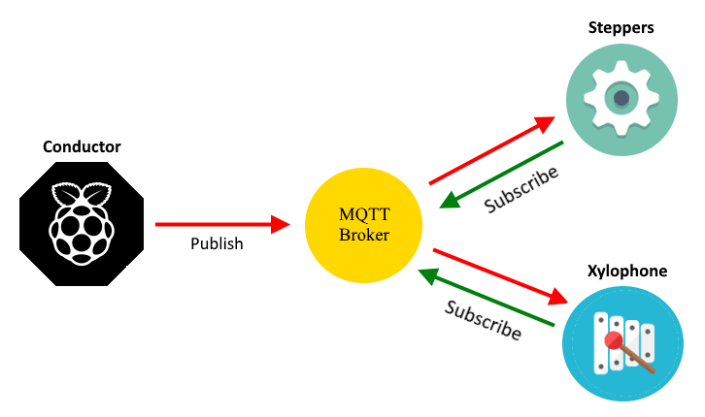

Figure . Operation of MQTT Protocol

### Keyboard

One of the first instruments that was decided on was the keyboard. To make this decision, several designs were reviewed and a paper by *Sugano* and *Kato* was reviewed [9].

In their paper, the authors aim to progress in the field of “soft robotics” [9] by creating two robotic hands that are capable of playing the keyboard by moving like human hands. To design a robot that can do this it is important to consider the degrees of motion that a robot must go through to play the keys. As *Sugano* and *Kato* explain, there are four primary degrees of freedom which occur at the three joints in the finger (MP, PIP and DIP in Figure 2.2) and the wrist.

|  |  |
| --- | --- |
| Figure . Degree of freedom found in the finger and thumb in a human [9] | Figure . Robotic hand proposed by *Sugano* and *Kato* [9] |

The DIP joint can be neglected because it is only used whenever the PIP joint is active, and it serves no purpose when pressing a key down on a keyboard [9]. The PIP joint differentiates between a white key and a black key on the keyboard with the MP joint being responsible for pressing down on the selected key. The wrist is responsible for rotating the entire hard to give the fingers access to more keys. Given that in this project 4 instruments were being designed, it was important to make the design of each of the instruments as simple as possible, which can be achieved by reducing the degree of freedom each of the joints described in [9] has. The design shown in Figure 2.4 is an example of a robot playing a keyboard where the PIP and wrist joint have been limited and fixed in place, with the MP joint controlled by solenoids that push down on the keys.

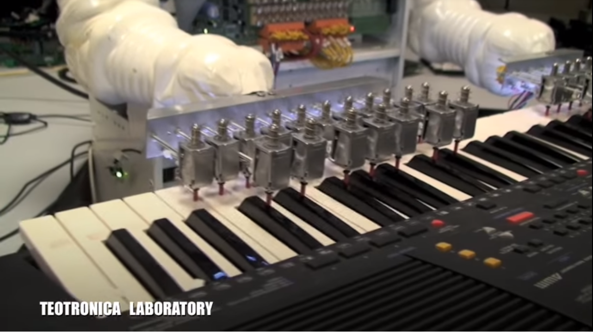

Figure . Teotronica robot keyboard [10]

The benefit of this type of design is that is significantly simpler to construct, both in terms of hardware and software, than the design proposed in [9]. By fixing the PIP and wrist [9] joint in place, only the MP joint has to be controlled through the software. However, fixing these two joints in place significantly reduces the flexibility of the instrument. The design shown in Figure 2.4 can only play songs that the solenoids are fixed above, any other song and additional hardware must be constructed. In addition to this, the design will look less human like which reduces the aesthetic appeal. For application in this project, simplifying the hardware is more important than creating a design that is human-like as the sound the orchestra produces is the most important metric whereas in [9] the aim was to create an anthropomorphic design. Also, simplifying the design reduces the time spent on each instrument allowing more time for others to be designed and reducing the chance that instruments will not be completed.

### Xylophone

One of the instruments that was also reviewed, is the xylophone. It is considered to be part of the percussion family, and is consisted of wooden bars that differ in size. Each bar is an idiophone (musical instruments which have a resonant solid material that vibrates in order to produce sound [11]) and produces various sounds which depend on their length. For example, shorter bars produce higher notes while longer bars produce lower notes [12]. According to the country of origin, the xylophone is tuned in different musical scales and therefore has different number of notes per octave. For instance, in Africa and Asia, the xylophone belongs in the pentatonic and heptatonic scale having in that way, five and seven notes per octave respectively [13], [14]. When it comes to orchestral use, the xylophone is tuned in the chromatic scale and hence, it is constituted by twelve notes per octave.

There were several designs found online and reviewed, but the team decided to create a customized autonomous xylophone, which is able to produce sounds according to the team’s preferences. That idea is based on a video found on YouTube, where a person created a customized xylophone with eight keys. Each key had a piezoelectric sensor mounted at its center and was programmed (through an Arduino) to produce a specific sound when it was hit.

### Stepper Motors

As stepper motors produce noise when rotating at different frequencies, the possibility of using them as an unconventional musical instrument was investigated. It was discovered that multiple videos of such an instrument were posted online such as those presented in [15] and [16] which confirmed that the instrument was feasible.

A stepper motor converts digital pulses into steps of a full rotation [17] and by varying the frequency of the pulses, the rotation of the shaft can be modified. The key difference between a stepper motor and a servo motor is that the stepper motor does not require a feedback mechanism since there is a direct relationship between a digital pulse and the amount by which the motor shaft rotates [18].

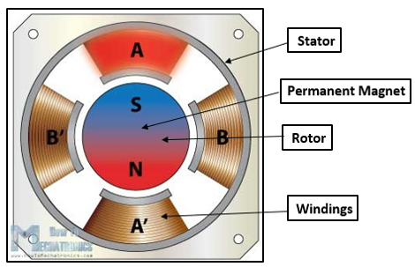

Figure . Cross section of stepper motor [19]

Figure 2.5 illustrates the cross section of a stepper motor. It can be observed that the permanent magnet in the centre acts as the rotor of the motor and is surrounded by stator’s windings. To understand how the rotational movement is generated, the rotor and stator will be analysed separately. The rotor consists of two discs placed back to back: one of them acts as the north pole and the other acts as a south pole. The windings act as electromagnets that can be independently controlled and when a winding is activated, it attracts the disc of opposite polarity of the rotor. As the windings get activated in turns, this results in the rotational movement of the motor’s shaft being generated [20]

A stepper motor can be controlled in three different ways, depending on the precision that is required. These modes are full step, half step and microstep and the difference between them is represented by the order in which the windings are energised. For example, one digital pulse sent to a motor operating in half step mode produces an angular movement that is half of the one that is obtained by the same pulse when using a motor operating in full step mode.

The key aspect of stepper motors for them to be used as a musical instrument is represented by their ability to generate frequencies in the audible range (20 Hz – 20 KHz [21]) that correspond to musical notes. A song can be replicated by the stepper motors by sequentially generating the frequencies of the musical notes required and ensuring that they are generated for the correct amount of time.

### Tesla Coil

The Tesla Coil was invented by Nikola Tesla in 1891 as a way to transmit electrical power wirelessly [22]. A tesla coil consists of a primary coil with a low number of turns and a Secondary (tesla) coil of which one side is connected to ground and the other is left as an open circuit [22]. A typical tesla coil circuit is shown in Figure 2.6 and Figure 2.7. In Figure 2.6 the voltage rises to a point at which a spark can form over the spark gap, at this point the combination of the capacitor primary and secondary inductance causes a high frequency current. This is created the energy oscillates between the capacitor and the primary coil inductance [23]. When there is no spark formed over the spark gap the capacitor charges. There are several disadvantages to this design as when a spark is formed there is a high power and current flow [22]. For DC operation the spark gap is exchanged for a switch which can be controlled to charge the capacitor and then to let it discharge over the primary coil [23].

|  |  |
| --- | --- |
| Figure . Spark gap Tesla coil circuit | Figure . Tesla coil circuit [24] |

The building of a tesla coil can be broken down into several parts: the primary coil, secondary coil, spark gap or switching circuit, capacitors and Toroid [25]. To make a tesla coil play music the switching circuit which charges up the capacitor is controlled using PWM [26]. There are also several descriptions on how to build a tesla coil from amateur enthusiasts [27] [24] [28].

A tesla coil instrument could also be a good idea for the robot orchestra as it can be used as an educational tool. As it can be used to demonstrate electrical fields and the wireless transfer of energy this can be done by holding a bulb close to the coil and it will light up with no connections [29]. Tesla coils can also be used for simulating lightning i.e. testing aircraft however, currently Impulse Voltage generators are more commonly used [30].

There are examples of tesla coils being used to play songs on YouTube, one such example can play ‘the Hall of the Mountain king’ which produces streamers several meters in length. [31]

### Panpipes

The panpipes were one of the instruments considered. They consist of 15 pipes and notes would be played by blowing air across the openings of the pipes. According to research done in [32], the pipes would require about 8.5 litres per minute [32] of airflow to play notes the octaves above C6 (if C1 is the first C).

Research was done on other wind instruments such as the Waseda Flutist Robot [33] but due to the complexity of some components such as the artificial lips and lungs this was considered an unfeasible option due to the time constraints of the project. Another example of a wind instrument was the Saxophone Playing Robot [34] but that too required complex moving parts mentioned before.

|  |  |
| --- | --- |
| Figure . Waseda Flutist Robot [33]. | Figure . Saxophone Playing Robot [34]. |

Proof of concept can be seen in video [35] where a set of panpipes is being played by a robot that moves the panpipes across a nozzle that blows air across the pipes producing the corresponding notes. The panpipes are easier to automate since there are less moving parts and Degrees of Freedom (D.o.F) involved compared to the other wind instruments. The panpipes were therefore the preferred instrument due its simplicity and range of notes.



Figure . Panpipe playing Robot [35]

The guitar was another instrument that briefly researched as a potential instrument. There are few research papers on 6-stringed guitars therefore videos were the primary source of analysis. A paper on the history of robot instruments [36] shows a guitar with “72 finger left hand” [36], and a video of Compressorhead preforming the *Ace of Spades* [37].

|  |  |
| --- | --- |
| Figure . Sergi Jorda’s Afasia from [36] | Figure . Compressorhead 6-String guitar robot preforming Ace of Spades [37] |

Both robots have a relatively simple plucking system but a complex fret mechanism consisting of multiple solenoids or other moving parts which could be well take up a large portion of the budget and time which needs to be given to other instruments. This instrument was later discarded due to these reasons.

## Decision on instruments

After the initial research period was over, three of the instruments had been decided on. The keyboard was chosen as an instrument due to flexibility it provides the orchestra to play a wide range of notes. The design incorporates the simplicity of the design shown in Figure 2.13 along with the flexbility to play any notes. It will incorporate solenoids mounted onto a Bosch bar to play a keyboard, more on the design of the keyboard can be found in Section 3.3.

The Xylophone was the second instrument to be decided on and uses a similar design to the keyboard. However, instead of using an actual xylophone the entire design will be bespoke. This allows greater control of the look of the instrument as well as increasing the flexibility so a variety of different sounds can be produced. More on the xylophone can be found in Section 3.4

The stepper motors form the third instrument due to their flexibility to play a wide range of notes as well having simple and cheap hardware requirements. Four stepper motors will be used, and a method will be found to amplify the sound (Section 3.5).

The fourth instrument, at this stage, was still to be decided on. Both the Tesla coil and the Panpipes went through an initial development phase where the designs were tested before a decision was made on one of the instruments to progress with (Section 3.6).

## Project Roles

In addition to the technical skills required for this project, the team will have to utilise several soft skills. Table 4 below shows the roles fulfilled by each of the team members and a brief description of what the role entails.

|  |  |
| --- | --- |
| **Project Manager**  **(Joyanto Chanda)** | The project manager role is responsible for tracking the progression of the project. In this project, a GANTT chart was used to determine the current progress of the project against the expected progress. This ensured that if adjustments to the plan needed to be made then they could be made whilst ensuring that project was still expected to be completed on time. |
| **Secretary**  **(Joshua Simpson)** | The secretary ensures that all the minutes and agendas are prepared for each of the meetings, both for individual team members and with supervisors. They are also responsible for ensuring that the minutes and agendas are filed away in a manner that makes them easily accessible. |
| **Auditor**  **(Andrei Buruiana)** | The auditor tracks the current expenditure of the project and ensures that the project is operating within the budget limits. In this project, this was done by having a Google Doc which contained details of all costs incurred to the project. |
| **Hardware Lead**  **(Theodoros Dimou)** | Important to define the approach to any upcoming hardware deadlines. Also, will be used to make decisions when the team is undecided on the approach to certain hardware challenges. Important to have prior experience in designing hardware (e.g. responsible for the bulk of the hardware design on the buggy project). |
| **Software Lead**  **(Francesco Fumagalli)** | The software lead in this project is a crucial role and was assigned to the person with the most experience of various embedded systems and in coding. They are responsible for defining the structure of the software for each of the instruments and how they will communicate with the conductor. |
| **Document Controller**  **(Antons Petrovs)** | Ensures that documents across the project have a consistent format and are mad easily accessible by each team member. They are also responsible for formatting and organising the two reports. |

Table 4 Project Roles

## Required Skills

In a project like this several technical skills will be needed to create the four chosen instruments and the conductor. For example, the keyboard example in Section 2.3.2 [38] would require technical skills in analogue circuit design, programming in C and a solid understanding in MIDI to text conversion alongside basic musical knowledge.

|  |  |  |  |  |  |  |
| --- | --- | --- | --- | --- | --- | --- |
| Indicates where skills were developed. | | | | | | |
| Degree | **Electronic Engineering** | **Mechatronic**  **Engineering** | | **Electrical and Electronic Engineering** | | |
| Skills | Andrei Buruiana | Antons Petrovs | Francesco Fumagalli | Joshua Simpson | Joyanto Chanda | Theodoros Dimou |
| Analogue Circuit Design | X | X | X | X | X | X |
| Electronic Circuit Design | X | X | X | X | X | X |
| Coding in C | X | X | X | X | X | X |
| Experience with Arduino |  |  | X |  | X |  |
| Experience with MyRIO |  | X |  |  |  | X |
| Experience with Raspberry Pi |  |  | X |  |  |  |
| 3D Modelling |  | X |  |  | X | X |
| PCB Design | X | X | X |  |  |  |
| Basic Music Knowledge |  |  |  | X |  |  |
| Experience in LabVIEW |  | X |  |  |  | X |

Table 5 Skills required for project

During the design phase of the instruments several different embedded systems were considered for each of the instruments. From looking at Table 5 above the team had previous experience in working with the Arduino and working with Raspberry Pi. However, there was no previous experience when working with the National Instruments’ (NI) MyRio. There was deliberation as to whether to include the MyRio as a part of the project because of this reason however, ultimately it was decided that it would form a part of one of the instruments since it provided several benefits. It has significantly more digital IO pins than any of the other embedded systems as well as an in-built Wi-Fi module. In order to address the skills gap an application was submitted to the NI Student Sponsorship Project. Although we were not successful with the application, once hearing about our project NI still provided a support engineer to help the team in incorporating a MyRio with the orchestra, which the team was able to contact through email or by phone.

## Interdependencies

Figure 2.14 below shows the main tasks for the project that had to be completed and how they relate to one another. The four instruments and the conductor were developed in parallel with each, so they were not interdependent on one another. Within each of the instruments, the software and hardware were developed in parallel with each other. This was possible as the first block of the project was spent solely on developing designs for each of the instruments. As the designs were solidified in the first block, the software could be developed without having the hardware present, just based off the designs created in the first project block.

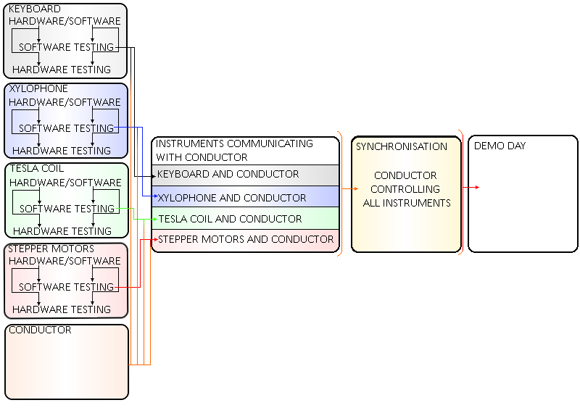

Figure . Interdependencies amongst tasks

The *“Instruments Communicating with Conductor”* task shown in Figure 2.14 was used to create and test the communication channels between the conductor and the instruments. This task was dependent on the preliminary software testing on the instruments and conductor being complete as there needed to be a host (conductor) and a node (instrument) to test that the messages sent by the conductor are being received. Fortunately, since the Keyboard, Stepper Motors and Tesla Coil use the same embedded system and communicate with the conductor in a similar way there is not a heavy need for the software for all three of these instruments to be completed at the same time. A delay in finishing the software for any one of these instruments would not have caused significant delays in the project as long as one of the three was completed on time. However, since the Xylophone uses a different embedded system to the others, a delay in the completion of the software for this instrument would have had significant impact on the project. It was important to identify this at the beginning of the project as it meant that if the Xylophone was falling behind, resources could be moved from the software development of one of the other instruments to try and keep the Xylophone on track.

The *“Synchronisation”* task is dependent on the *“Instruments Communicating with Conductor”* since the synchronisation cannot begin until a solid connection has been established between the instruments and the conductor. A delay in establishing a connection between the instruments and the conductor may have had a significant impact on the project. It was difficult to predict, in the early stages of the project, how long the synchronisation of the instruments would take so it was important to stick to the deadline in the previous task to enable sufficient time to synchronise the instruments, should they take a significant amount of time to synchronise and play in time with another.

The final task, *“Demo Day”*, is dependent on the orchestra being completed and synchronised with one another. This task is to largely to increase the aesthetic appeal of the project as well as sorting out logistics behind moving the orchestra, how many plugs were necessary etc. At the end of the *“Synchronisation”* task, the orchestra should be functioning as expected but is unlikely to look as professional as needed. That is why the *“Demo Day”* task exists, to give time for the team to adjust the aesthetic appeal and prepare to showcase the orchestra.

## Report Structure

The report is structured as follows: Section 2 focuses on the aims, objectives, motivation and interdependences of the project. Additionally, it presents the literature review underlining the research done on the conductor and on each instrument of the orchestra. This is an enhanced version of the literature review presented in the Interim Report which is presented in **Appendix C**. Section 3 presents the technical work undertaken for the conductor and for each musical instrument in the orchestra. Following, **Section 4** offers a summary of the work done during the project and presents the available options for future work that can be done for each individual element of the orchestra. Lastly, **Section 6** draws a conclusion on the work presented in this report.

# Technical Chapters

## Conductor Overview

Part of the specification for the project required the team to build and develop a conductor. The only requirement of the conductor is to synchronise the instruments together. However, the team added additional functionality to allow it to act as a ‘bridge’ between the user and the instruments. The choice of hardware for the conductor was a Raspberry Pi single-board computer, and it was made on account of it being able to run Python scripts, having built-in WIFI and Bluetooth as well as it being small and cheap. Python was the programming language of choice for the conductor, as it allowed the team to quickly develop scripts using the vast collection of libraries available. The following section will explore the various components of the conductor and their implementations. It will follow the order which the user needs to follow to play a track on the orchestra.

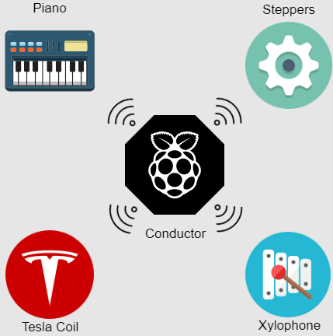

Figure .: Conductor with four instruments

### SDManager

SDManager, is the name given to a collection of Python scripts used to prepare the orchestra to play a track. Initially the user selects a song in a MIDI format and edits it using Anvil Studio to remove/add/modify channels of the track. However, MIDI files are too complex for a microcontroller to work with, and too tedious for the team to work with, so a script called *MIDI2Text* was written which takes as an input a MIDI file, parses it and returns to the user a stripped-out version of the MIDI file with only the core information needed for the orchestra to recreate the track accurately. The information returned are three arrays: a time array; with the timing information, a note array containing the note to play/release and finally a status array which tells the instrument weather to play a note or release it. The script also handles other things such as converting the time from ticks (MIDI notation for time) to seconds and was also used in the development of the instruments as it can return data to the developer such as the number/notes each track uses. Furthermore, the script can separate the MIDI file into separate channels which correspond to each instrument so only the portion of the MIDI file which corresponds to the selected instrument in extracted. MIDI2Text is crucial to the development of the instruments as it saved the team a substantial amount of time and effort which would otherwise had to be put in converting the MIDI file manually.

The team chose to use SD cards to store the various tracks on the microcontrollers since they are a cheap non-volatile memory solution. Another script was developed which takes the output of *MIDI2Text* and transfers it onto the SD card in either a text format or a binary format (depending on how the instrument interprets the data). The script creates a folder with the name of the song, as well as four subfolders, on containing the timing file, note file, status file and one containing some metadata required by the instrument. Although most instruments use the binary format, the text-based format is used in the xylophone and is also useful when checking that the data written is correct. Additionally, another script was developed to allow the user to easily check the contents of the SD card and delete any tracks directly through SDManager.

Once these pieces of software were developed and tested they were merged together, so the user needs to follow five simple steps to take an edited MIDI file and save the portion of the MIDI file required by the instrument onto an SD card in .bin or .txt format for the instrument to play. These steps are:

1. Select path to SD card.
2. Select path to MIDI file.
3. Select .bin or .txt format.
4. Select name to save as.
5. Select instrument.

|  |  |
| --- | --- |
| **Name** | **Description** |
| **MIDI2Text** | Converts a MIDI file into either a text file or a binary file  containing the three arrays needed by the instruments. |
| **SDManager** | Saves the output of MIDI2Text for into an SD card. |
| **bitHoven** | Handles the communication between the Raspberry Pi and the instruments. Used to PLAY and STOP a track. |

Table 6: Summary of scripts

### Bithoven

The second collection of scripts are used when playing music on the orchestra. The team opted to exploit the wireless capabilities of the Raspberry Pi to create a network of instruments with the conductor acting as a central server. This removes any wiring between the conductor and the instruments resulting in a more professional and refined product. It also given the project an Industry 4.0 feel, something which has been of great interest lately. The conductor can then transmit commands to the instruments wirelessly and fulfils the requirement of synchronising the instruments.

### Wireless Network

The RPi has been configured as an access point for the instruments to connect to, this removes the need for an external WIFI network, which might not always be available or secure. Messages in the MQTT protocol contain ‘topics’ which nodes can subscribe to. A node can publish to any topic and any other nodes subscribed to the topic will receive the messages. In more detail, the RPi runs the MQTT ‘Broker’**,** all messages which are published go through the broker, which sorts them and retransmits them to each node which has subscribed to the topic of the message. Each instrument has a topic associated with it and is subscribed to that, furthermore all instruments are subscribed to a BROADCAST topic. The conductor itself is also a node within the RPi; it is subscribed to all the instruments and the broadcast topic and can transmit commands to each instrument individually or to all instruments simultaneously. The IP address of the RPi has been configured as a static IP and the instruments are programmed to connect to that specific IP once they are powered on, allowing them to receive and transmit messages to the RPi.

The conductor can then publish one of three commands to the instruments. A PLAY command followed by a song name causes the receiving instrument to download the song from the SD card and play it once it receives a START condition from the conductor. A STOP command from the conductor cause the instrument to halt any song that is currently playing, this allows the user to play another song or simply stop the song. Finally, a LISTtracks command causes the instrument to read the tracks stored in the SD card and returns them to the RPi, this allows the user to see which songs have been saved without having to remove the SD card and putting it in a computer. Since all the configuration for the MQTT protocol has already implemented, adding additional features mean they only need to be implemented on the microcontroller, allowing the developer to expand the functionality without prior knowledge of the protocol.

### Summary

In summary, the conductor contains various scripts to handle any interaction the user might need with the conductor. It allows the user to easily convert MIDI files and load them onto an SD card without any knowledge of the MIDI protocol, and in a format which is easily read by any microcontroller and computer. Since the conductor was designed with the intention to add additional instruments to the orchestra it can also be very useful for developers to obtain various information about the songs their instrument will need to play. To wrap up this collection of scripts into a neat and easy to use way, a graphical user interface (GUI) was developed to run on the RPi with the goal of simplicity in mind. The GUI in combination with a touchscreen connected to the Pi allows the user to have a fluid experience with the orchestra.

## Instrument Software Overview

The software for the instruments was written in two programming languages, the Tesla, Steppers and Keyboard instruments were written in C++ and that of the Xylophone was written in Labview. However, regardless of the programming language all instruments follow the same structure. This was done deliberately in order to allow the team to manage the software for the various instruments and make debugging and maintaining the code easier. Regarding the software for the Teensy board this was taken even further by making all the code for the instruments almost identical except for one function. The section below describes the software for the instruments.

### Initial setup

When first powered on the instruments executes a setup() function which initiates various internal and external hardware some specific to each instrument and some common to all. For example, interrupts are enabled and two *Universal Asynchronous Receiver Transmitter* (USART) busses (one for transmitting data to the IDE for debugging and one for communicating with the WiFi module) are initalised. Finally, the necessary pins are set as inputs or outputs. Then specific hardware for each instrument is set up. Once the setup is finished the program enters a loop() waiting for instructions. The main loop was designed to resemble a finite state machine (FSM) with two states, a PLAY state and a listTrack state. **FigureX** depicts the two states and Figure 3.2 C++ to resemble finite state machine shows the C++ code. In order to enter a state a command is sent by the conductor. The next section will explain how the WiFi module receives commands from the conductor.

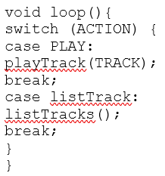

Figure . C++ to resemble finite state machine

### WiFi module

The ESP-8266 is a low cost WiFi chip with full TCP/IP stack with microcontroller capabilities. Although many versions exist, the exact module used in this project is the ESP-01. The module was selected due to its low cost and small package size which allows it to be integrated with any of the instruments. The software for the WiFi module was written in C++ using third party libraries. The WiFi module allows the user to communicate wirelessly with the instruments thereby removing the need for wires. This has two effects: firstly, it gives the orchestra a more refined look making it more appealing to the public and secondly, it adds Internet of Things (IoT) capabilities to the instrument which is something of great interest in the technology sector and is likely to attract more attention. Since the module can be programmed separately and acts as a standalone system it can be used in conjunction with any microcontroller which supports UART. For this reason, the WiFi module is used on all instruments including the ones with processors which already support WiFi. This was done deliberately to save time as the code as well as hardware needs to be developed only once.

Due to the extremely small package on the module, only 8 pins are available. Out of those 2 are reserved for serial communication (Rx and Tx), 2 are GPIOs and the rest are used for programming. When the module is first powered on it automatically connects to the WiFi of the Raspberry Pi and subscribes to a unique topic for each instrument. Once a message arrives from the conductor to the WiFi module it then passes that message to the microcontroller of that instrument via UART (Tx and Rx). Once the WiFi module is ready to transmit via serial one of its GPIO pins goes high which triggers an interrupt in the microcontroller to read the serial buffer. The instrument is also capable of transmitting messages back to the conductor which is useful for debugging purposes as well as transmitting information such as the songs stored in the instrument. If at any point the connection between the WiFi module and the conductor is broken the module will automatically attempt to reconnect. The user can send a PLAY command followed by the track to be played, a STOP command or a listTrack command. The next section explains what happens when these commands are sent to the microcontroller.

### playTrack

A PLAY command followed by the track to be played causes the program to enter a function called playTrack(track) which takes the track name to be played as an argument. This function initially gets the sizes of the three time, note and status arrays needed to play the track. It then downloads the data from the SD card and stores them locally on the microcontroller and enters a while loop while it waits for the conductor to transmit a START signal (which it does 3 seconds after the PLAY command is sent). Once the start signal is received the track starts playing, this will be described in the following section.

### Playing a track

A key idea when developing the code was reliability when playing a track. The largest cause for causing the song to sound distorted is playing the notes at the wrong timings. Any delay in the code during a track playing could potentially have that effect and for that reason timer interrupts are used to ensure that notes are played at the exact times as specified in the MIDI file. An *Interrupt Service Routine* (ISR) enters each time and turns on or off the corresponding notes. The timer interrupt is then updated with the first value from the timer array. The ISR for each instrument varies depending on how the instruments play notes and is described in the software section of each instrument. A while loop is used in order to stop the program from continuing while the track being played. When the track has finished, or a STOP signal is received, the program exits from the while loop and performs any tasks necessary to setup the instrument to play another track. Finally, it enter the main loop()awaiting further instruction from the user.

### listTrack

The listTracks()function reads the contents of the SD card, transmits it to the WiFi module via USART which then transmits it back to the user via WiFi.

## Keyboard

The following sections will first summarise the main components of the keyboard and then describe the design decisions made in the design. To meet the aims of the project, the keyboard needs to meet the following specification:

* play the tracks chosen for the keyboard from the three selected pieces of music (objective 2). The main step to doing this are:
  + be able to play 25 notes
  + design and manufacture PCBs to power solenoids
  + design and build a stand to hold the Solenoids and PCBs
  + write software for the Teensy microcontroller to control the instrument
  + integrate the software with the hardware
* communicate with the conductor so it can be controlled alongside the other instruments (objective 3):
  + write software so it can be controlled with the conductor
  + integrate the WIFI module with the Teensey
  + integrate the conductor with the instrument
* be transportable (objective 2):
  + design the hardware so it can be dismantled for transport.

### Overall design description

Figure 3.3 Keyboard hardware overview shows the keyboard Design. The robot keyboard design uses solenoids to press the keys and a Teensy microcontroller board to control the instrument. The solenoids are supported by a Bosch bar and are connected to the Bosch bar using threaded rods, which are split into two different lengths: 60mm and 105mm for the white and black keys respectively. The solenoids attach to the threaded rod using a bracket made from clear Perspex, allowing the solenoid to be positioned at any point along the rod and allow it to be adjusted vertically by 25mm. The Bosch bar has a threaded rod at each end to support it, so its position above the keyboard is adjustable. The PCBs to control the solenoids are mounted on a Perspex plate that is attached to the Bosch bar. There are only 25 solenoids set up, these cover the notes required for the three chosen test tracks (see **appendix D** for table). This decision was made to keep within the project budget of £1500 as each solenoid costs £10.40 so to buy 25 is a cost of £260. It would have cost £634.40 to outfit the entire keyboard, which would have been about 42% of the projects budget. The instrument has been designed so that in the future more solenoids to cover the full range of notes can be easily added. For the time being, if when expanding the range of songs to be played by the orchestra the notes required are outside the range of the solenoids set up, the notes can be shifted by an octave into the notes played by the keyboard without too much effect on the sound of the music. The design can be dismantled, the threaded rods unscrew from the Bosch bar and the base plates meaning it can be transported in a … box(need to put it in a box to test).

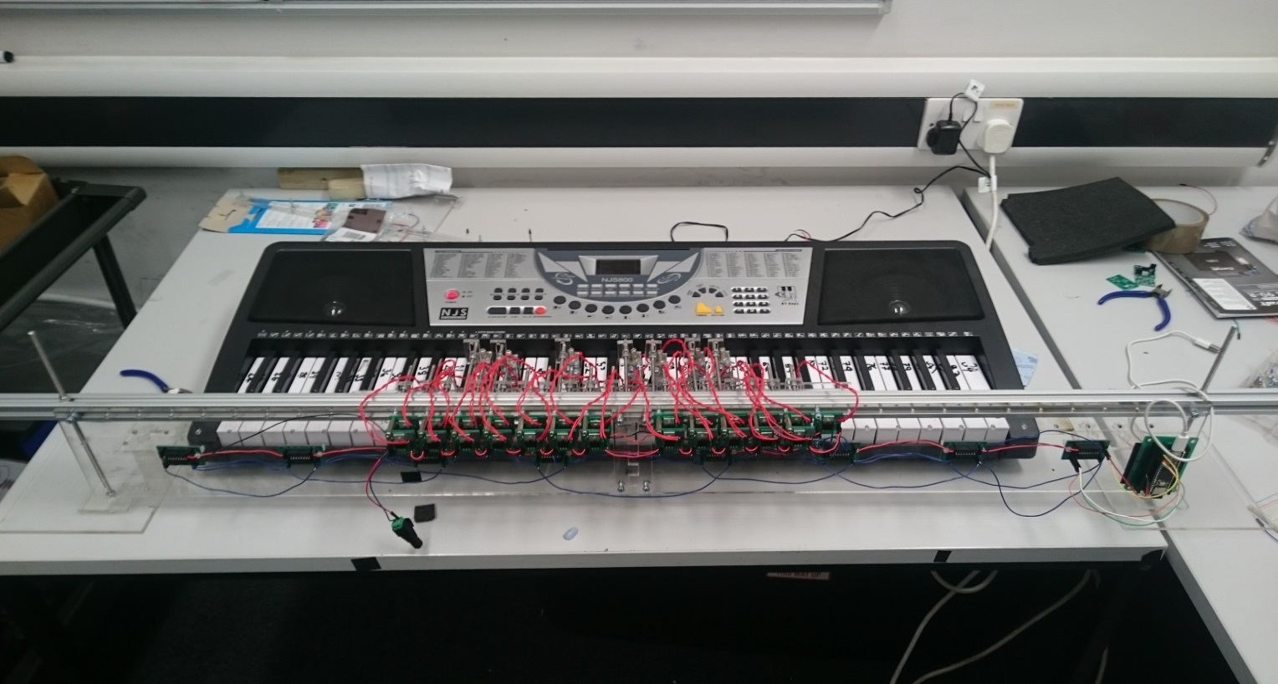

Threaded rod supports with base plate

Shift register PCB

Solenoid switching Transistor PCB

Solenoids and brackets

Bosch Bar

Teensy Embedded system

Figure . Keyboard hardware overview

### Solenoid Selection

Firstly, a test was carried out to find the force needed to cause the keys to play a note the table is given in **Appendix E**. A mass of 70g is required to press down allowing so using a safety factor of 25% the keys need a force of 1.25\*0.070g\*9.81m/s^2=1.03N=105gf to be pressed. The distance the key needs to be depressed is 3mm so the solenoid throw needs to be at least 3mm. In the music chosen up to 4 keys can be played at the same time so the solenoid also needs a low current demand so they can be powered using an off-the-shelf power supply. The 12V 3W SD0630 fulfils these requirements it can provide 120gf with a duty cycle of 50% (none of the songs require any one note to be depressed 50% of the time (section 4.3 of the interim report calculates the maximum to be 30%). It also has a throw of 10mm and has a current requirement of 0.25A so 8 could be pressed at once using a 12V 2A supply (solenoid datasheet in Appendix F).

Initially, one solenoid was bought to test. The solenoid came without a stopper so one was laser cut in the mechanical workshop this allows the solenoid throw to be adjusted. It was decided this was a useful feature as the throw could be adjusted to the exact value necessary. The solenoid was tested and it was able to press both the white and black keys. The main issue found when testing the solenoid was the clicking made when the solenoid switches on and off. This was partially solved by putting foam between the stopper and the solenoid as shown in Figure 3.4.

|  |  |
| --- | --- |
| C:\Users\Josh\Downloads\DSC_0092.JPG | C:\Users\Josh\Downloads\DSC_0095.JPG  Stopper  Stopper Foam  Plunger Foam  Plunger |
| Figure .: Solenoid with foam | |

This lessened the effect however; another clicking sound was made when the plunger hit the inside of the solenoid. An attempt was made to lessen this as well by putting a small piece of foam on the plunger Figure 3.4. This caused issues to the working of the solenoid as it added extra resistance for the solenoid to work against. Therefore, it re-acted slower when turning on and caused different delays between each solenoid. It was decided this would cause issues with playing the songs and the synchronisation of the instruments so the foam on the plunger was removed. The volume of the keyboard can be turned up to a level that mitigates the sound of the clicking. The clicking is not entirely a negative as it gives the instrument a mechanical sound which fits in with the aesthetic of the orchestra.

### Supporting the Solenoids

To make the assembly of the rail supporting the solenoids flexible a Bosch bar was used as it allows the solenoids to be placed at any point along its length. This is achieved using T-slot nuts to secure the threaded rod in the Bosch bar to which the solenoids can be attached. The threaded rods will be 4mm in diameter as the T-slot nuts are M4. The assembly is shown in Figure 3.5

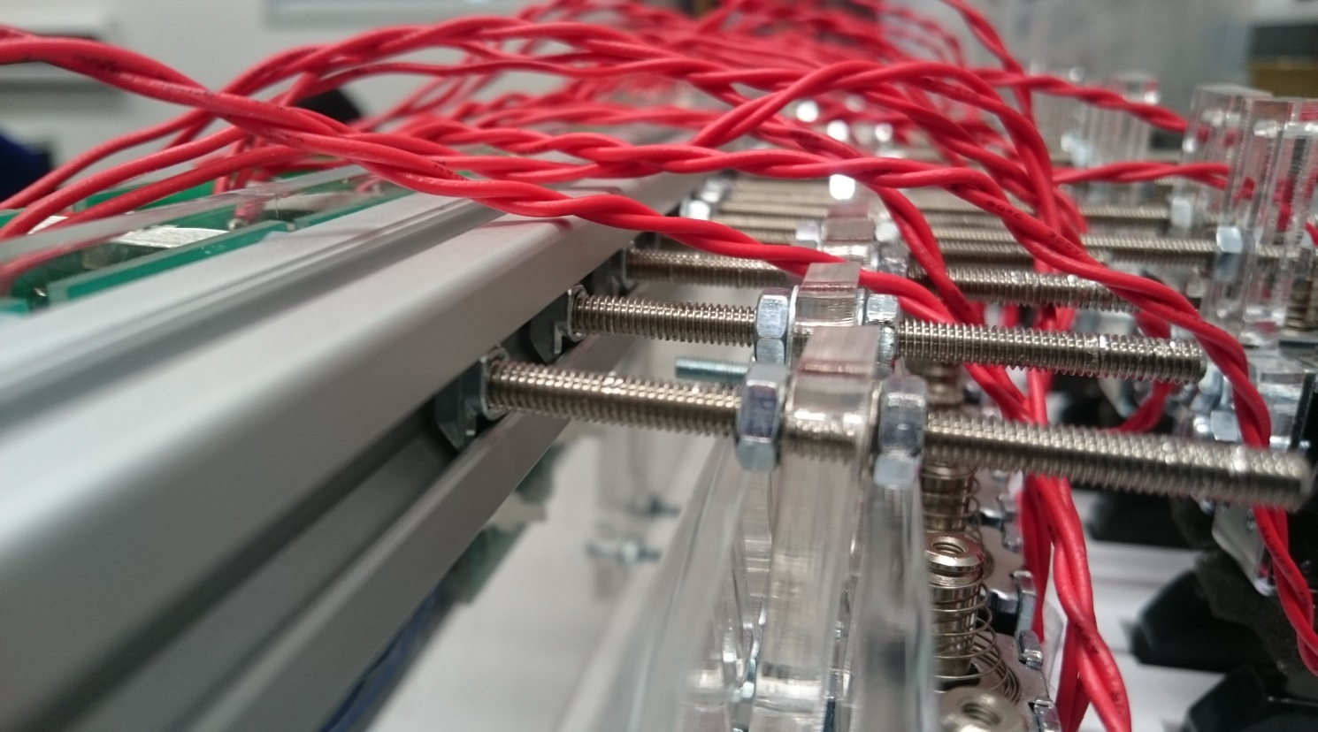

T-slot nut

Threaded rod

Bracket

solenoid

Bosch Bar

Figure .: Close view of Bosch bar structure.

A bracket was required to connect the solenoid to the threaded rod. This needed to be easily adjustable so the solenoid could be put into the correct position. It also had to be limited in width as the keyboard is 726mm long with 36 white keys which leaves 20.16mm per key for the bracket. However, space for a 4mm rod also has to be left for rods to pass through to the black keys leaving 16mm. The width of the solenoids is 15mm meaning that the bracket must be the same width as the solenoid

The design went through several iterations. The first design is shown in Figure 3.6 it allows for vertical movement but not movement along the length threaded rods therefore, the rods would have to be made to the exact length and it wouldn’t be adjustable. The next design is in Figure 3.7 this allows for horizontal and vertical movement (25mm) the design is stepped so the threaded rod can pass the solenoid plunger. It also means that the solenoid connection part can be greater than 16mm as the threaded rod for the black keys will run past the upper section. The third design (Figure 3.8) just adjusted the distance between the step so there was a 1.5mm difference between each side which makes it easier to overlap them in the mounting process.

|  |  |  |
| --- | --- | --- |
| Figure . 1st design | Figure . 2nd iteration | Figure . 3rd iteration |

### Solenoid PCB design

The solenoids are controlled by the shift registers which use the Teensy’s 3.3V supply as the solenoids require 12V a transistor is needed to switch the power supply to the solenoids on and off. A transistor PCB was designed to turn the solenoid on and off. The required current for the solenoid is 0.25A. The instrument uses shift registers to deliver all the notes to the keyboard at the same time. The Teensy can provide 250mA with its 3.3V power rail, a worse case of 8 solenoids playing at the same time would split the current into a maximum possible 31.25mA per transistor. So the gain required is 8.3. It was decided to use the same transistor for the xylophone solenoids so only one type of transistor needed to be ordered and the same circuit could be used for both. The xylophone solenoid requires 2A and the MyRIO can provide 150mA per digital output so the gain needed is 13.3. The decision was made to use the BJT, TIP120 which can handle 60V 8A and can provide a gain of 1000 when Ic=0.25A. The circuit is shown below figure. The equation is Rb=(Vin-Vbe)/ib =(Vin-Vbe)/ic/Hfe=(3.3-1.5)/0.25/250=1.8kΩ. This calculation contained a mistake as the gain is actually 1000 at Ic=0.25A however, as the real gain is higher the circuit still provides a collector current to meet the requirements of the solenoid.

### Supporting the Bosch Bar

It was decided to support the Bosch bar using two threaded rods located at either end as shown in Figure 3.9 which allows the solenoid rail to be adjusted vertically. The threaded rods were set at 230mm long this allows for the key height of 70mm, the 20mm thickness of the Bosch bar, 80mm for the solenoid and leaving 70mm to allow the rail to be moved upwards and remain supported while, the keyboard is removed from under the solenoid rail. A 5mm threaded rod was chosen as the Bosch bar has a 5mm gap in its design which allows a hole for the threaded rod to go through.

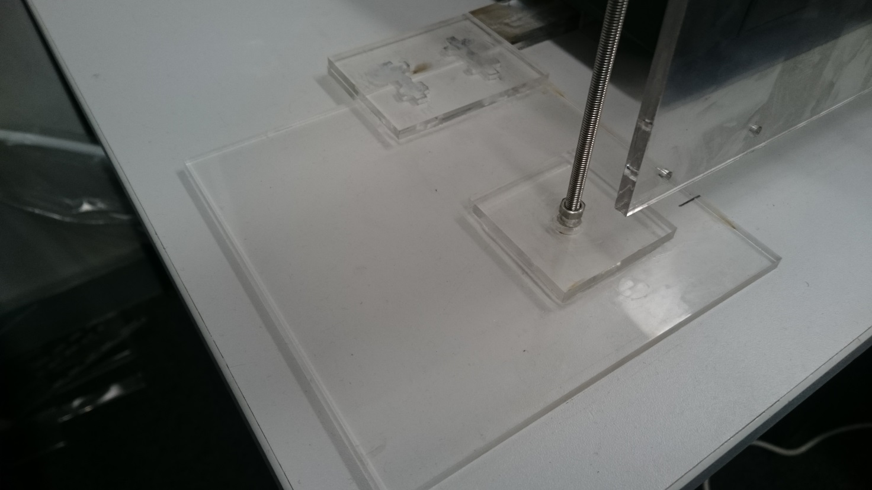

Large Base plate

1. Plate clamped to threaded rod with two nuts

Connection to the Perspex bar that connects both feet each end of the Bosch bar

Threaded rod

Figure . Solenoid rail stand

A base plate was needed to hold the threaded rods vertically. It was decided to use Perspex for the various brackets and supporting plates for the instrument. So, to keep with the aesthetics of the design Clear Perspex was used for the support. The design is shown in Figure 3.9 and uses a two Perspex pieces, one for which the threaded rod is attached using two nuts which clamp the Perspex tight to the threaded rod (label 1 in Figure 3.9). The second piece is glued to the other so the holes overlap allowing the lower nut clamping the other plate to be counter sunk into the base so the base can be flush with the surface its placed on. An M5 nut is 3.5mm thick and 9mm wide so the Perspex needed to be thicker than 3.5mm and the hole needs to be at least 10mm wide. The laser cutter in the workshop can only cut 1cm thick Perspex and 5mm was the maximum thickness the workshop has in stock. So, it was decided to buy a 600mm by 600mm sheet of Perspex from the workshop for £40 as it could be used for all the other Perspex laser cutting needed.

With the two stands at either end of the keyboard there is a possibility the stands will be knocked and move the solenoids out of position. A bar was designed to connect the two stands together. There is a channel running the length of the keyboard in which a bar can be run to connect the two Perspex stands together. It is 60mm away from the edge of the keyboard and the stands can be located at any distance from the keyboard as the lengths of the threaded rods holding the solenoids can be made any required length. However, to keep the design compact the rail should be located a maximum of 10cm away and a minimum of 2cm away to allow for room to mount the threaded rods. Ti was decided to locate the rail 4cm away from the keyboard as it is a compromise between the two. The larger base plate for the nut to be counter sunk into was made 150mm by 150mm with the centre of the 10mm hole 50mm in from each edge locating the threaded rod 100mm from the edge of the channel running the length of the keyboard. The top plate which clamps the rod in place was 60x60mm with a 5mm hole in the centre.

The bar connecting the two stands can be seen in Figure 3.10. To do this a channel that runs the length of the keyboard was utilised. The channel is 29mm wide and 20mm high. A Perspex rod was designed to run along it to attach to the two base plates at either end. The design used four lengths of Perspex two 29mmx550mm long that were attached in the middle using a 29x60mm plate to overlap the two pieces so they could be glued together (It was done in two sections, as the laser cutter cannot cut pieces longer than 600mmm long). The other two were 29xxxmm these were glued directly on top of the other two bars to create a bar 10mm in height to make sure the bar was secure in the channel. The bar was attached to the two supports using an overlapping 60x85mm plate at either end to glue the pieces together. Initially the stand and the bar were connected using a screw and nut (the locations can be seen in Figure 3.10) however, this method was found to loosen over time. Two stopper pieces of Perspex were made to stop the keyboard sliding along the bar the design is shown in Figure 3.10. This means the solenoid rail is held in place by the keyboard.

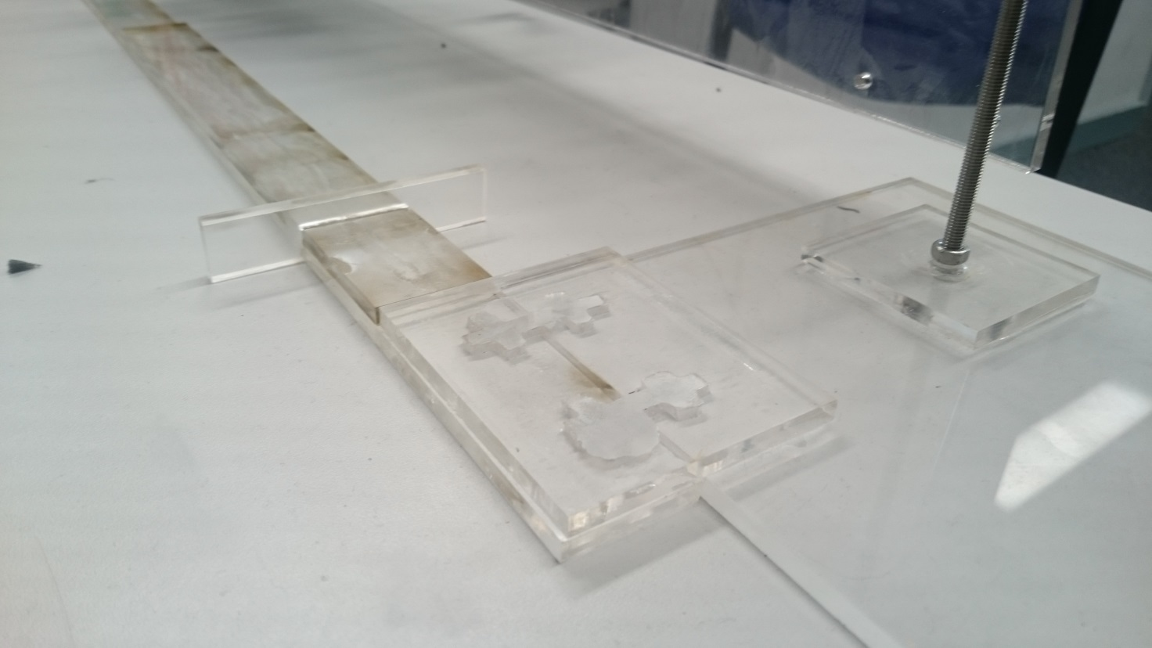

Threaded Rod

Connecting Bar

Keyboard stopper

Stand and connection bar attachment plate

Previous screw connection points

Figure .: Stand and bar connection

### PCB Support Plate

The instrument has 8 shift registers, 25 transistors and 1 Teensy PCBs it was decided to mount them on the Bosch bar using a Perspex plate to display them. The keyboard instrument is designed is so that it can be expanded to have solenoids for all the keys, so space has been left on the plate for more transistor PCBs. The size limits of the plate were set at 1100 mm long and 120 mm wide so it would fit neatly along the front of the keyboard. The transistor PCBs were mounted along the top to make wiring up the solenoids easier, to fit all the PCBs on they had to be mounted as a double layer (shown in Figure 3.11) as each PCB is 25mm wide and with a 3mm gap between PCBs there was space for 1100/28=39 PCBs not 61. The shift registers are mounted below these in the middle of 8 transistor PCBs that they control so they can be easily wired up and the teensy is located at the end as it only needs wiring to the first shift register. The design for the plate is in Appendix G.

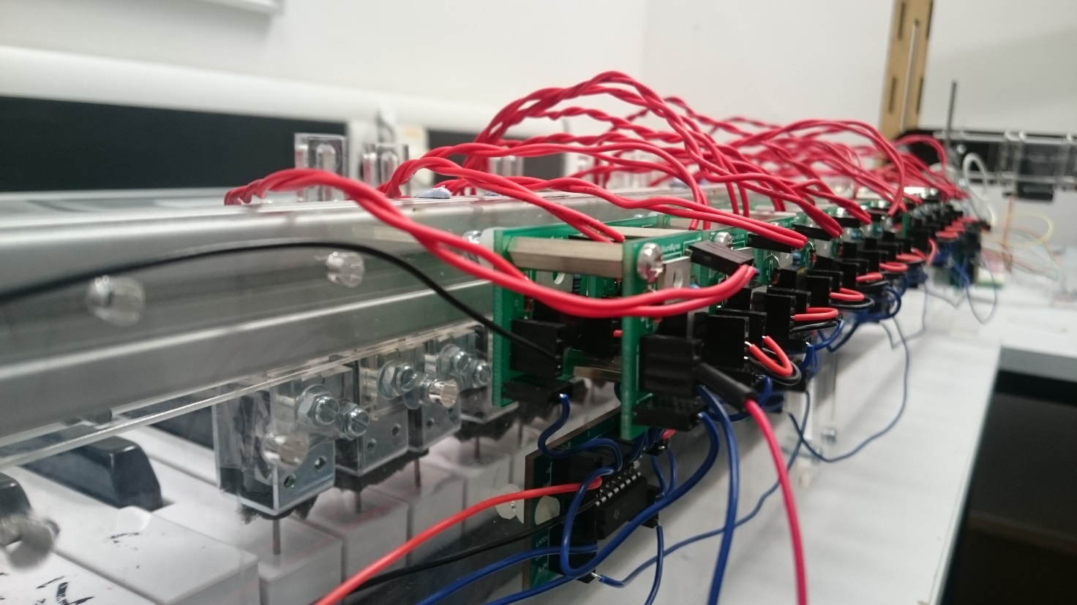

Figure .: Transistor PCBs mounted on the Perspex plate

### Keyboard Software

The keyboard is driven by a Teensy 3.5 [39] connected to eight SN74HC595N shift registers [40]. Initially, an Arduino Uno was to be used to drive the keyboard however it was found that the Arduino did not have enough on-board memory to hold the large arrays needed to describe the note, status and timings of a song. For example, the files needed for *Californication* amounted to 84 kB whereas the Arduino only has 32 kB flash memory. The Arduino was replaced with a Teensy 3.5 which has 512 kB, enough to store the files for either of the songs needed for the demonstration.

The keyboard software was designed with the ability to expand in mind. In this project, only 25 out of the 61 keys will be needed to play the two songs. However, the software will be designed so that songs containing more than just the 25 keys can be played without having to change the software, just adding the additional solenoids. As described in the previous section, each of the solenoids are connected to a transistor circuit, where each transistor circuit is connected to the output of one of the shift registers.

### SN74HC595 Shift Registers

There are four ways that shift registers operate, the SN74HC595 is an example of a serial in-parallel out shift register (SIPO). The other three are, Serial-In to Serial-Out (SISO), Parallel-In to Serial Out (PISO) and Parallel-In to Parallel Out (PIPO).

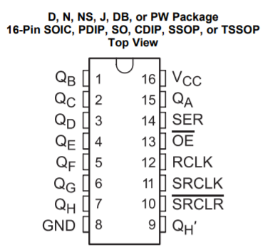

Figure . Schematic for SN74HC595 shift register from Texas Instruments [40]

From Figure 3.12, there is one *Serial Input* pin located on pin 14 and there are eight output pins located on pins 1-7 (QB to QH) and 15 (QA). To control the shift register, an 8-bit variable is sent, bit by bit, to pin 14 which writes each bit to the corresponding output pins starting at pin 15 (Q­A) and finishing on pin 7 (QH). In this way an 8-bit variable can be written to the shift register. Once this writing process has been completed, pin 12 (latch pin – RCLK) is set high and all the output pins are written to their connections at once.

In this way the shift registers allow for control of more output pins that are available on the Teensy. Several shift registers can be connected in series with one another to act as one large shift register, increasing the number of outputs in multiples of eight. This is done by connecting the *Serial Out* pin (QH’ – pin 9) from one shift register to the *Serial Input* pin (SER – pin 14).

To cover the full 61 notes available on the keyboard, eight shift registers will be needed. This means that, since each solenoid represents a specific key, they must be connected to specific pins on the chain of shift registers. The benefit of this is that it is simple to continuously add solenoids to the keyboard so that all the notes are available to play without making any change in the software. The shift registers will be represented by a 64-bit variable in the software, where each bit of the variable represents a specific solenoid and note. For example, bit 0 of the of the 64-bit variable represents the lowest note on the keyboard, which is the MIDI note 24.

The latch feature will be very useful when the keyboard must play a chord (multiple notes played at the same time) as it means the solenoids will be pressed down at the same time. If the commands for each note in the chord were sent sequentially then it would not sound like chord, but a series of notes played quickly after each other.

### Structure of the program

To test the shift registers, a circuit consisting of 16 LEDs and two shift registers was constructed. The cathode of each of the LEDs was connected to ground and the anode of each LED was connected to a pin on one of the shift registers. From the testing it was found that, even though there were two shift registers connected in series (providing 16 output pins) it was only possible to write an 8-bit variable to the registers. This means that to write a 16-bit variable and display them on the shift registers, it would have to be split in to two 8-bit variables which will have to be written to the shift registers one after another. So, for use on the keyboard eight 8-bit variables would need to be written to the shift registers to cover the full 61 keys, meaning that the shiftout() function (the function that writes to the shift registers) would need to be called eight times. This means that more instructions will have to be executed, which needs to be taken into consideration when synchronising different instruments together.

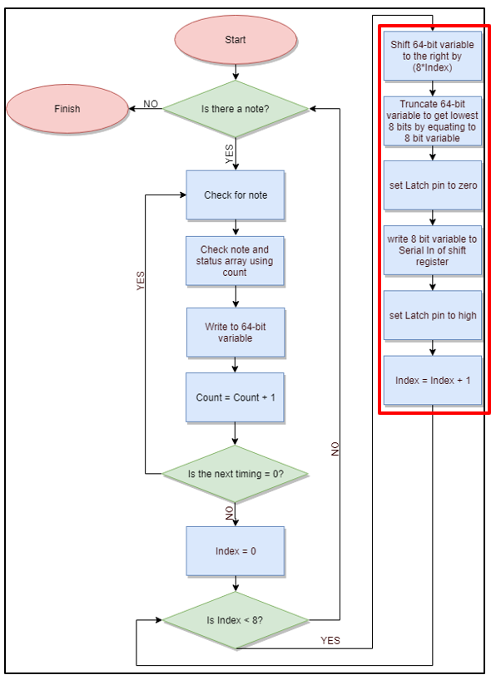

Figure . Structure of keyboard software that occurs within an Interrupt

Figure 3.13 shows the structure of the software for the keyboard. Once the program has started the *Count* variable is used to check whether there is a note available in the note array found on the SD card of the Teensy. Since the lowest MIDI note supported by the keyboard is 24 and the 64-bit variable starts at bit 0, then 24 needs to be subtracted from the note number obtained from the note array to get a corresponding bit number. For example, if note 54 needs to be played then this corresponds to bit 30 of the 64-bit variable. Once the note number has been achieved the *Count* variable is used again to determine the status of this note from the status array. Using the note and its corresponding status, the 64-bit variable can be updated to represent the current status of the song.

To update the 64-bit variable, the bitWrite() [41] function found in the Arduino library is used. The bitWrite() function takes three variables, the variable which will have its bit changed, the number of the bit to change and the status to be written to that bit. Each of these parameters is represented by a 32-bit variable, but the keyboard uses a 64-bit variable, so the functions had to be redefined in order to make them work with a 64-bit variable. This was done by redefining the bitWrite() function so that it works with an unsigned long long variable as opposed to just an unsigned long variable. This makes it so that the bitWrite function can now accept and modify a 64-bit variable.

Once the 64-bit variable has been modified the next stage of the program checks whether there is another change to the notes at this particular time. As the software is controlling a keyboard, a possible of 16 changes are possible at any one time (8 notes turning off, 8 turning on). A simultaneous change can be detected by checking whether the next element in the timing array is a zero. If it is a zero, it means that the change in note is happening with the previous change in notes before progressing. To detect whether these changes are happening at once the program enters a while loop, this increments the *Count* variable and checks the corresponding element in the time array to see whether it is zero. If it is a zero, it updates the 64-bit variable using the bitWrite() function. Once the loop is complete (i.e. when the program detects that the next element in the time array is non-zero), the program updates the interrupt timer to the value of the next non-zero element in the time array.

Once the next non-zero element is found in the time array this indicates that all the changes to the notes have been for this particular time in the song. The next stage is to take the 64-bit variable, break it into eight 8 variables and write these to the shift register. This is done by first setting the latch pin (pin 12) of the shift register and *Index* variable to zero and then entering a for loop. Within the for loop (shown in red on Figure 3.13) the 64-bit variable is shifted by (8\**Index*) and is truncated by equating it to an 8-bit variable. This truncated version is then written to the *Serial In* (pin 14) of the shift register. This is repeated eight times, each time incrementing the *Index* variable by one. In this way, the entire 64-bit variable is written to the shift registers 8 bits at a time. Once this is complete, the latch pin is set high, which outputs the bits on the shift registers to the solenoids. Since it does this in parallel all the changes at that particular instant in the song are made at once. Once the latch pin is driven high, the program waits for the start of the next interrupt and starts again.

### Keyboard Testing

To test whether the keyboard hardware and software had been built and constructed correctly several tests were run. The first test involved creating a program where the user could specify a specific key and get that single key to press down on the keyboard. This was a way of testing whether each of the solenoids fixed to the Bosch bar can press down and producing a note on the keyboard. The test results showed that each of the solenoids was capable of producing a note, the test results can be seen in **Appendix H.** This test showed that each of the solenoids was capable of doing so when played individually.

In addition to this test, the *Game of Thrones* theme song was played on the keyboard and timed to see how long it would take to complete. This was compared with the MIDI file version to show in both cases the song completed playing after 1 minute and 24 seconds. Both of these tests combined showed that the keyboard, when being played on it own, was performing as expected.

### Summary

The keyboard software utilises a chain of eight shift registers, totalling 64 output pins to cover the 61 keys available on the keyboard. Each of the pins represents a single note of the keyboard. A while loop is used to modify the 64-bit variable to represent the current status of the song. Once this has been done, a for loop is used to break the 64-bit variable into eight 8-bit variables that are written to the shift registers one by one.

## Xylophone

### Xylophone Software

The concept of the xylophone software, is to have three text files from each song, generated by the conductor, in order to define not only the physical condition, but also the rhythm, of the solenoids; i.e. which solenoid needs to be turned on and off at a specific time and play a particular note. Therefore, the first text file contains the notes that need to be played for a specific song, the second text file determines the time delays between the notes that are being played and the final text file, defines the state of the solenoid; either on or off.

### Structure of the program

To begin with, the three text files for each song, which are generated by the conductor, are saved in a file directory within the MyRIO.

The WIFI module produces a number of different commands (“PLAY”, “STOP”), along with the song that needs to be played. In order to make these commands interact with the xylophone, the UART of the MyRIO is used. Therefore, the transmitter of the WIFI module is connected to the receiver of the UART of the MyRIO. The UART (Universal Asynchronous Receiver/ Transmitter) is a piece of computer hardware (a microchip) which translates data between parallel and serial forms [42] [43]. It is mainly used for serial communications that contain a receiver and a transmitter; each clocked differently [44].

Focusing on the program structure, a flat sequence is used which has two frames. The use of the flat sequence is to ensure that a sub-diagram/ frame executes before or after a sub-diagram/ frame. The first frame contains the interrupt which may occur while running the program, whereas the second frame encloses the main program. In more detail, the interrupt is directly connected with the UART of the MyRIO and therefore when the UART reads a command, the interrupt is triggered. The commands sent by the WiFi module are two: “STOP” and “PLAY”, where the second is followed by the song which needs to be played, for instance “PLAYGoT” if the Game of Thrones theme song is selected. In order to make the UART interact with the rest of the program, two global variables are used; the first one contains the action that need to be performed by the xylophone, i.e. “PLAY” or “STOP”, whereas the second one has the song which need to be played.

Within the second frame, a while loop is created which repeatedly executes the main program. This while loop is fed from the first global variable which contains the action, and therefore either stops or plays the specified track. Inside the while loop, a case structure exists which acts according to the action command read by the UART. If the command is “STOP”, then there are no text files loaded in the program and therefore inertia prevails. On the other hand, if the command is “PLAY”, then the second global variable comes to use and informs the program which song needs to be played. Additionally, the appropriate text files are loaded from the c file directory of the MyRIO and three arrays begin to form; one containing the time delays between the notes in microseconds, a second one containing the notes of the song that need to be played and finally the third one, containing the state in which the solenoids need to be, i.e. on or off (add image).

Since the xylophone has only 12 notes, the next step of the procedure is to minimise the number of notes used in the songs. In order to do so, a formula node is used, in which the preferred octave is selected and all the notes (from that octave) are used. For instance, the Game of Thrones theme song, which has 19 notes from three consecutive octaves (octave 2, 3 and 4), is configured to have 12 notes all of them from the same octave. The appropriate octave, is selected either according to the most frequent notes that are being used within the song, or in the case of having three consecutive octaves, the middle one is selected in order to minimise the deviation from the original song. Finally, 12 digital output ports are used from the MyRIO in order to control the solenoids of the xylophone.

For that reason, a while loop is used, which runs that many times as the number of notes in each song. Inside the while loop, there is a case statement which reads the status text file and acts accordingly. In more detail, if the status is 0, the digital output pins are not enabled and therefore the solenoids are turned off, whereas when the status is 1, the pins are enabled and according to the note array, the appropriate solenoid turns on for an amount of time which is determined by the time array (Figure 3.14). However, the while loop will only terminate if one of the following two cases occur. The first one is when the number of iterations of the while loop exceeds the number of the notes in each song and the second, is when the UART reads the value “STOP”, where it forces the loop to stop executing and start again when the command send to the UART (from the WiFi module) is “PLAY”.

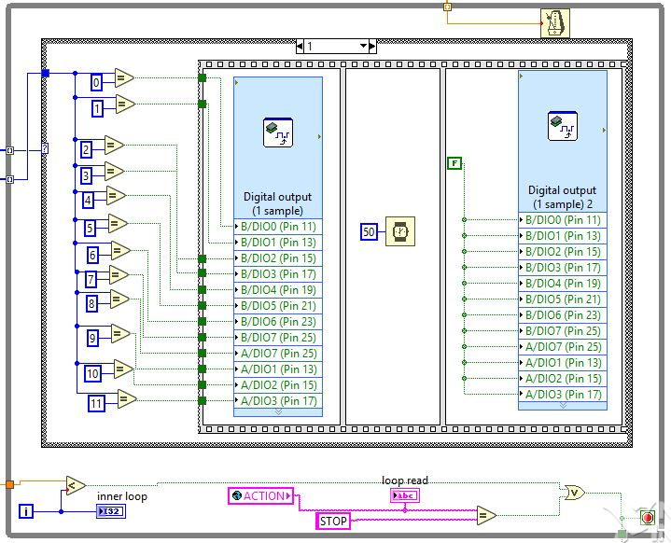

Figure .: While loop which enables solenoids according to status

### Piezo Sensors

Piezo sensors were put on top of the xylophone keys to detect the solenoids hitting the keys. They were connected to a comparator circuit that compared the voltage from the piezo sensor and the reference voltage of the voltage divider at the non-inverting input. The output of the comparator circuit was connected to the MyRIO so whenever the output was high, the LabView program on the MyRIO played the corresponding note through a speaker. The MyRIO was the preferred microcontroller since it already had a built-in audio output.

|  |  |
| --- | --- |
| Figure . Piezo sensors on the keys connected to the comparator | Figure . LM311 Comparator PCB |

**Comparator circuit**

After making the initial comparator circuit using a LM741 [45] and a voltage divider, several values of resistors were tested and it was found that a sensitive reference voltage was found to be around 0.2V that would detect the impact of the solenoid upon the piezo sensor. An LED was also placed at the output as an indicator. This circuit is seen in Figure 3.17.

R1 = 8000 Ohms and R2 = 330 Ohms.

$$Vref=V* \frac{R2}{R2+R1}=V*\frac{330}{330+8000} (1)$$

Where V is the supply voltage (5 V) there for $Vref=0.04*5=0.2 V$.

The circuit worked very similar to the final PCB and circuit design shown in Figure 3.16 and Figure 3.18, the only important difference being that the LM741 is powered by -15 and +5 volts whereas the LM311 can be powered by Ground and +5 volts. There were 12 of these circuit connected to each other and to the 12 xylophone keys and in turn connected to 12 individual inputs on the MyRIO.

After tests were done, there were problems with the piezo sensors when they were used for around 20 seconds, the LEDs indicated that the comparators stopped responding to the solenoid hits. This was fixed by adding a resistor in parallel with the piezo sensor to get rid of any build-up of static charge. Later it was noticed that there was -15 V at the output of the comparator when it was in the off state, which could damage the MyRIO, therefore the circuit was slightly modified, and a new comparator was added: LM311. This comparator could function of off ground as negative voltage supply so the danger of damaging the MyRIO was no longer there. The new circuit can be seen in Figure 3.18.

This leads to the LabView code that was used on the MyRIO to play the different sounds for each individual key.

|  |  |
| --- | --- |
| Figure . LM741 comparator circuit | Figure . LM311 comparator circuit |

**LabView code**

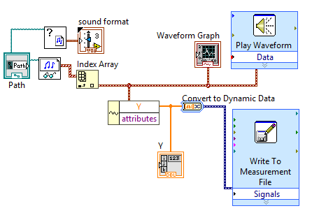

Figure . Converting wav. files to waveforms with help from [46].

The code to play the different notes was made in LabView. The MyRIO cannot directly output a wav. or mp4 format files to the audio output therefore the wav. files of the xylophone notes which were obtained from the University of Iowa Electronic Music Studios [47], were converted to a waveform and stored as an 1D array Y seen in Figure 3.19. This was all done offline since the MyRIO cannot do the converting in real-time according to this forum post [46], which was helpful in the development of the converter.

This array was then converted to a constant and moved to the main program seen in Figure 3.20.

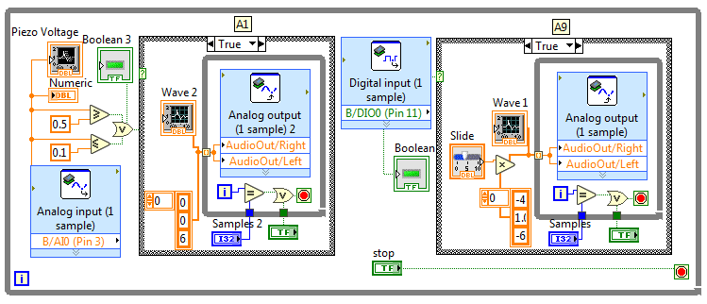

Figure . LabView code for analogue and digital piezo inputs

This code looked at the input from the pin to which the comparator was connected to and whenever it was high, it played the waveform from the 1D array through the audio output. The waveform was played at 44,400 samples a second, the number of samples played could be set to any number and the volume was changed by multiplying the amplitude of the waveform. The front panel (interface) for testing can be seen in **Appendix I.**

This code was then expanded to 12 inputs and 12 waveforms for all the xylophone keys. The real-time module of the MyRIO was then used to store the code onboard and execute it every time the MyRIO was started up. Appendix J.

**Speaker**

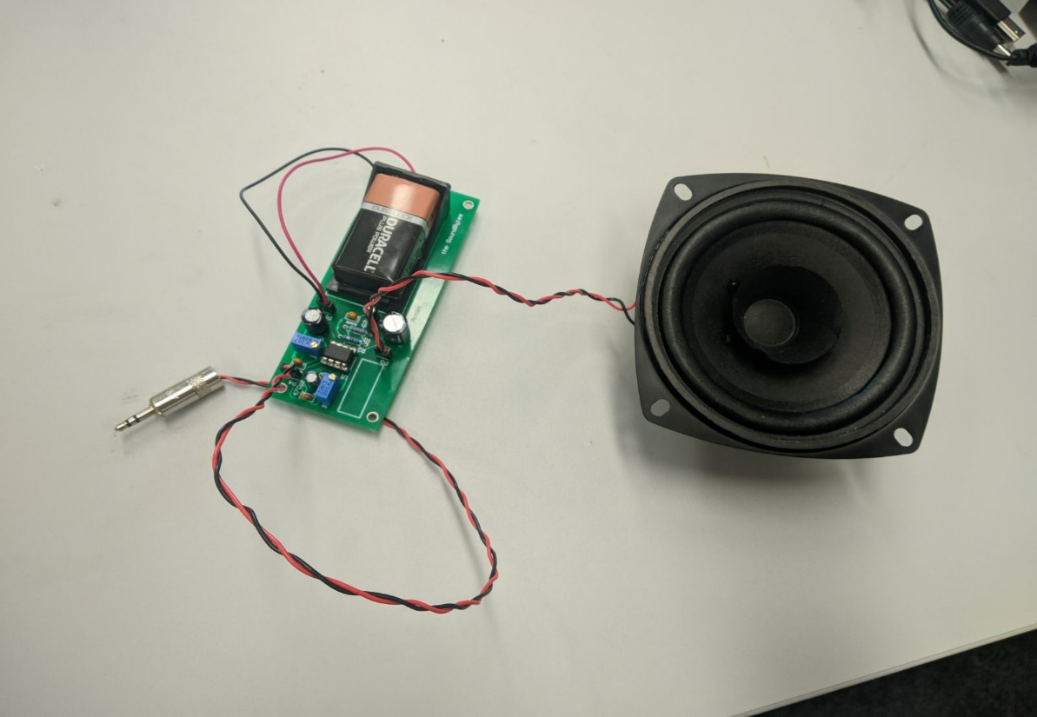

Figure . Visaton Speaker [48] connected to the amplifier circuit.

A speaker which would play the xylophone notes was installed and an amplifier circuit connected it to the MyRIO output. This circuit allowed to tune the volume and gain of the speaker since it did not come with any inbuilt controls.

The datasheet [48] stated that the speaker was capable of outputting 86 dB between 80 and 20000 Hz frequencies which was loud enough to play with the rest of the orchestra. The issue was that the signal from the MyRIO needed to be amplified.

An amplifier circuit was built following the instructions from [49]. This circuit allowed the user to control both volume and the gain of the signal using potentiometers. This circuit can be seen below:

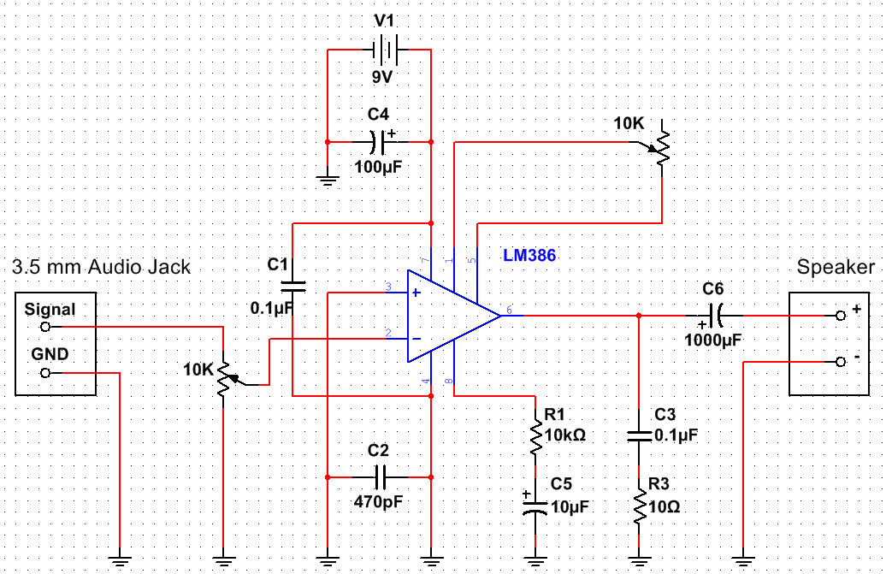

Figure . **.** Amplifier circuit with volume and gain controls based on [49].

This circuit used the LM386 chip for amplification. A 9 V battery was used as the power supply, but a MyRIO +15 V and ground could also be easily used as the LM386N-4 [50] chip can support up to 22 V as a power supply. The designed PCB can be found in Appendix K.

This circuit was later used to amplify the microphone input for the Tesla coil setup, but it was later found out that the circuit could pick up the signal from the Tesla coil wirelessly, without a microphone.

### Xylophone Testing

In order to evaluate the functionality of the xylophone, several tests have been performed (similar to the tests that the keyboard has been subjected to) which concern not only the hardware but also the software of the instrument. More specifically, each solenoid was tested individually by writing a program where the user is able to choose which solenoid to be played. The purpose of this test is mainly to check the response of each solenoid (i.e. whether they turn on or off) and secondarily the ability of the Bosch bar (which hold the solenoids above the keys) to preserve its initial condition and not be affected by the impact of the solenoids.

On the other hand, in order to test the software of the xylophone, each song played by the instrument, was timed and compared with the MIDI file version. By doing so, the accuracy of the software was tested and since the two timings match (of the MIDI file and of the instrument), then it means that the xylophone behaves as expected.

For the piezo sensor testing, the first step was to test each comparator individually by connecting them to a MyRIO and running the code for only one note using code shown in Figure 3.20. After making sure all the circuits work and produce a note, the circuits were all mounted and all the 12 keys with the piezo sensors were attached to the xylophone. The testing for 12 notes showed that each key produced different note, going from low to high as the keys were hit from one end of the xylophone to the other.

### Summary

The xylophone has 12 solenoids that are controlled by the MyRIO. The MyRIO receives the commands through the wireless module which tell the MyRIO which song to play. Once the commands have been received, the solenoids start hitting the keys that have piezo sensors on them that are connected to another MyRIO using comparator circuits. The second MyRIO interprets the high input and plays the note corresponding to the key that is being hit. The sound is played through the speaker that is connected to the audio output of the MyRIO.

## Stepper Motors

The stepper motors were chosen as an instrument as they were able to play each musical note without requiring hardware modifications and as they offered a low-cost option for a musical instrument to be added to the orchestra. The stepper motors instrument contributes to the overall project objectives as follows:

* It can play all the required tracks for the selected songs (objective 2)
* It is easy to transport (objective 2)
* It can communicate with the conductor (objective 4)

### Stepper Motor Hardware

The stepper motor instrument is controlled by a Teensy 3.5 board. Similar to the keyboard, the instrument was initially designed to be used with an Arduino Uno but as the Arduino board did not have enough memory to store the data required for playing an entire song, the design was adapted for the more suitable Teensy board.

This microcontroller board was used to program a AD9837 Digital Synthesizer (DSS) IC [51] to generate the required frequency for each note to be played as the song progressed. The frequency generated by the DSS chip was then used together with a DRV8825 motor driver board [52] to control the rotation of the stepper motor. The DRV8825 was selected because of its high current rating of 2.5 A that matched the stepper motor current requirement of 1.5A [53]. Additionally, the driver board also had a current limiting potentiometer which allowed for each motor to be tuned individually so that each motor would produce a clear sound. To generate the musical notes, NEMA 17 stepper motors were used as they were rated at 12V and 1.5A [53] which allowed for easy interfacing with the DRV8825 motor driver board. Additionally, as the stepper motors are not loud when rotating, a wooden acoustic box was built for them to be mounted on so that the sound produced by the motors would be amplified and easier to hear in larger spaces such as those that are used for trade fairs and other expo events.

### Acoustic box

Due to the fact that the stepper motors do not produce loud sounds when rotating and as the instrument is likely to be played in crowded areas, a decision was made to amplify the sound produced by the motors by using an acoustic box. After testing the sound level produced with materials such as Perspex, wood and cardboard, the data presented in Table 7 has been obtained. As it can be observed, wood produced the highest sound amplification and as a result, the designed acoustic box was built using this material, acting similar to the acoustic box used by guitars to amplify the sound produced by the strings vibrations. The motors are held in place by using aluminium brackets fixed on the top side of the box. The designed box is presented in Figure 3.23

|  |  |
| --- | --- |
| **Material Used** | **Measured Sound Level (dB)** |
| Perspex | 48 |
| Wood | 52 |
| Cardboard | 46 |

Table 7 Sound Level measurements for different materials

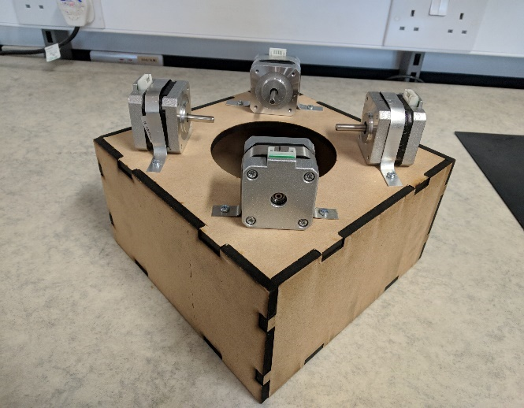

Figure . Acoustic box built for stepper motors

The acoustic box also has attached to it a PCB that contains all the components required for the operation of the stepper motor instrument: a Teensy board, four DSS circuit boards, four motor driver boards and a WiFi module for connecting to the conductor. The PCB that is mounted on the acoustic box was designed in a way that allows for each component to be easily replaced. This was done in order to minimise the impact on the instrument in the situation in which one component might fail and to also reduce the time it would take to fix the instrument in such a situation. Additionally. The slots on the PCB dedicated to the motor driver board are also compatible with other motor driver boards such as the Allegro A4988 which mitigates the risk of some components being difficult to source. (photo to be added after the pcb is manufactured)

### Digital Signal Synthesizer

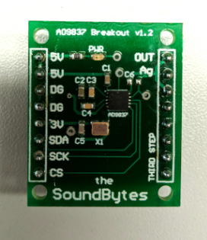

Figure .Digital Signal Synthesizer PCB

The selected Digital Signal Synthesizer (DSS) chip was the AD9837. This was due to its high accuracy, having a resolution of 0.02 Hz and being able to produce frequencies between 0-3 MHz [51]As the frequencies in the audible range only go up to 20 kHz [54], the DSS chip was well suited for this application as it was able to produce the frequencies of all musical notes with high accuracy, meaning that the replicated songs sounded as close as possible to the original versions.

Figure 3.24 presents the PCB designed for the DSS to be used with the other circuit units. As the IC was only available as a surface-mount component, particular care had to be paid when placing the components on the PCB.

### Motor Driver Board

In order to ensure that the stepper motors receive enough current, a motor driver board was used. For the stepper motor instrument, the selected model was the Texas Instruments DRV8825 [53]. This is because this model of driver board was recommended by multiple sources and according to [53], it was able to operate with voltages between 8.2V and 45V while supplying a current of up to 2.5 A, which was suitable for use with a NEMA 17 stepper motor. Appendix M.

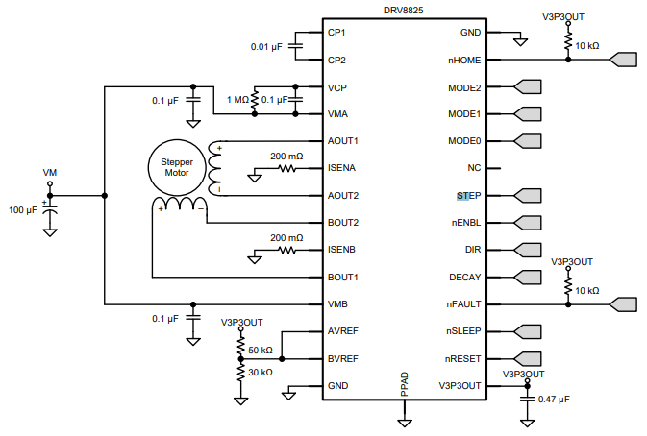

Figure 3.25 Schematic for DRV8825 IC [52]

Figure 3 presents the DRV8825 pinout and its required connections. The STEP pin is used for controlling the movement of the motor. Each pulse sent to this pin is converted to a step rotation and the DIR pin is used for controlling the direction in which the motor spins. Additionally, a decoupling 100 µF capacitor has been used as indicated in Figure 3 in order to protect the IC against voltage irregularities. In setting up the control circuit, the wiring diagram presented in [55] has been used for ensuring the wiring was done properly so as not to damage the components.

### Stepper Motor Software

The stepper motor instrument relies on the SD card of the Teensy board to play a particular song. This contains the arrays with the information required to play a song: note (contains the frequencies to be played), time (contains the time until the next action) and status (determines whether a note should be played or stopped).

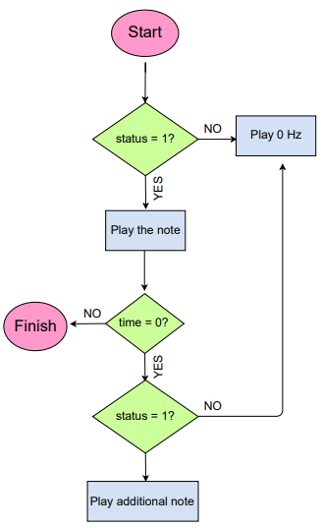

Figure 3.26 Flowchart of stepper motor software

Figure 3.26 presents the code execution flowchart of the stepper motor instrument that occurs every time the ISR is executed. The note status has a value of either 0 or 1 which determines whether a note should be played (status is 1) or muted (status is 0). Additionally, a value of zero in the time array indicates that multiple actions have to be executed at the same time. The instrument’s code uses a function named “playnote” in order to play a specific musical note on a stepper motor. This function takes a frequency value as a parameter and encodes it onto the DSS chip which generated the corresponding signal which is further played by the stepper motor. By using this sequence with four stepper motors and four DSS ICs, the instrument can play up to four musical notes at the same time, thus increasing the number of songs that it can replicate.

### Stepper Motors Testing

In order to confirm that the stepper motors instrument was designed properly, a series of tests was run. The first test consisted of a program designed for Arduino that would send square waves of different frequencies directly to the driver board of the motor. This confirmed that by varying the frequency of the pulses, the stepper motors could produce different musical notes. Following, a test code for the DSS IC was written in order to confirm that the IC could be programmed with a specific frequency to generate with high accuracy which could then be further transmitted to the motors. Next, the *Game of Thrones* theme song was played on one stepper motor and timed in order to compare with the duration specified by the MIDI file. As the instrument finished the song at the time specified by the MIDI file, it was confirmed that the stepper motors instrument was performing as intended.

Additionally, a test code was written for two DSS ICs to run in parallel in order verify that the instrument could play different notes at the same time. Figure 3.27 presents the output of two DSS ICs that are playing at the same time which confirms that the stepper motors instrument is able to play different notes simultaneously.

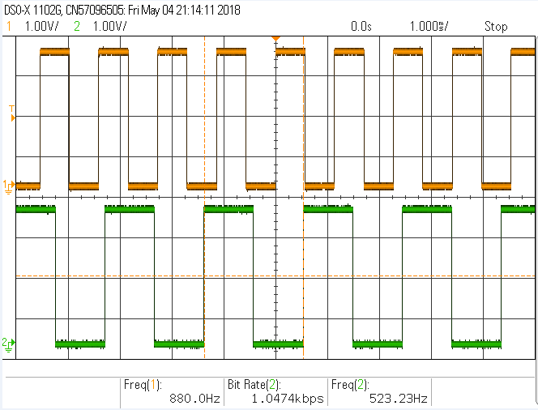

Figure . Signals of independent motors playing simultaneously

### Summary

The stepper motor instrument uses four stepper motors to play a song, meaning that it can support up to four musical notes being played at the same time. As the DSS chip can produce all the frequencies in the audible spectrum, the instrument is able to produce any musical notes that are required for a song, being a versatile instrument that can play both independently as well as in an orchestra, producing good replications of original songs.

## Fourth Instrument Decision

The selection of the fourth instrument came down to two either a tesla coil or panpipes. Both designs were considered and feasibility testing for each instrument was done in parallel with a deadline of the 14th of February set to make a final decision.

The selection of the fourth instrument came down to two either a tesla coil or panpipes. Both designs were considered and feasibility testing for each instrument was done in parallel with a deadline of the 14th of February set to make a final decision.

### Panpipes

After testing was done both on the panpipes and Tesla coils, the Tesla coils were chosen to be the fourth instrument for reasons that are later discussed, but there was a considerable amount of work done on the panpipes before this decision, which will be discussed in this section.

### Versions

There were 3 main designs for the panpipes throughout the project.

|  |  |  |
| --- | --- | --- |
| Figure . First design | Figure . Second design | Figure . Third design |

**First design**

The initial design seen in Figure 3.28 had the panpipes fixed to a base and the nozzle that directed the air from the pump (mattress pump at the time). The nozzle was on an elevated platform that would move from side to side to play different notes and had a breaker that would cut off the airflow when the platform would be moving from pipe to pipe. This platform would be powered by a stepper motor allowing it to move to individual pipes.

This design was later changed to the second design shown in Figure 3.29 which would simplify the moving mechanism.

**Second design**

Instead of a stepper powered track moving sideways, the idea was to mount the nozzle onto a servo motor which could rotate 360 degrees. The pipes would also be taken apart and mounted in a circle around the servo with the nozzle.

This design had flaws due to the moving components and how there might been and increasing error over time of where the nozzle is aiming, to the point where the nozzle will be blowing air past the pipe. This will lead to the final design which removed most of the moving parts.

**Third design**

The final design seen in Figure 3.30 would have an air compressor providing the airflow since after tests were done it was established that the mattress pump did not provide enough pressure to produce a loud enough sound. There were to be 15 pipes providing airflow to each of the 15 panpipes and at the end of each airflow pipe there would be a solenoid valve that is normally closed, and when a specific note needs to be played, the valve would be turned on to let the air through. Plumbing fittings would be used to distribute the pressure and airflow between all the panpipes.

### Research and testing for the tesla coil

A tesla coil is a transformer with a high turns ratio between the primary and secondary coils to produce a high voltage over the secondary coil. One end of the secondary coil is left as an open circuit and when the voltage goes above the dielectric breakdown of air 3kV/mm [56] it produces a spark. This spark can be modulated to change amplitude and frequency to vibrate the air and produce music.

As mentioned in the literature review there are many examples of a tesla coil being used to play music with producing streamers with lengths greater than 1m. It was decided that building this type of tesla coil would not be feasible in this project. Firstly, the testing would have to take place in the High Voltage lab, which was undergoing improvement works, so the remaining test spaces were under demand and would only leave a 3 week block to complete the testing when the hardware was complete (ref gant chart??). Secondly, the cost of building a lager one could also be a limiting factor as one estimate to build a small tesla coil was £300 [57]. This estimate doesn’t include a switching circuit to play music and issues in development, adding a further 50% to account for these would increase the cost to £450 which is which is 30% of the budget. Finally, the other factor to take in to consideration is that the orchestra is to be taken to outreach days and having a high power tesla coil could be difficult to meet health and safety regulation. Due to these issues it was decided to buy three low power mini tesla coil kits available from amazon to test.

The tesla coil kits included a circuit diagram with an explanation however the description was in Chinese as can be seen from Appendix N. Therefore, to progress with the tesla coil the kits were tested to figure out how the circuit works, shown in Figure 3.31.



Figure . Circuit diagram for Tesla Coil

The circuit works as a high frequency oscillator where Q1 and Q2 switch on and off which creates an approximate sinusoidal waveform Figure 3.32 over the primary coil causing a voltage to be induced in the secondary which produces sparks/corona discharge at the open end of the secondary coil. When a music waveform is applied at V1 it modulates the power supply to the coil causing the switching waveform to be amplitude modulated.

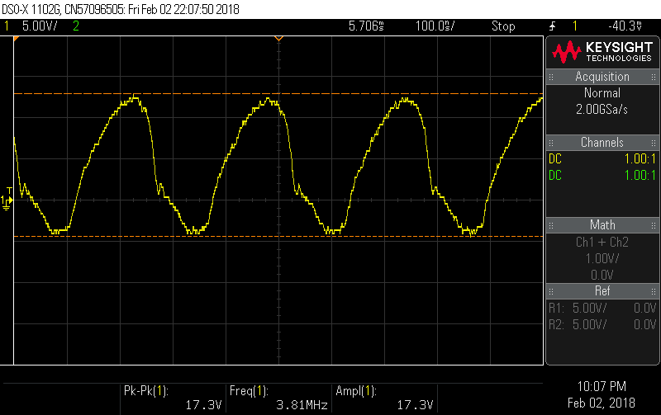

Figure . Single oscillation over the primary coil

As it can be seen the switching frequency is about 1/250n=4Mhz and has a voltage range of+13 to -4V over the primary as the turns ratio is 350 there will be a voltage ranging from and 4550 to -1400V. over the secondary.

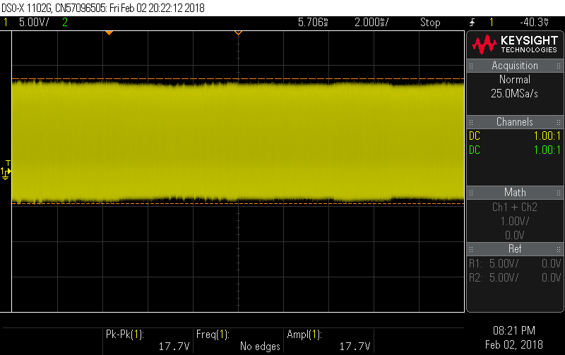

Figure . Voltage waveform over the primary coil with no music playing

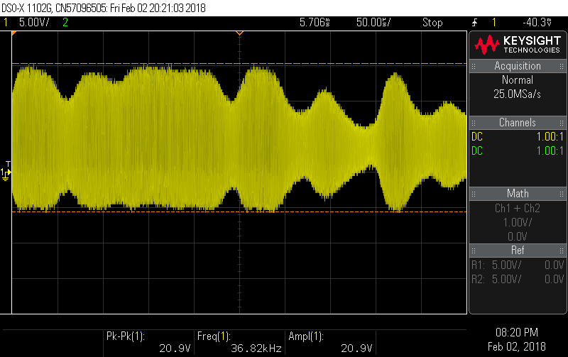

Figure . Voltage waveform over the primary coil with ‘eye of the tiger’ playing

The frequency of the audio wave form is about 1/75us=13khz this is as expected as it is in the audible frequency range.

The maximum current in the primary coil is estimated to be 30mA. As the base resistor is R4=10KkΩ and the voltage measure over R4 varies between 16 and 22V so the maximum current is 2.2mA. The gain of the BD243C is 100 so the collector current is 220mA in the primary. In the secondary coil the current is 220mA/350=0.6mA. Therefore, the current in the secondary coil is not dangerous.

The peak to peak voltage over the secondary coil is estimated to be about 6000V as the breakdown of air is 3kV/mm the length of the sparks are about 2mm long. As the spark from the is small that is also not going to cause any serious damage and can be controlled by putting the coil into a box, so it cannot be touched.

### **Issues found while testing**

After continued use the heat sinks become hot and the volume produced by the coil reduces and the sparks become smaller. This is suspected to be due to the BJT heating up and so the losses increasing. The amazon description does warn about using the tesla coil for more than 3 minutes.

The sound produced by the tesla coil is currently not that loud at only 55DB (using a phone app). This is about the same as conversational speech [58] as can be seen in Figure 3.34 the amplitude of the sound is controlled by the voltage amplitude.

### Possible Solutions

To deal with the heating problem new heat sinks that can deal with the heat better could be selected. The choice will be discussed in the Section 3.7.

To increase the volume the voltage over the secondary coil needs to be increased this can be done by increasing the number of turns in the secondary coil or increasing the input voltage. Increasing the input voltage has the limitation that it cannot exceed the amplitude of the power supply the components are rated for a 24V supply would be possible, but this would only increase by a factor of 30%.

Currently the sparks produced by the tesla coil are 2mm long as the breakdown of air is 3kV/mm. if the number of turns was increased to 10000 from 350 it would increase the length of the streamers to 10000\*20/3000=67mm=6.7cm. If this was done the switching circuit for the tesla coil on it would be at risk of being damage by the streamers as they would be able to reach the PCB. So to remove this problem the PCB would have to be split so the switching circuit can be removed from the coils vicinity. A rod would also probably need to be provided to catch the streamers. The secondary coil would have to be placed in a faraday cage so nobody can touch the coil and get injured.

As stated in the previous section the testing of the new coil would have to take place in the high voltage lab discussion were had with Dr. Vidyadhar Peesapati however, due to improvement works and demands on the remaining test spaces the team was unable to get access for testing in the time available. Therefore, this could be possible future work to increase the size of the secondary coil. For this project the solution decided on was to explore the use a microphone and play the sound through a speaker. This will be discussed in the Section 3.7.

### Summary

Using the mini tesla coil circuit would be cheaper as the components cost around £10 and safer due to the low current and small sparks (2mm). It would also fit within the time limits of the project as there is already a working circuit so with some developments it will be a viable option.

### Decision between Tesla coil and Panpipes

## Tesla Coil progress

The developments needed for the tesla coil to become a part of the orchestra are as follows: the heat management needed to be improve so it can be played for longer; the tesla coil needed to be integrated with a DSS and Teensy to control it; a new PCB needed to be designed to meet these requirements and a box is to be designed to mount the tesla coil this will make it easier to transport and provide a safety feature as the spark will not be able to be touched. The components will also be specified to cope with higher voltages and currents so in the future the circuit could be adapted to work with a larger coil. The current power supply used to power the tesla coil is 18V capable of supplying 2A so the maximum current the circuit can supply to the primary coil is about 2A.

### Heat sink calculations

The heat sinks were over specified with development with larger coils in the future. Power dissipated as previously calculated the current in the transistor is estimated to be about 0.22A and the voltage Vce= 2V so power is P=0.22A\*2=0.44W

Equations

Δθ =R\*P

Where P is the power dissipated in W, R is the thermal resistance in ⁰C/W and temperature difference between maximum temperature and ambient Δθ in ⁰C.

Δθ =(Rjc+Rca)\*P

Δθ =(Rjc+Rch)\*P

T=70\*0.44+25=55.8⁰C

The temperature specified by the British government state that surfaces acsssible to touch should not exceed 43⁰C [59]. Along with this touching a surface for 17s at 55⁰C will cause second degree burns [60] to avoid this a heat sink was chosen to aid heat loss. The maximum temperature for the surface of the heatsink was set to 30⁰C to ensure ther will be no risk of burns.

Using equation ? 30-25=0.44(2+Rhs) therefore, Rhs<9.36⁰C/W. To meet this requirement the …. was chosen as it has a thermal resistance of 3.4 ⁰C/W. If the circuit was used for 2A the temperature of the heat sinks would become 25+2\*2\*(2+3.4)=46.6⁰C. Which is above the governments recommended maximum temperature so the circuit would have to be contained in a box so it can’t be touched.

### Component specification

Two new PCB’s were made the components chosen for this are specified below:

BJT requires: a colector current >2A; $V_{be}$ =2V, $V_{ce}$ >24V, DC current gain at 40mA≈100, Switching frequency>4MHz, TO-220 package type.

MOSFET requires: Vgs=4V, Vds>24V, Id>2A, Switching frequency =4MHz, TO-220 fitting

Capacitors: C2 is 1uF with a voltage rating larger than 25V, C1 is a 1uF electrolytic capasitor requiring a voltage rating of >5V

The components except for the heat sinks, BJT and the MOSFET were obtained from stores. The selected BJT was the BD243C and the selected MOSFET was the STP75NF70.

### Testing PCBs

Two new PCB was designed to house the new components and are shown in Figure 3.35. One is the circuit producing the oscillations across the primary coil and the other is for the secondary coil. this will allow a larger tesla coil to be exchanged for the current one in the future. During testing several issues were found with the PCB. There was a connection missing to the collector of the BJT (Q1) and it was also found that the circuit provided in the tesla kits was not the same as the PCB layout used in the test kits. This meant that the position of LED1 was changed from the positive terminal connected to the secondary coil and with the negative terminal connected to the base of the transistor. To the positive side connected to the transistor base and the negative to the ground leaving the secondary coil connected to the base of the transistor (the new circuit can be seen in figure) and the old in the Appendix O).

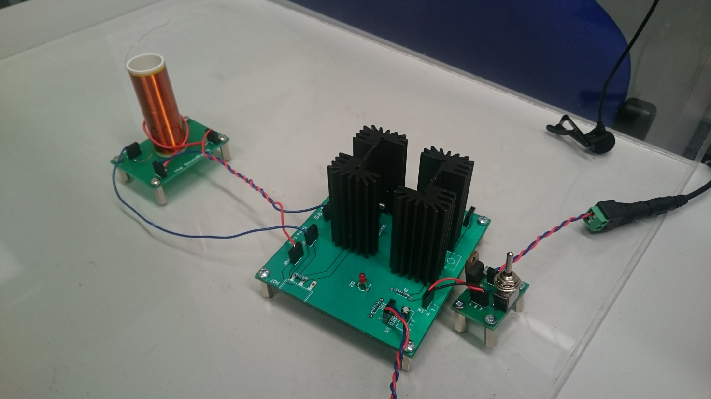

Tesla Coil

High frequency oscillation circuit

Microphone

Power Switch

Figure . Tesla coil instrument

These errors were fixed and a new PCB was printed. An alternative method was explored to so it could be used with the Teensy. So, if the new PCB still had faults when reprinted this would allow the instrument to be finished and tested with the orchestra and mitigate the risk. There was also switch for the power-in made so the tesla can be turned off in-between songs to limit the amount of power the heatsinks have to dissipate. This includes a manual switch and a PNP transistor that can be turned on and off by the microcontroller. The TIP126 PNP transistor was one available from the school stores and was rated for 80V and had a gain of 1000 so, to make sure the transistor allows 2A to flow a resistor to give a collector current of 2.5A was set at 1.2kΩ

A Teensy microcontroller board and DSS was used to control the tesla coil so it works in the same way as the stepper with a few changes such as different tracks to be played a switch to turn off the tesla between uses.

To amplify the tesla coil a microphone was chosen pick up the sound. This utilised an amplifier circuit already designed for the xylophone to amplify the microphone output so it could be connected it to the speaker. The tesla coil will be housed in a box to keep it from being touched by observers, so it can be used safely as part of the orchestra. The health and safety document for the coil is in the appendix.

### Testing

### Summary

# References

# Appendices

**School of Electrical**

**and Electronic Engineering**



**Robot Orchestra**

**Appendices**

**Group 11**

|  |  |  |
| --- | --- | --- |
| Group Members: | Buruiana, Andrei | 9478411 |
|  | Chanda, Joyanto | 9015629 |
|  | Dimou, Theodoros | 9126435 |
|  | Fumagalli, Francesco | 9017237 |
|  | Petrovs, Antons | 9474345 |
|  | Simpson, Joshua | 8929879 |

Tutors: Prof. Danielle George and Dr. William McGenn

Date: 15 May 2018

Table of Contents

[Appendix A 3](#_Toc513542342)

[Appendix B 7](#_Toc513542343)

[Appendix C 8](#_Toc513542344)

[Appendix D 45](#_Toc513542389)

[Appendix E 46](#_Toc513542390)

[Appendix H 47](#_Toc513542391)

[Appendix I 48](#_Toc513542392)

[Appendix J 49](#_Toc513542393)

[Appendix K 50](#_Toc513542394)

[Appendix N 51](#_Toc513542395)

# Appendix A

**Project Proposal**

**Project Title:** New core infrastructure for the Robot Orchestra

**Supervisors:** Prof Danielle George and Dr William McGenn

**Industrial Involvement:** National Instruments, Siemens, EPSRC, The Granada Foundation

**Overall Aim and Objectives of the Project:**

The aim of this project is to develop a 4-piece (min) robot music band/orchestra with a robot conductor. The Robot Orchestra is a project that fuses engineering with music/arts in order to give people a new perspective on engineering, highlight the creativity of engineering to prospective employees and reach audiences that are traditionally under-represented in the engineering sector. The instruments in the current orchestra have been made by school children, university students, maker groups and other members of the public, and use a wide variety of software and hardware platforms.

This project will involve building and developing a new core infrastructure for the Robot Orchestra that will be stand-alone as well as increase the flexibility, usability and reliability of the existing orchestra. This will include building a new robotic conductor as well as building several new instruments and developing others to form a centre piece for the orchestra. These instruments should allow for as large a range of musical styles to be played as possible. This new core infrastructure for the Robot Orchestra should be usable independently or with existing instruments and any new instruments, irrespective of the hardware platform that has been used to build them.

**Tasks to be undertaken** (a list is preferred and brief explanation if necessary)

* The new core for the robot orchestra should consist of at least 4 instruments/robots; these can either be built from scratch or developed from pre-existing instruments in the orchestra. These should have visual elements as well as being musical in order to increase the visual appeal of the orchestra. The instruments chosen should allow for the core orchestra to be capable of playing a wide variety of styles of music.
* It is worth noting that the challenges involved will differ depending on the instruments chosen and the way that the instruments are played. Careful selection of the instruments and their implementation into robots will be one of the key challenges for the team, not only on a technical level but it is also a key challenge for the project management.
* Develop a conductor for controlling all of the instruments/robots, which should be capable of controlling those that are being built as part of this project, those that already exist in the orchestra and also have as much flexibility as possible to include any that could be built in the future.
* In order to increase the ease of use of the orchestra we would like to develop a common MIDI file interface for the conductor and the other instruments (where appropriate).
* In order to increase the flexibility of the orchestra, we would like the orchestra to be programmed to play a selection of different pieces of music (to be chosen and justified by the team) that will appeal to a range of different ages and tastes in music, and could also be used in different situations (during Robot Orchestra performances, live shows and demonstrations).

**Relevant Background Information** (attach as separate if necessary)

The Robot Orchestra is an EPSRC-funded outreach project led by Professor Danielle George at The University of Manchester, in collaboration with Siemens and the Granada Foundation plus many more. The project originally began as to celebrate Manchester being the 2016 European City of Science and has continued to develop this year. In 2017 the BBC filmed the orchestra on a number of occasions including at Maida Vale Studios in London.

The orchestra has been part of a UK engineering tour sponsored by the Royal Academy of Engineering and showcased at both the institution of Engineering and Technology and the Institution of Mechanical Engineers. It is envisioned that the professional standards of the Meng teams output will attract further attention from the professional bodies as well as industry.

**Other Information**

To give an idea of range of musical styles, currently the orchestra is set up to play Hall of the Mountain King (https://www.youtube.com/watch?v=kLp\_Hh6DKWc) and Ed Sheeran’s Shape of You (https://www.youtube.com/watch?v=\_dK2tDK9grQ). It is not necessary that the new orchestra developed as part of this project need to play either of the songs.

During performances the audience is generally made award of the experimental nature of the current orchestra and will as such give allowances for some technical/musical mishaps. However part of the aim of this project is to reduce the experimental nature of the orchestra as much as possible, and thereby minimising both technical and musical problems.

**More information about the Robot Orchestra can be found at the website and on social media**

Website: http://www.robotorchestra.co.uk

Instagram: https://www.instagram.com/robotsarecoming/

Twitter: http://twitter.com/robotsmcr (@robotsmcr)

In addition there are a number of films of the orchestra performing and that we have been included in

The Making of the Robot Orchestra: <https://www.youtube.com/watch?v=SQdIGueRKj4>

The Robot Orchestra at the Manchester Science Festival: <https://youtu.be/9v1Jr8TDo0A>

Can a Robot Replace Ed Sheeran? <http://www.bbc.co.uk/programmes/p04sxvgw>

and

<http://www.bbc.co.uk/programmes/articles/55sKXKxMjBb9jdVyRgJXM72/could-a-robot-replace-ed-sheeran>

What if… Robots Replaced Teachers: <http://www.bbc.co.uk/programmes/articles/50xFTZWjLhb0Rv5v76bXsNs/what-if-robots-replaced-teachers>

**Desirable Skills** (note that the majority of the class are EEE students – some skills are in short supply). H,M,L =High, Medium, Low priority.

|  |  |  |
| --- | --- | --- |
| Please fill in as many relevant requirements as you wish **Skills** | **Number of students** | **Priority**  **H,M,L** |
| Power Electronics | | |
| Power Systems | | |
| High Voltage | | |
| FPGA | 1 | M |
| Embedded System | 1 | H |
| Digital Signal Processing | | |
| Image Processing and Vision systems | | |
| Analogue Circuits | 1 | M |
| Software Engineering | 1 | H |
| Control | 1 | M |
| Data Analysis | | |
| Sensors and Instrumentation | 1 | M |
| Communication Systems | 1 | L |
| Silicon Fabrication/Clean room | | |
| Mechatronics | 1 | H |
| Robotics | 1 | M |
| Sensors | | |
| Other (specify) | | |
| Knowledge of music etc (in addition to the above technical skills) | 2 | L |

**Metrics (Norms) for Technical Delivery**

Write a short statement to suggest what a “typical” M.Eng team would be expected to deliver on this project to achieve the following classifications. It is suggested that these statements are based on no more than 10 criteria:

**First Class**

Satisfied the 2:1 level and in addition:

* Full automation
* The finished orchestra is capable of playing, and programmed to play, a wide range of different songs to suit a wide variety of audiences and situations.
* Steps have been taken to ensure that new instruments can be added to this core orchestra in the future without needing the make changes to this core, irrespective of the hardware platforms to be added.
* Investigated further potential developments for increasing the interactivity of the orchestra
* Well thought out solutions for how the orchestra can be transported and set up to minimise the time set up/pack down takes.

One of the key differences between a 1st and a 2:1 is the quality of the final orchestra, the performance it is able to put on and its usability, i.e. how straightforward is it to operate, maintain and further develop. The key metric for evaluating the performance of the orchestra is recognisability of the song being played and the quality of the playing.

**Upper Second**

Satisfied the 2:2 level and in addition:

* The finished product is a fully working robot orchestra containing at least 4 instruments/robots that have been built/developed as part of the project. When performing all of the instruments play in time with each other and other visual elements are in sync with the music.
* The robotic conductor is capable of controlling the instruments/robots that have been built/developed as part of this project and also controlling those that already exist in the orchestra when desired. The conductor also has a midi file interface that is standardized with the other instruments in the orchestra. There is some degree of communication between the conductor and the instruments/robots to automate the change of song where appropriate.
* The instruments included in the orchestra have been well justified and will allow for a large range of different styles of music to be played, even if not currently programmed. All of the instruments/robots have a standardized midi file input. All of the robots also include well thought out and coordinated visual elements.
* Consideration has been paid to how the robots are to be transported and set up/packed down, and also to the general usability of the orchestra.

**Lower Second**

* Undertaken a literature review covering similar robotic instruments/orchestras and other relevant musical technology (e.g. Midi).
* Formulated a system specification for the orchestra.
* Investigated multiple design options for the conductor and the instruments/robots that could be included within the orchestra. This includes consideration of the instruments to be included to allow for a range of different styles of music to be played.
* The final product is a robot orchestra that consists of less than four instruments/robots or of only pre-existing instruments with minimal development. When performing the instruments do not play in time musically or the visual elements are not in sync with the music (or non-existent).
* Built a conductor that is capable of controlling instruments/robots that have been specifically developed as part of this project.
* No attention has been paid to the flexibility, usability and reliability of the orchestra.

# 

# Appendix B

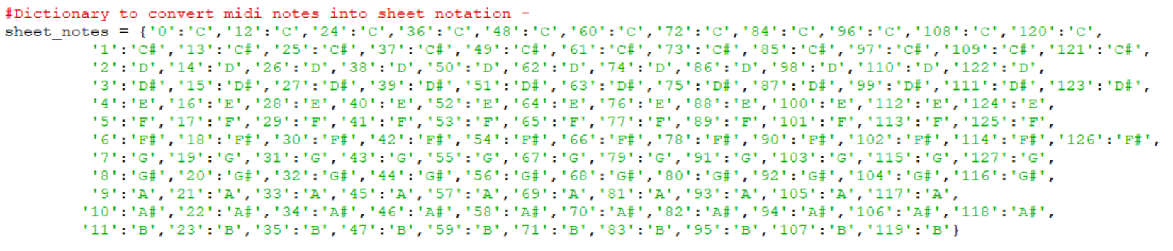

Figure . Binary values corresponding to musical notes

# Appendix C

**School of Electrical**

**and Electronic Engineering**



**Robot Orchestra**

**Interim Report**

**Group 11**

|  |  |  |
| --- | --- | --- |
| Group Members: | Buruiana, Andrei | 9478411 |
|  | Chanda, Joyanto | 9015629 |
|  | Dimou, Theodoros | 9126435 |
|  | Fumagalli, Francesco | 9017237 |
|  | Petrovs, Antons | 9474345 |
|  | Simpson, Joshua | 8929879 |

Tutors: Prof. Danielle George and Dr. William McGenn

Date: 26 November 2017

Table of Contents

[1. Executive Summary 3](#_Toc499491620)

[2. Project vision 4](#_Toc499491621)

[2.1. Introduction 4](#_Toc499491622)

[2.1.1. Required Skills 4](#_Toc499491623)

[2.1.2. Project Roles 5](#_Toc499491624)

[2.2. Aims and Objectives 5](#_Toc499491625)

[2.2.1. Aims 5](#_Toc499491626)

[2.2.2. Objectives 6](#_Toc499491627)

[2.3. Motivation 6](#_Toc499491628)

[3. Literature Review 7](#_Toc499491629)

[3.1 Keyboard 7](#_Toc499491630)

[3.2. Xylophone 7](#_Toc499491631)

[3.3. String instruments 8](#_Toc499491632)

[3.4. Wind instruments 8](#_Toc499491633)

[3.5. Stepper motors 10](#_Toc499491634)

[3.6. Tesla Coils 11](#_Toc499491635)

[3.7. Embedded Systems 11](#_Toc499491636)

[3.7.1. Conductor 12](#_Toc499491637)

[3.7.2. Instrument Microcontrollers 12](#_Toc499491638)

[3.7.3. Wireless Link 13](#_Toc499491639)

[3.8. MIDI 13](#_Toc499491640)

[3.9. Music Background 15](#_Toc499491641)

[3.10. Anvil Studio Overview 16](#_Toc499491642)

[4. Technical Progress 16](#_Toc499491643)

[4.1. Conductor Design 16](#_Toc499491644)

[4.1.1. High Level Overview 16](#_Toc499491645)

[4.1.2. MIDI2Text 17](#_Toc499491646)

[4.2. Solenoids 18](#_Toc499491647)

[4.3. Keyboard 19](#_Toc499491648)

[4.4. Xylophone 21](#_Toc499491649)

[4.5. Panpipes 23](#_Toc499491650)

[4.6. Tesla Coils 25](#_Toc499491651)

[4.7. Stepper motors 25](#_Toc499491652)

[4.7.1. Hardware 25](#_Toc499491653)

[4.7.2. Software 26](#_Toc499491654)

[4.8. Guitar 27](#_Toc499491655)

[5. Progress and Planning 28](#_Toc499491656)

[5.1. Approach towards 2nd Semester 30](#_Toc499491657)

[5.2. Risk Management 31](#_Toc499491658)

[5.3. Minutes and agendas 32](#_Toc499491659)

[5.4. Logistics 32](#_Toc499491660)

[5.5. Procurement 33](#_Toc499491661)

[5.6. Conclusion 33](#_Toc499491662)

[6. References 34](#_Toc499491663)

# Executive Summary

This report presents the progress made by MEng Team 11 on the “New core infrastructure for the Robot Orchestra” project. The aim of the project is to expand The University of Manchester’s existing Robot Orchestra by adding at least four new robot instruments as well as an electronic conductor to control the instruments. This would increase the orchestra’s capabilities and allow for a wider selection of musical styles to be played while also being able to be used as a standalone band. Additionally, the new instruments need to be able to play at least two different recognisable songs and allow for future additions of instruments as well as for easy transportation and set up.

The individual objectives of the project are: choosing the songs to be played, selecting four instruments, designing and manufacturing them and finally, assembling them into a core orchestra that can play at least two songs together. The project is motivated by the rising interest in the existing Robot Orchestra which, if expanded, will be able to showcase the operation of multiple embedded systems to perform a shared task that combines engineering and art. Additionally, this expansion can also lead to the Robot Orchestra appealing to a wider audience and advertising engineering to people who would not normally consider it.

To date, a decision on the songs to be played has been made, *Eye of Tiger by Survivor* and *Californication by Red Hot Chili Peppers* having been chosen. Additionally, the instruments selected for the new core infrastructure are: keyboard, xylophone, panpipes, stepper motors and Tesla coils. Mechanical models of the robots for the keyboard, xylophone and panpipes have been designed and for playing the keyboard and xylophone, solenoids that press the keys have been chosen as the preferred method. After having tested various models, a decision was made on which solenoid model to use and for the panpipes, the final design has been narrowed down to two final versions and a part used by both designs has been manufactured. For the stepper motors, decisions on the driver board, microcontroller and stepper motor model have been made and currently, the motors are able to play simple songs individually. The Tesla coil instrument has been investigated and an off-the-shelf kit has been ordered and constructed, which was able to play a song when a source was plugged into the audio jack. In terms of the conductor, Raspberry Pi has been chosen as the embedded platform and software code that is able to extract the key information from the industry-standard file format used for music encoding (MIDI) and convert it to a format that can be used by the instruments designed in this project has been produced.

The report concludes that according to the progress made to date, the keyboard and the stepper motors instruments are expected to be completed by the end of the third project block with the xylophone being expected to be completed shortly after this. The conductor is expected to be completed in a similar timeframe, depending on the selected type of communications between it and the instruments. Lastly, the Tesla coil and robot panpipes are both considered as viable options for the fourth instrument, with a final decision due to be made after the testing stage.

# Project vision

## Introduction

The University of Manchester Robot Orchestra was originally created to celebrate Manchester becoming the European City of Science for 2016. Since its inception, the project has gained backing from Siemens, The Granada Foundation, EPSRC and National Instruments [1]. The Orchestra debuted to the public at the Museum of Science and Industry in Manchester and has since gone on to feature in a BBC iPlayer documentary [2]. It has proven to be a popular STEM activity, promoting engineering to younger students by showing that an array of technical engineering skills can be used to produce something that is accessible to the masses. Due to its high praise, this project has been dedicated towards developing a new stand-alone core by constructing four new instruments and a robot conductor. It will also improve the reliability, flexibility and usability of the existing orchestra.

### Required Skills

Looking at previous instruments that have been used in the Orchestra it can be seen that an array of skills are needed in order to make each of the instruments. For example, the Glock-O-Bot [3] required technical skills in analogue circuit design, coding in C and a deep understanding of MIDI files and text conversion. Creating the expansion for the robot orchestra will require these same skills in addition to several more, since the design is more complex and four robots are being built instead of just the one. Table 2.1 below shows how the different disciplines covered by the team help in meeting the skills requirement for this project.

|  |  |  |  |  |  |  |
| --- | --- | --- | --- | --- | --- | --- |
| Indicates where skills need to be developed. | | | | | | |
| Degree | **Electronic Engineering** | **Mechatronic**  **Engineering** | | **Electrical and Electronic Engineering** | | |
| Skills | Andrei Buruiana | Antons Petrovs | Francesco Fumagalli | Joshua Simpson | Joyanto Chanda | Theodoros Dimou |
| Analogue Circuit Design | X | X | X | X | X | X |
| Electronic Circuit Design | X | X | X | X | X | X |
| Coding in C | X | X | X | X | X | X |
| Experience with Arduino |  |  | X |  | X |  |
| Experience with MyRIO |  |  |  |  |  |  |
| Experience with Raspberry Pi |  |  | X |  |  |  |
| 3D Modelling |  | X |  |  | X | X |
| PCB Design | X | X | X |  |  |  |
| Basic Music Knowledge |  |  |  | X |  |  |
| Experience in LabVIEW |  |  |  |  |  |  |

**Table 2.1.** Different skills met by individual team members.

The approach for this project will potentially make use of three different embedded systems: the Raspberry Pi, Arduino and National Instruments’ MyRIO so previous experience working with embedded systems is crucial. As can be seen, both the Arduino and Raspberry Pi come within the scope of past experience the team has, however, no one has worked with the National Instruments (NI) MyRIO. In order to tackle this issue, an application was submitted for the National Instruments Student Project Sponsorship [4]. The main benefit of the scholarship is that NI will provide a technical engineer to assist in the use of any NI software or hardware. In addition to the NI MyRIO the project is likely to utilise LabVIEW, the team does not have much experience in utilising either of these so having an engineer from National Instruments will help in meeting this skills gap.

The bursary also has the added benefit of allowing the team to compete in the National Instruments Student Design Competition. This is a competition designed for students from different universities to submit project designs and have the chance to be showcased at the Engineering Impact Awards in London. This is also a highly technical competition which will further emphasise the technical skills that are needed in this project as well as showing how technical engineering skills can be used to create something that is enjoyed by a non-technical audience.

### Project Roles

In addition to the technical skills that will be required to complete the project, several soft skills will be required according to the role that each member has taken on. There are six main roles that need to be fulfilled by team members:

|  |  |
| --- | --- |
| **Project Manager**  **(Joyanto Chanda)** | Main purpose of the project manager is to ensure that the project is running on schedule and can be completed on time. This is done by defining the milestones that need to be completed in order to achieve each of the objectives and overall aim of the project. |
| **Secretary**  **(Joshua Simpson)** | Important to make sure that minutes and agendas are prepared for each team meeting. These are crucial documents since they track important decisions made by the team. |
| **Auditor**  **(Andrei Buruiana)** | Ensure that the team does not exceed the allocated budget. They are also responsible for placing the orders on behalf of the team, whether that is through iProc or other means. |
| **Hardware Lead**  **(Theodoros Dimou)** | Defining the team’s approach to the upcoming hardware deadlines. Important to have previous experience in hardware design (e.g. hardware lead on Buggy Project). |
| **Software Lead**  **(Francesco Fumagalli)** | Defining the team’s approach to upcoming software deadlines. Important to have previous experience in software development (e.g. third year individual project had a significant software component). |
| **Document Controller**  **(Antons Petrovs)** | Responsible for ensuring that documents across the project are the same format and follow a similar theme. Will also be responsible for assembling and formatting the reports. |

**Table 2.2.** Team roles to be fulfilled during the project.

## Aims and Objectives

### Aims

The aim of this fourth-year project is to create four or more new robot music instruments. These robots should follow a consistent aesthetic and theme that should represent electronic and mechanical engineering so it does not fall out of line with the existing robot orchestra. They must also be controlled by an electronic conductor which will control the robots playing the instruments.

These four robots need to be able to reproduce at least two different songs or themes, but should also be designed to be able to be programmed to play a variety of other musical pieces. A high level of autonomy is expected from the robots; ideally the only interaction should be the communication between the conductor and the robots.

Apart from the flexibility in the ability to play different styles of music, this new core of instruments as well as the conductor should be mindful of future additions and should be expected to accommodate for new instruments as well as the old ones. The robot instruments must also allow being disassembled, transported and reassembled quickly and easily so that time is saved when preparing for concerts and demonstrations.

### Objectives

After the roles were assigned to individual members planning was done for the upcoming blocks, setting the following objectives:

* Propose designs for the four new instruments:
* Select multiple songs and assign instruments that could perform its parts.
* Select two suitable songs that use four of the same instruments.
* Divide the team into four groups to work on designing each instrument.
* Construct the four instruments:
* Design and manufacture prototypes for each instrument taking into account how they will interface with the conductor.
* Test the prototype instruments to play tunes or songs individually.
* Redesign / remanufacture as required based upon testing.
* Design a conductor:
  + Design the conductor which will communicate with the instruments.
  + Assemble the conductor.
* Assembling the new core orchestra:
  + Test individual instruments with the conductor
* Interface the conductor with all the instruments.
* Synchronise the four instruments to produce coherent music.

## Motivation

The work undertaken in this project is motivated by the rising interest in the university’s existing Robot Orchestra with the orchestra having most recently been part of an engineering tour sponsored by the Royal Academy of Engineering as well as having been part of a BBC programme [2].

As the existing orchestra has a limited range of songs it can play, adding a conductor and new instruments that can enhance its capabilities would allow for a wider selection of musical styles to be played and appeal to a broader audience. In addition to its outreach aspect, the project also stands to illustrate the operation of multiple embedded systems in performing a common task, making use of platforms such as Arduino, Raspberry Pi and MyRIO to control the performance of the orchestra.

Additionally, due to the combination of different development platforms that the orchestra uses, its commercial exploitation by leasing the orchestra to various businesses and events will also be investigated. As companies in the technology industry can be expected to be present at several trade fairs throughout the year, the Robot Orchestra offers a good opportunity for technology companies to showcase the creative aspects of engineering as well as the applications of their products in an atypical project that has a high chance of drawing attention and attracting new customers. Moreover, the project will also represent a good reference point for future projects focused on developing robot instruments.

Lastly, since it can be difficult to explain the benefits of pursuing one’s interest in science and engineering to an audience of different age categories and backgrounds, the combination of engineering and arts in the robot orchestra developed during this project can also serve as a good aid for the university to promote its courses as well as advertise engineering to people who normally would not consider it.

# Literature Review

To gather some initial ideas for the instruments to be constructed during the project the team was split in to sub-teams and each of these sub-teams was given a specific category of robot instrument to investigate. The following section describes some examples of robots that were found, categorised by the type of instrument.

### 3.1 Keyboard

Early on in the project it was decided that using a keyboard would be a good choice for one of the instruments. There were several designs that were found online, but the two that stood out the most are shown below.

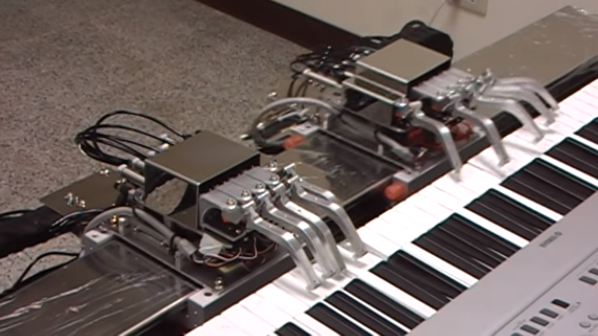

**Figure 3.1a.** J. Shauw robot keyboard [5].

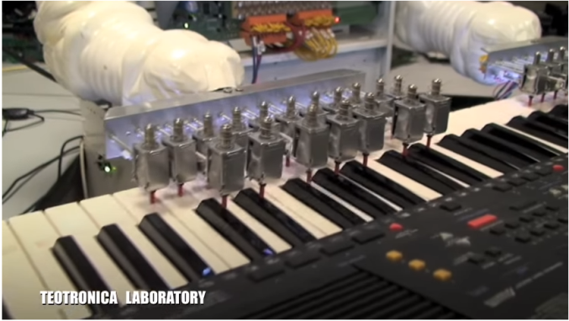

**Figure 3.1b.** Teotronica robot keyboard [6].

These videos showed the problem of a robot piano being approached in two different ways. Figure 3.1a utilised ten robotic fingers split in to two ‘hands’. One of the hands remained stationary (presumably to play chords) and the other would slide up and down a rail, able to play an array of different notes. This was quite a visually appealing design because of how closely the robot managed to replicate human movement. The design shown on the right is a much more practical and easy to implement design. It utilises solenoids to push down the keys. From Figure 3.1b it can be seen that the solenoids are staggered so that the black and the white keys can both be hit.

Comparing the two designs, the one on the right is going to be easier to make both in terms of the hardware and the software. Using a moving hand poses significant challenges, specifically in terms of the software, that limit the number of songs that can be played. If the hand had to move, then the software would have to predict not only where the next note is based but where the next four notes are also based. If it did not do this, then there is a chance that the hand would have to move for each individual note. This form of software is within the skillset of the team but due to the time constraints it is not feasible to build and still construct three other instruments. The design on the right is significantly simpler, using only a series of solenoids in a fixed position to push down on the keys. The software for this style of design is a lot simpler to create as well, this is an important factor to consider since four instruments are being created.

## Xylophone

Another instrument that was considered was the xylophone, which belongs in the percussion family and more specifically in the idiophone group [7, 8]. In general, the xylophone is tuned in different musical scales according to the country of origin. For example, in Africa and Asia it belongs in the pentatonic (i.e. five keys) and heptatonic (seven keys) scale respectively. If the xylophone is part of an orchestra, it is tuned in the chromatic scale and therefore has 12 notes [9].

After researching on how to integrate the xylophone with the robotic orchestra, the team decided to design their own xylophone which would be able to play 12 notes. The idea is based on a video found on YouTube [10], where a person created a customised xylophone with eight keys. Each key had a piezoelectric sensor mounted at its center and was programmed (through an Arduino) to produce a specific sound when it was hit (Figures 3.2a and 3.2b).

Piezoelectric sensor

Arduino shield with multiplexer

The shield contains a multiplexer and is connected to the 5V, ground, analog input and three digital outputs of an Arduino, whereas the other strip board illustrated in Figure 3.2a, is connected to the piezoelectric sensors. The Arduino is programmed to read signals from the piezoelectric sensors and it sends them back to the computer which in turn plays the corresponding note. The multiplexer is used in order to minimise the number of pins the Arduino needs to read the piezoelectric sensors.

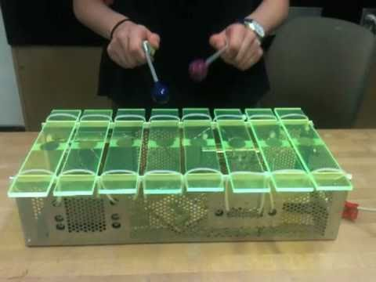

**Figure 3.2b.** Customised xylophone [11].

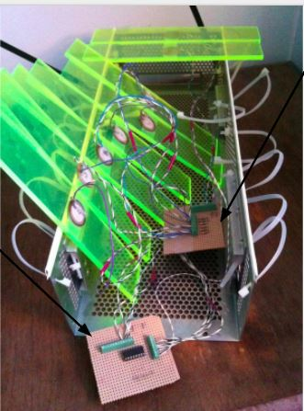

Piezoelectric sensor

Arduino shield with multiplexer

Board that connect piezos to shield

**Figure 3.2a.** Xylophone parts [11].

## String instruments

String instruments are musical instruments with a set of strings which vibrate and produce sound when they are pulled, hit or rubbed with a bow [12, 13].

Among the various string instruments, a decision was made to use the classical acoustic guitar, which is an instrument used in various different songs. Therefore, research was conducted on how to integrate the guitar with the robotic orchestra. The outcomes of the research showed that it is necessary to build two robots; the first one would control the notes that will be played on the upper part of the guitar (neck), i.e. the strings that need to be pressed for each song, whereas the second robot would control the strings that need to be played at the bottom part of the guitar (body).

## Wind instruments

It was decided it would be interesting to demonstrate a wind instrument so current robot wind instruments were researched using YouTube. One issue with creating a robot wind instrument is that they require the air flow to be controlled in a specific way. For example, when playing the trumpet, the lips are vibrated in order to create a specific note or sound [14, 15]. There is a video of a robot playing the trumpet to achieve this using artificial lungs and lips [16]. Another example of a robot with artificial lungs and lips was used to play the flute [17] as seen in Figure 3.3, it was realised that designing and manufacturing a robot like this would be unrealistic due to time limit and budget.

Due to this it was decided that a wind instrument would have to be chosen in which the lip position required does not change and the airflow could be constant removing the need for artificial lungs. The instruments found to meet these requirements were the recorder and panpipes.

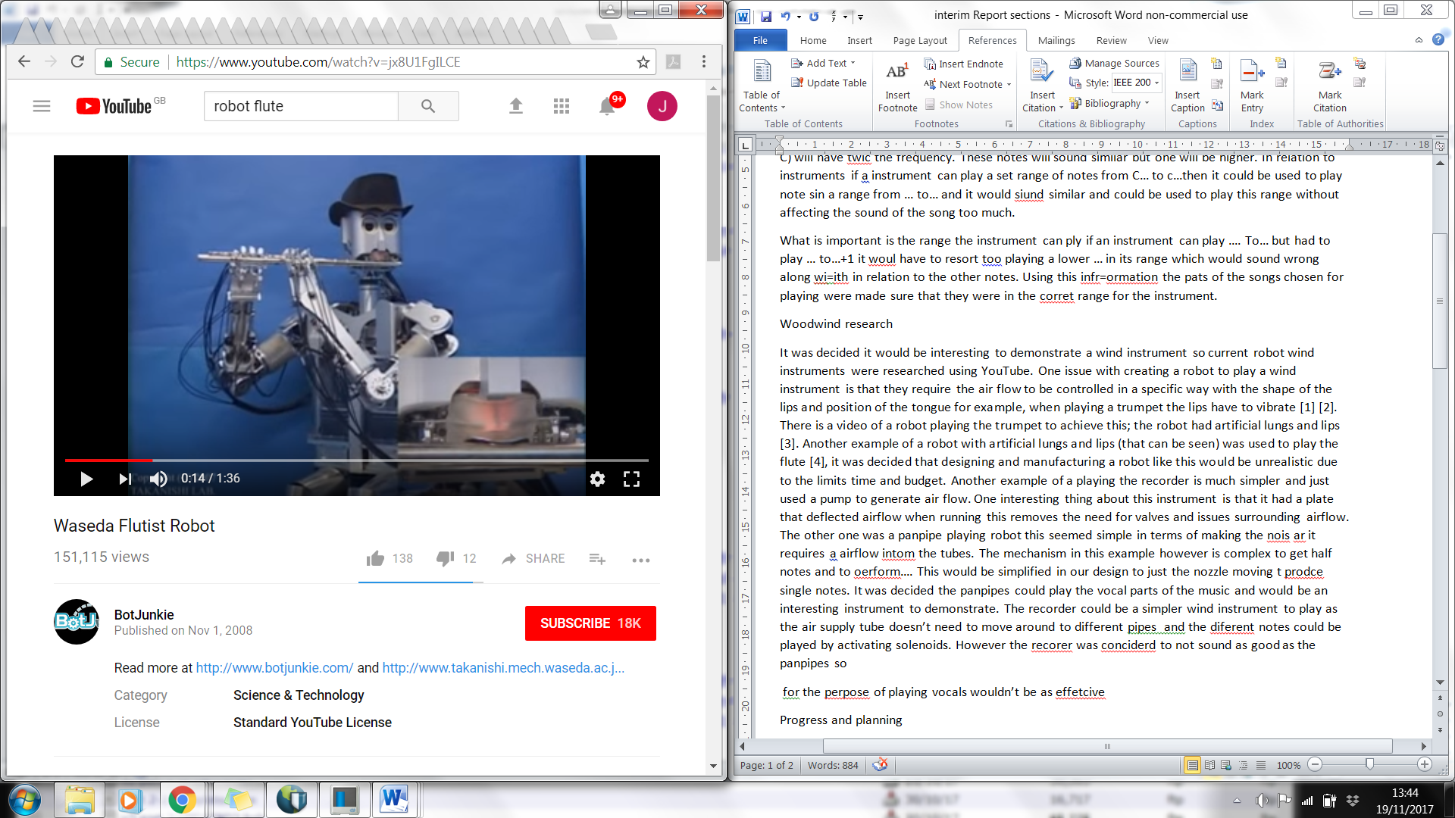

Lungs

Lips

**Figure 3.3.** Flute playing robot with artificial lungs and lips [17].

The panpipes are played by forming a small gap between the lips and blowing across the panpipe opening [18] and for the recorder there is just one tongue position which is maintained while blowing to produce the note [19]. Examples of robots playing the recorder [20] and the panpipes [21] were found on YouTube.

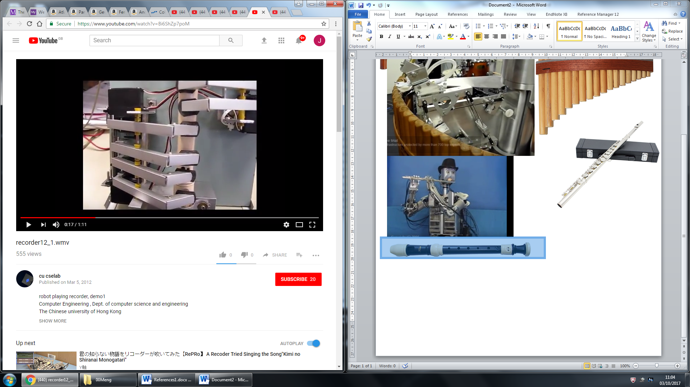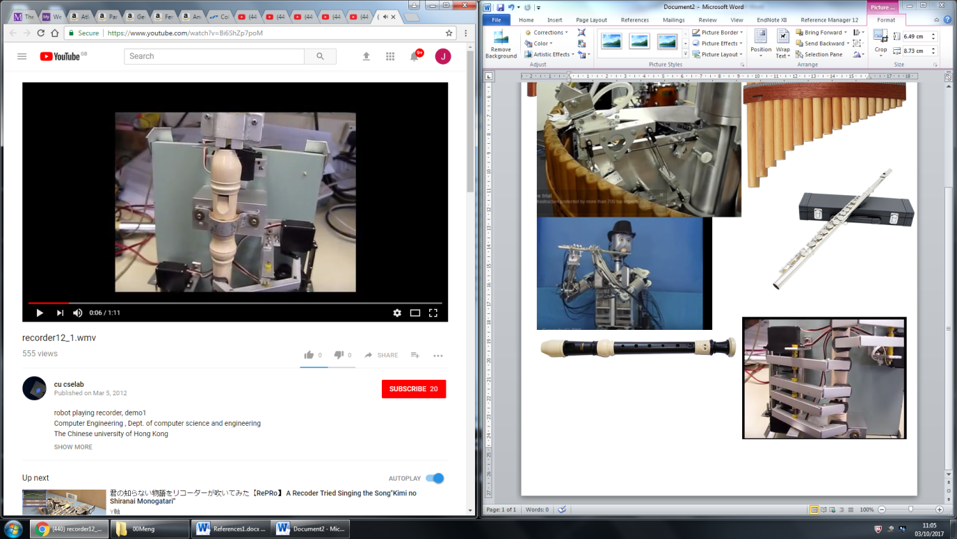

Air deflection plate

**Figure 3.4a.** Recorder mouthpiece section [20].

**Figure 3.4b.** Recorder fingers section [20].

The robot playing the recorder, as seen in Figures 3.4, uses a pump to generate air flow and does not have lips that go around the mouthpiece. One interesting thing about this instrument is that the air is produced continuously and it has a plate that moves in front of the air flow when no note is being played to deflect it away from the recorder. This removes the need for valves and the possibility of pressure building up behind the closed valve that is released when the next note is being played, which could lead to the note being produced incorrectly.

The panpipe playing robot, as seen in Figure 3.5, has one pipe that produces the air and that can be moved to change the angle at which the air is directed into the pipe, this is to create half notes which correspond to sharp and flat notes. The panpipes itself is rotated under the nozzle to line up different tubes with the nozzle to produce different notes. It also has a metal plate between the nozzle and the panpipes which is used to direct the air flow and simulate the lip position required. In this example the panpipes are used to play the vocals which could be an effective way of incorporating them into the orchestra.

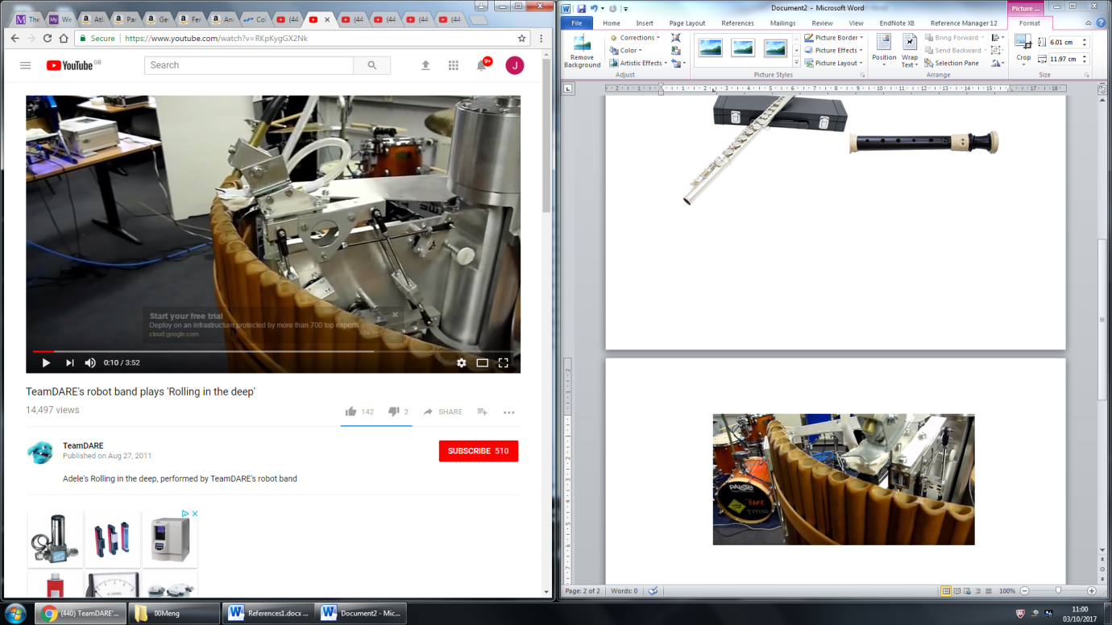

Plate to direct air flow

**Figure 3.5.** Robot panpipe example [21].

## Stepper motors

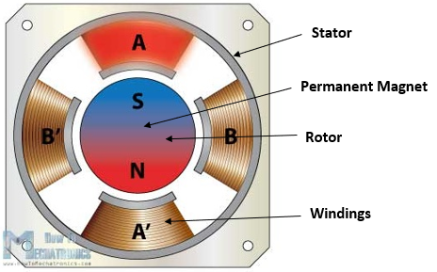A stepper motor is a DC motor that is able to convert digital pulses into equal steps of a rotation [22]. Generally, stepper motors are used in high-precision applications that use digital pulses as control signals rather than analogue voltage levels and by varying the frequency of the digital pulses, the mechanical shaft rotation can be modified. A high frequency of the pulses results in a continuous movement of the motor shaft. The advantage of stepper motors when compared to other type of high-precision motors such as servo motors is that it does not require a feedback mechanism as each individual pulse translates to the shaft rotating a precise angle [23].

**Figure 3.6.** Cross-section of stepper motor [24].

Figure 3.6 presents the cross-section of a permanent magnet stepper motor. As it can be observed, the permanent magnet acts as the rotor of the motor, being surrounded by the windings of the stator.

A good way of understanding how the rotational movement is achieved is to analyse the rotor and the stator of the motor individually. The rotor comprises of two discs placed back to back, one acting as a magnetic north pole and the other as a magnetic south pole. As illustrated in Figure 3.6, the stator is placed around the rotor and is fixed. Each winding acts as an electromagnet that can be controlled independently. When activated, the stator will attract the disc of opposite polarity in the rotor, leading to the rotor’s rotational movement [25].

Depending on the level of precision required, a stepper motor can be driven in 3 different modes: full step, half step and microstep. The difference between these modes is represented by the order in which the windings in the stator are energised and the effects it has on the rotational movement. For example, in half step mode, a digital pulse would produce an angular movement that is half of the one produced by the same digital pulse when the motor is operated in full step mode. The rotation of the motor can be controlled with a PWM signal (pulse-width modulated signal) of different frequencies and if this frequency is in the audible range (20 Hz - 20 KHz [26]), the motor is able to produce different musical notes.

## Tesla Coils

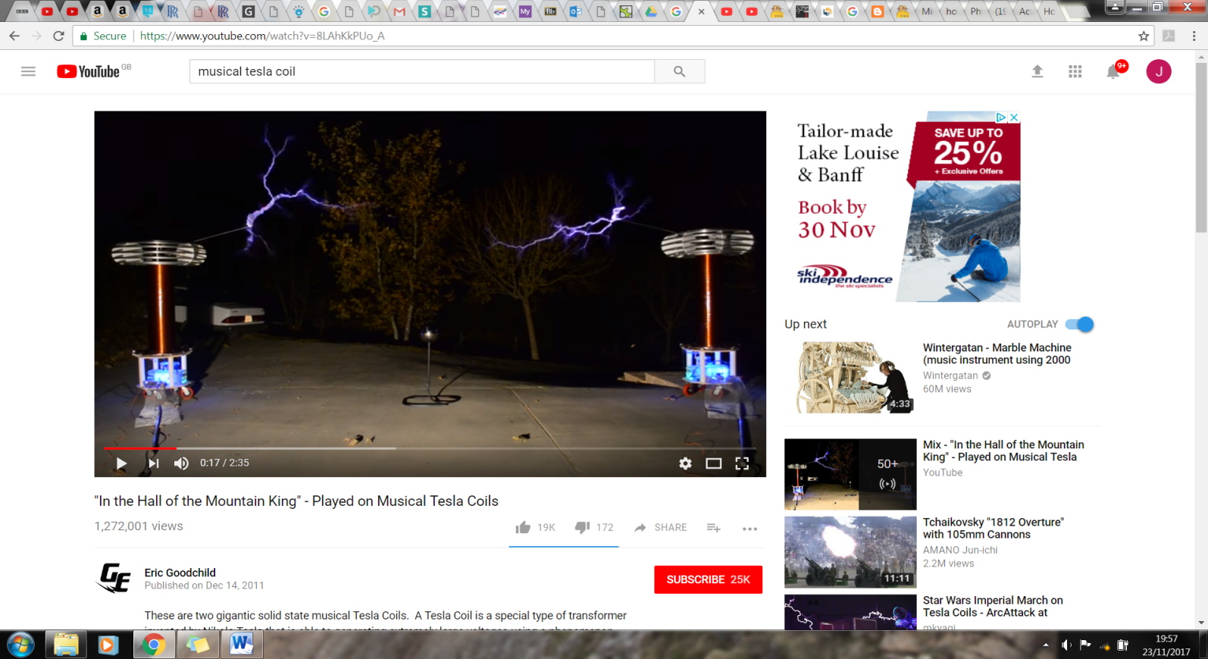A Tesla coil is a transformer where the secondary coil is left with an open circuit. Figure 3.7a shows a Tesla coil circuit with a spark gap. In this circuit the capacitor is charged and when the voltage over the capacitor is large enough a spark forms over the spark gap and the capacitor is connected in parallel with the primary coil and it discharges [27]. This causes a voltage to be induced over the secondary coil with the voltage level increased by the turns ratio N2/N1. The turns ratio needs to be large such that the voltage over the coil is large enough to overcome the dielectric strength of the air to create steamers. The dielectric breakdown of air is 3 kV/mm [28] so to get a streamer of 10 cm a voltage of 300 kV is needed. The image in Figure 3.8 shows streamers being created as "In the Hall of the Mountain King" is being played with the Tesla coil.

**Figure 3.8.** Streamers being created by Tesla coil playing “In the Hall of the Mountain King” [29].

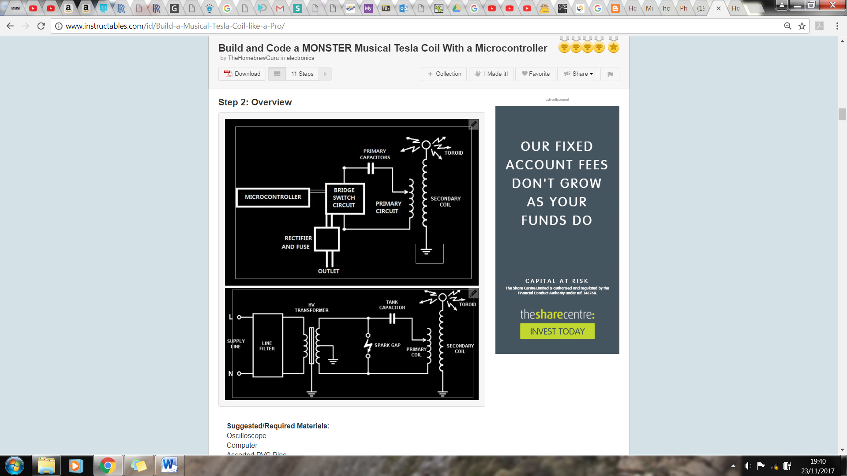

**Figure 3.7b.** Switching Tesla coil circuit [27].

**Figure 3.7a.** Spark gap Tesla coil circuit [27].

To make it play music the spark gap needs to be replaced by a switching circuit (Figure 3.7b) which connects and disconnects the capacitor from the primary coil (switching circuit diagram in Figure 3.7b). To get it to play music the switching frequency is modulated by the music signal which induces a voltage in the secondary at a given frequency, producing streamers at a certain frequency which will cause the air to vibrate at that frequency and produce the correct sound [30].

## Embedded Systems

Embedded systems are one of the key aspects of the Robot Orchestra project. Every instrument requires a controller, and they all need to interface with the conductor. At the heart of all embedded systems lies a microcontroller so additional care needs to be taken when selecting the appropriate one. Various parameters affect the choice of microcontroller, most notably, the clock speed, number of IO pins as well as the different interfaces used to connect peripherals. Each part of the orchestra also requires certain things, for example the conductor should be able to have a graphical user interface to allow user friendly interaction. However, there is a lot of flexibility when choosing microcontrollers for the instruments and therefore choice of microcontroller for the instruments will be based on other factors discussed next.

As the project is also used to showcase specific skills as well as how to apply them whilst learning new things, the majority of the microcontrollers and peripherals will be chosen with that in mind. Moreover, using diverse programming languages, such as C, Python and LabVIEW will also allow for continual development of team members’ programming skills. To conclude, apart from the conductor which has specific needs to be met, the rest of the embedded systems will be selected with the team members’ personal development of skills in mind.

### Conductor

The conductor has three tasks to perform. The first is to convert MIDI files into a format which can be interpreted by the various microcontrollers used (more in Section 3.7.2 below). The second is to transmit the converted MIDI files to the corresponding instruments, and lastly to synchronise the instruments. Furthermore, to make the conductor more elegant, a decision was made to use a GUI to allow the user to interface with the conductor. Due to these requirements, a Raspberry Pi 3 (RPi) model B single board computer was chosen. Due to the familiarity with the RPi and the complexity of the conductor the RPi was considered the best choice. The RPi is a System-On-Chip which runs various Linux distributions, including the official OS known as Raspbian [31]. It is compatible with WiFi and Bluetooth and has 40 GPIO pins [32]. It also has various other interfaces such as SPI and I2C which are commonly used to connect to peripheral devices. Python will be exclusively used to run scripts on the RPi and PyQt, a python based GUI builder to design the user interface.

### Instrument Microcontrollers

Since four different instruments will be built, in order to use a variety of microcontroller at least two different ones will be used. As mentioned previously, since the load on the microcontrollers will be relatively low the choice will only be based on educational factors. The following four microcontrollers have been considered for the instruments.

**ATmega328P (Arduino Uno)**

The ATmega328P is the microcontroller used in the Arduino Uno platform. Arduino is an open-source platform consisting of both hardware and software. The hardware is based around the ATmega 8-bit microcontroller which is flashed with the Arduino bootloader, allowing Arduino programs, known as sketches to run on the microcontroller [33]. Arduinos can be used to program simple tasks as well as more complex ones with relative ease, thanks to the Arduino language which is a simplified version of C++. Arduino also has vast online support and many libraries for various peripheral devices have been written for it, allowing faster development. The ATmega328P consists of 14 digital IO pins, 6 analogue pins, SPI, I2C, USART as well as other standard peripherals such as timers and interrupts [34]. It also interfaces with USB, WiFi, Bluetooth and XBee to name a few. This gives flexibility when developing the instruments. In order to customise the Arduino board to include various other integrated circuits needed for the instruments as well as to make it as professional as possible, a breakout board for the ATmega328P was made. The Arduino bootloader was then flashed onto it to allow the user to upload Arduino sketches.

A prototype board was first developed which included USB to UART FTDI chip which allows the user to upload sketches directly from a PC through USB without any additional external components as well as allowing the Arduino to transmit back to the serial monitor on the PC. Moreover, SPI, I2C as well as all the digital and analogue pins have been broken out. A schematic can be found in Figure 1.2 of Appendix A; photographs of the final design can be found below in Figure 3.9. The prototype was designed by looking at existing ATmega328 circuits as well as reading the datasheets and application notes of the various components used [35, 36, 37, 38]. The prototype was tested and found to be working as expected. The next step will be to expand the board by adding other integrated circuits and components needed for each instrument. Another advantage of building the modules needed for the project is the cost. the overall cost of making the ATmega328P breakout was less expensive than buying an official one from the Arduino store. The final cost of making the breakout with all the components was under £5 whereas the Arduino Nano can be bought for £20.

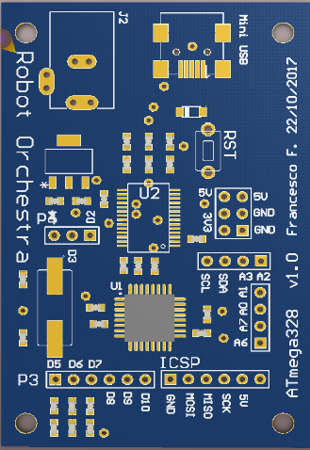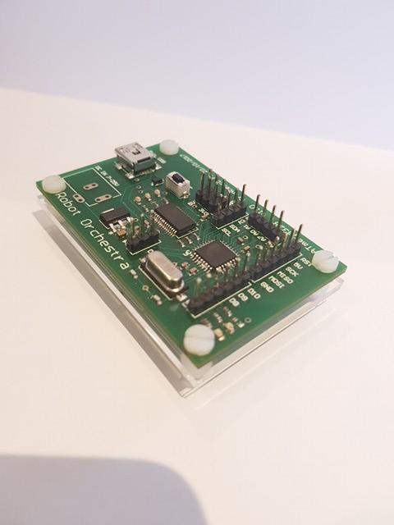

**Figure 3.9.** ATmega328P breakout.

**NI MyRIO**

The MyRIO is an ‘Embedded Device’ [39] developed by National Instruments. It consists of digital IO pins as well as analogue pins. It includes a Xilinx FPGA as well as a dual core ARM A9 processor. It can be programmed using both LabVIEW as well as C [39]. The MyRIO is also compatible with WiFi and Bluetooth standards and has all the peripherals which can be found on the ATmega328. The team has decided to use the MyRIO as the main driver for the xylophone. The reason for using MyRIO in the project is purely educational as the team does not have any previous experience with MyRIO and only limited experience using LabVIEW. It was seen as an opportunity become familiar with an industry standard software suite used by many engineering firms.

### Wireless Link

The link between the conductor and the individual instruments will be wireless. The team has considered a few different options. It should be pointed out that the team is currently working on developing the instruments and therefore is not actively developing the communication between the Pi and the instruments. Preliminary research of the available options was conducted. However, an in depth look at the various options as well as testing each one will be done in semester two.

**Bluetooth**

The Raspberry Pi has an inbuilt Bluetooth module capable of transmitting to other Bluetooth enabled devices [32]. The Arduino would require an external Bluetooth module as it does not have an in-built one. To have the Raspberry Pi transmit to multiple devices at once a piconet is set up. Up to seven devices can be connected to the piconet as slaves, with the RPi acting as the master. The group does not have any experience setting up piconets, making Bluetooth rather challenging. However, prior to conducting further research into the feasibility of Bluetooth, it will not be ruled out.

**WiFi**

After researching WiFi as a transmission method the team found that it is much easier to implement than Bluetooth. The Arduino platform is capable of transmitting and receiving WiFi packets using an inexpensive additional module. Since the data transmitted will be relatively simple, a User Datagram Protocol (UDP) can be used with the RPi acting as a server and the instruments as clients. The Arduino platform provides a library which converts the Arduino into a client capable of receiving UDP packets over WiFi. The MyRIO has an inbuilt WiFi card and a the MyRIO toolkit makes setting up the connection straightforward. Although this has not been tested yet.

**Radio**

Radio is the only method which the group has experience connecting multiple devices to. The NRF24L01+ [40] is a 2.4 GHz radio module which interfaces with both the Arduino and the Raspberry Pi. This specific module allows for up to 127 different modules to be connected simultaneously over different channels. Arduino and Python libraries allow easy development on either platform. The NRF2L01+ uses SPI to communicate with the microcontroller making it compatible with the MyRIO, however due to the high complexity of the device a library is needed for fast development and stable operation. Another benefit of using the NRF24L01+ module is that it is much cheaper than the WiFi/Bluetooth modules.

## MIDI

MIDI stands for Musical Instrument Digital Interface and is used to compile all the information needed to reproduce a song under a common format. MIDI files allow specification of which note to play, for how long and with what velocity the instrument key is to be pressed [41, 42]. MIDI has become a standard interface used in the music industry and, for the sake of simplicity, will be the only format used in the project. MIDI files for a vast number of songs can be easily found online, allowing the team to easily choose from many songs that are available.

Each MIDI file starts with a *Header Chunk*. The header chunk specifies various parameters needed to decode the rest of the file. It is constructed as follow [43, 44, 45]:

|  |  |  |  |  |  |
| --- | --- | --- | --- | --- | --- |
| **Length** | *4 bytes* | *4 bytes* | *6 bytes* | | |
| **Value** | *‘MThd’* | *Length (6 bytes)* | *FF FF* | *NN NN* | *TT TT* |

**Table 3.1.** MIDI Header Chunk.

The top row in Table 3.1 indicates the size allocated to each section of the header. The bottom row is the actual MIDI header. The following is a breakdown of a MIDI header chunk:

* The first 4 bytes of the header chunk correspond to **‘MThd’** in ASCII (4D 54 68 64 in HEX), this specifies that the incoming chunk is a header chunk.
* The next 4 bytes specify the length of the data which is to come. For header chunks this is always 6.
* The next 6 bytes of data specify three things [43, 44, 45]:
* **FF FF -** The file format of the MIDI file. Three formats are accepted:
* FF FF = 1: One track in the MIDI file.
* FF FF = 2: Multiple synchronous tracks in the MIDI file. Which means that the file contains multiple tracks which all start at the same time.
* FF FF = 3: Multiple asynchronous track in the MIDI file. Which means that the file contains multiple tracks all with different starting points.
* **NN NN -** The number of tracks in the MIDI file.
* **TT TT -** The timing parameter.
* The MIDI standard defines timing in its own way, which is *delta ticks per quarter note* and essentially defines the timing for the rest of the MIDI file.

The remaining MIDI file consists of the *Track Chunk;* Table 3.2 shows its layout.

|  |  |  |  |  |
| --- | --- | --- | --- | --- |
| **Length** | 4 bytes | 4 bytes | Variable depending on specified length | |
| **Value** | *‘MTrk’* | *Length* | *Delta time* | *Event* |

**Table 3.2.** MIDI Track Chunk.

* The first 4 bytes of the track chunk are **‘MTrk’** denoted in ASCII (4D 54 72 6B in Hex) this specifies that the incoming chunk is a track chunk.
* The next 4 bytes specify the length of the data which is to follow, which varies depending on the data.
* The following 4 bytes specify the *Delta Time,* this is the amount of time that needs to pass prior to executing the MIDI event.

The last section of the file specifies the event which is to be executed.

|  |  |  |  |
| --- | --- | --- | --- |
| **Length** | 1 byte | 1 byte | 1 byte |
| **Function** | *Status Byte* | *Note Number* | *Note Velocity* |

**Table 3.3.** MIDI event message.

The track event can be one of three things. MIDI, meta and sysex events, all of which are always preceded by specific timing information. For this project, only MIDI events need to be considered. MIDI events contain messages sent to each individual channel (instrument), an example MIDI event message is shown in Table 3.3. MIDI events consist of three bytes, the first byte is known as the status byte and its function is to specify the type of command. A table with examples status bytes and their function can be found in Table 3.4. The second byte specifies the note to which the status byte is applied to and the third byte specifies the note velocity (loudness or softness).

A table showing the musical note to which each binary value corresponds to can be found online [43, 44, 45, 46].

|  |  |
| --- | --- |
| **Status Byte** | **Function** |
| 0x80 | Channel 1 note off |
| 0x81 | Channel 2 note off |
| 0x90 | Channel 1 note on |
| 0x91 | Channel 2 note on |
| 0xB0 | Channel 1 Control Mode Change |

**Table 3.4.** MIDI Status Byte example functions.

A complete MIDI track chunk containing only MIDI events would look like the following:

|  |  |  |  |  |  |  |
| --- | --- | --- | --- | --- | --- | --- |
| **Length** | 4 bytes | 4 bytes | Variable depending on specified length | | | |
| **Value** | *‘MTrk’* | *Length* | *Delta time* | *Status Byte* | *Note Number* | *Note Velocity* |

**Table 3.5.** MIDI Track Chunk example.

## Music Background

In music a specific set of frequencies called notes are used which follow the sequence CDEFGABC. For example, if this started at C1 it would end at C2 which would have double the frequency of C1 [47]. This is called an octave.

**Figure 3.10.** Diagram showing different musical note notations [48].

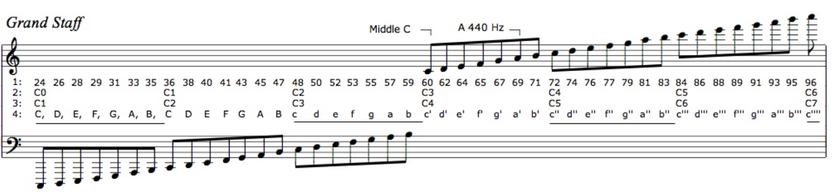

MIDI numbering

Scientific notation

The important parts of Figure 3.10 are point 1 which is the MIDI numbering and point 3 is the scientific musical notation. These are the notations that will be referred to in this section.

An octave contains 12 notes, four of which are sharps or flats, e.g. the black keys on a piano. The frequency of each note is 21/12 larger than the previous note’s frequency. This is the reason why in the previous example C1 has half of the frequency of C2 [47]. These two notes are both classed as C’s as they sound similar due to the relationship between the frequencies being a multiple of two.

A limitation of some of the instruments like the panpipes and xylophone is that they have a limited range of notes they can play. Therefore, the range of notes should be chosen to match the song choices. If the range of notes one of these instruments is required to play exceeds the range available to the instrument, it will sound out of key. For example, if the instrument has a range of C1 to E2 and the range of the music is C1 to C3 the instrument would have to revert back to C2 or C1 when trying to play C3 which would sound out of place in relation to the other notes being played. However, if an instrument had a range of C1 to E2 and was needed to play notes from the range C2 to E3 it would still work, as it is the same range of notes only an octave higher so the notes would sound similar.

## Anvil Studio Overview

Anvil Studio is a MIDI and audio editing package developed by Willow Software [49]. Anvil Studio offers various tools which allow to edit MIDI files. It was also used in the development of the MIDI2Text script due to its ability to convert MIDI files into text files. The output of the MIDI2Text script were compared to those of Anvil Studio to verify proper operation of the script.

More importantly, Anvil Studio allowed the team to edit the different tracks so that unwanted tracks were removed to make the song compatible with the instruments in the orchestra. It also allowed the team to change the specific instrument on each channel, simulating the actual instruments used. Moreover, the channel can be altered in order to match pre-defined channels for each instrument rather than the default channels of the MIDI file.

The software package was critical in the decision-making process for the songs. Various instruments were altered in each track depending on requirements for each instrument, previewed each instrument individually and then played each song. Once the team was happy with the outcome, the MIDI file was saved under a new name allowing it to be imported into the Python script. The package contains 128 different instruments and sounds so the team managed to find sounds similar to the non-conventional instruments used, such as the stepper motors and the Tesla coils as well as common instruments such as the xylophone and the panpipes. Although a decision for the songs which the instruments will play has been made, Anvil Studio is currently used to edit songs used to test individual instruments and could be used in the future for adding additional songs for the orchestra to play.

# Technical Progress

The following section describes the technical progress that has been made on the instruments mentioned in literature review during the two project blocks.

## Conductor Design

The structure of the embedded systems has been mentioned briefly in Section 3.7, however this serves as a more comprehensive description. Figure 4.1 depicts a diagram showing the hierarchy of the system. First and foremost, the Raspberry Pi conductor takes input from the user through its GUI. The GUI takes in a few parameters, the file location of the MIDI file that the orchestra will play and the file location which the text output will be saved. The GUI is kept relatively simple, however if more features need to be implemented they can be added in the future. Once the MIDI file is selected the song is then converted after the user clicks on the ‘Convert’ button. More on the conversion can be found in Section 4.1.2. The converted file can be found in the specified location. This is useful for the user to check that the output matches with what is expected. Finally, the user clicks the ‘Play’ button causing the conductor to send the corresponding text file to each instrument. For simplicity, the instrument channels are static and have been predefined. The user is expected to edit the MIDI file prior to uploading it to the Pi to make sure that each channel corresponds to the correct instrument.

### High Level Overview

GUI

Raspberry Pi

MIDI2Text

Xylophone

CH1

Stepper Motors

CH2

Piano

CH3

Panpipes

CH4

Tesla Coil

CH5

**Figure 4.1.** High Level System Overview.

### MIDI2Text

The process of converting MIDI files into a format which can be interpreted by the various microcontrollers is a hard one, especially when done manually. For that reason, after having obtained a good understanding of the MIDI format, a Python script was written to automate this task. The Python script will run on the Raspberry Pi and will be controlled by the user through a GUI. Below is a flowchart with the steps the program follows to convert from a MIDI format into a text format.

**Figure 4.2.** MIDI2Text flowchart.

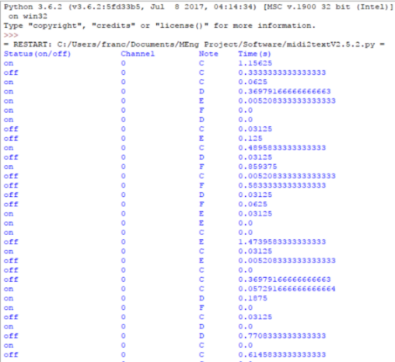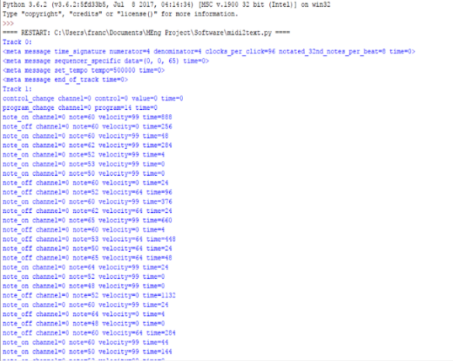The use of regular expressions [50] to extract each individual element gives the programmer great flexibility, since the data can be reused in various ways. The MIDI2Text script has been tested extensively and after a few revisions is currently working properly. Figure 4.5 shows the GUI. The full code can be found in Appendix B[50, 51].

**Figure 4.4.** Processed data.

**Figure 4.3.** Raw Output.

## Solenoids

**Figure 4.5.** MIDI2Text GUI.

Solenoids will be utilised in both the robot keyboard and robot xylophone as shown in Section 4.3 and Section 4.4 respectively.They are common electronic components that come in various forms, electromechanical, pneumatic and hydraulic [52]. The solenoids used in this project are electromechanical, they were selected as they were cheap to purchase and were simple to implement in the robot keyboard and xylophone. A significant amount of force would not be needed so pneumatic and hydraulic (which are more expensive as well) were not considered.

**Figure 4.6a.** Pull action solenoid from *Solentec Ltd* [53].

**Figure 4.6b.** *Solentec* solenoid’s force/stroke characteristic[53].

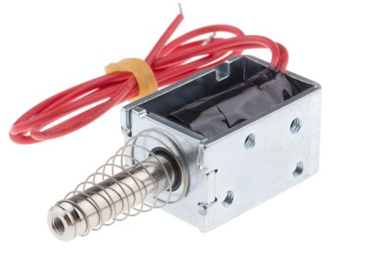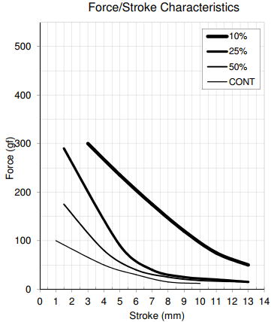

Electromechanical solenoids consist of two main components: a coil and plunger or slug that is placed inside the coil (this is usually made out of steel) [52]. According to Ampere’s Law [54] when a current is passed through the solenoid a magnetic field is created in and around the coil which forces the plunger to be drawn in. As can be seen in Figure 4.6a a spring is used to hold the plunger in place, this is so that when a current is not being passed through the solenoid and no force is acting on the plunger it returns to its normal position outside of the coil, this is typical of a ‘Pull’ type solenoid. ‘Push’ type solenoids are also available where the spring holds the plunger inside the coil when the coil is not energised, when a current is passed through the plunger is forced out of the coil. A solenoid is dictated by two parameters, the duty cycle of the solenoid and the force produced according to the duty cycle. The duty cycle is calculated by the following formula:

$Duty Cycle \left(\%\right)= \frac{On Time}{On Time+Off Time}* 100$ (1) [53]

In this case the “On Time” refers to the amount of time that the coil is energised and the “Off Time” refers to the time that it is not. Figure 4.6b shows how the force exerted by the solenoid reduces as the duty cycle increases i.e. as the rate at which the solenoid is energised and de-energised increases the force exerted by the plunger decreases. This is because as the solenoid is energised and de-energised it begins to gain heat which increases the losses in the solenoid, so less force is delivered. The stroke is the amount of the plunger that is outside of the coil when it is energised. It can be seen that as the duty cycle decreases the force that can be exerted by the solenoid increases, this means that if the solenoid is not switched on and off very quickly then more force can be expected to be produced.

## Keyboard

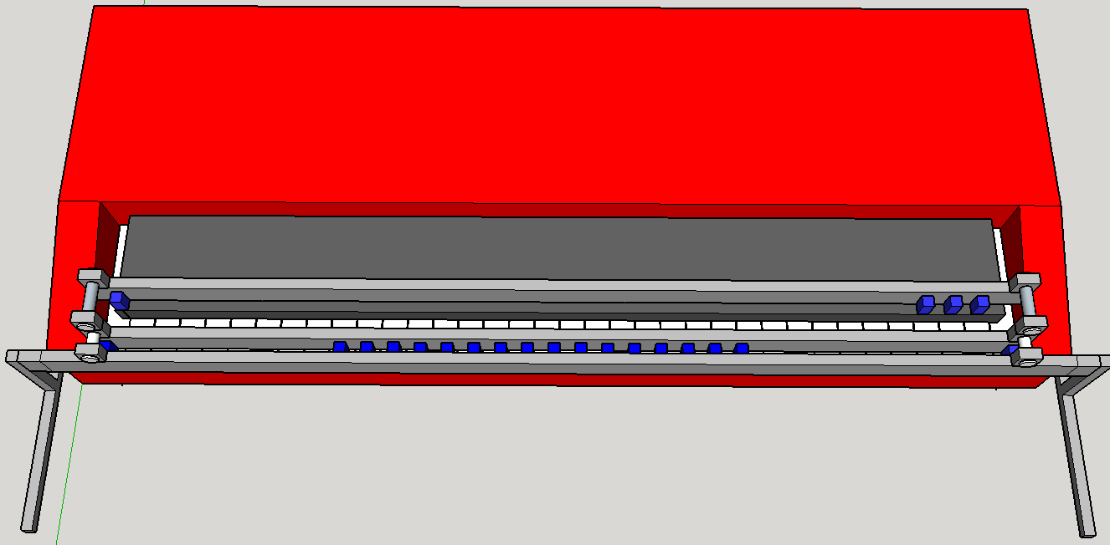The main aim of the keyboard design was to be as simple as possible, since the design for both the xylophone and panpipes was quite complicated. With this in mind, the first design was created.

**Figure 4.7.** Initial Keyboard Design shown using Google SketchUp.

1

2

3

The first design utilised three metal panels and can be seen in Figure 4.7. Panels 2 and 3 were used to screw the solenoids into. The solenoids are represented by the blue boxes in Figure 4.7, they would be screwed into the panel and spaced out so the plunger of each solenoid fell in line with a key. It was important to have two separate rails of solenoids since the robot needed to be able to play both the black keys and white keys. Panel 1 acted as a support for the other two panels and was attached to the legs of the frame, various other views of the design can be seen in Figures 3.2 and 3.3 of Appendix C. This design had the advantage of being simple in construction and not needing many steps in order to be complete.

This model was completed at the end of the first project block (13/10/17) but at this stage the keyboard that was going to be used in the demonstration had not been ordered, this meant that the design could not be properly dimensioned. It also meant that the exact solenoid needed for the design could not be chosen since the force needed to push down the key was unknown. Since it was impossible to determine the exact solenoid that was needed some common 5V solenoids were ordered from SparkFun Electronics [60]. These were ordered in low numbers since it was expected they would have to be changed in the second project block.

When the testing phase of the second project block began a circuit to connect the solenoids to a digital I/O pin on the Arduino was created which energise the coil and pulls the plunger. This circuit was used to test whether the preliminary solenoids ordered in the first project block were strong enough to push the key down on the keyboard. It was quickly found that a 5 V solenoid was simply not strong enough to push the key down, this was to be expected since they had been ordered without any measurement of the forces needed.

To measure this force some M10 nuts were weighed and then placed, one by one, on a single key until a sound was triggered. It was found that when the weight of the nuts equated to ≈70 gf this was strong enough to trigger a sound from the keyboard. A solenoid that is able to produce ≈105 gf (1.5\*70 gf [55]) should then be used for the keyboard design. In addition to this, the maximum duty cycle had to be determined for the solenoids, this would be dependent on the specific song being played since each of the songs had the keyboard on for different amount of time. Using Anvil Studio, the piano track for each of the songs was looked at, from this it could be determined that the song that would produce the greatest duty cycle would be *Eye of the Tiger* by *Survivor*. Since one solenoid controls one note with this design it was important to identify the note that would be need to be ‘on’ the most during the song. Through using Anvil Studio again to study the *Eye of the Tiger* MIDI file the note C# was determined to be ‘on’ the most during the song. By using Equation 1 and measuring the seconds that the C# was being played throughout the song the maximum duty cycle was determined (Equation 2) to be 30%.

$Duty Cycle \left(\%\right)=\frac{162 seconds}{162 seconds + 385 seconds}*100$ (2)

Using this and the required force, a new more appropriate solenoid was selected. Initially the *MCSMO-0630S12STD* from *Multicomp* was selected since the Stroke Vs Force characteristic met the requirements needed for this project (Figure 3.1 from Appendix C [56]). In order to test this solenoid a new circuit had to be created to interface the solenoid with the Arduino board since it cannot deliver enough current to meet the needs of the solenoid. At approximately 30% duty cycle the solenoid consumes 9.6 W of power at 12 V DC. This means that it needs 800 mA to operate at this power, the Arduino is only capable of supplying 40mA from one of its digital IO pins. In order to power the solenoid a circuit was created using a transistor that allows the solenoid to be powered from an external power supply while being connected to the Arduino (see Figure 4.12 in Section 4.4).

Using this circuit, it was determined that this solenoid was strong enough to push one of the keys down on the keyboard. However, this solenoid has since been replaced with the *905-9931* from *Solantec Limited*. This is because the solenoid from *Multicomp* did not come with a spring attached to hold the plunger in place when it was not energised. The solenoid from *Solantec* comes fixed with a spring and has very similar stroke vs force characteristics, using this solenoid will save significant time as individual springs will not have to be fixed on to the solenoids manually.

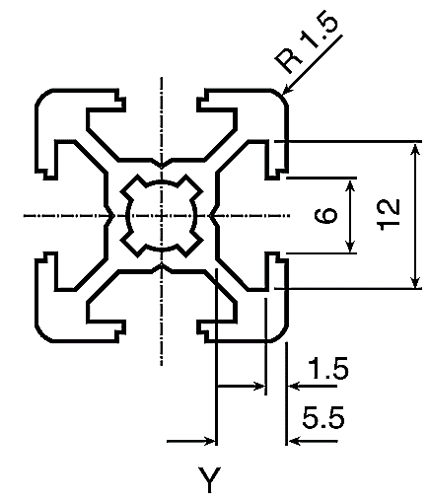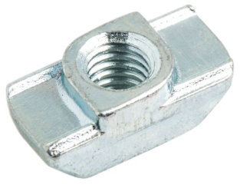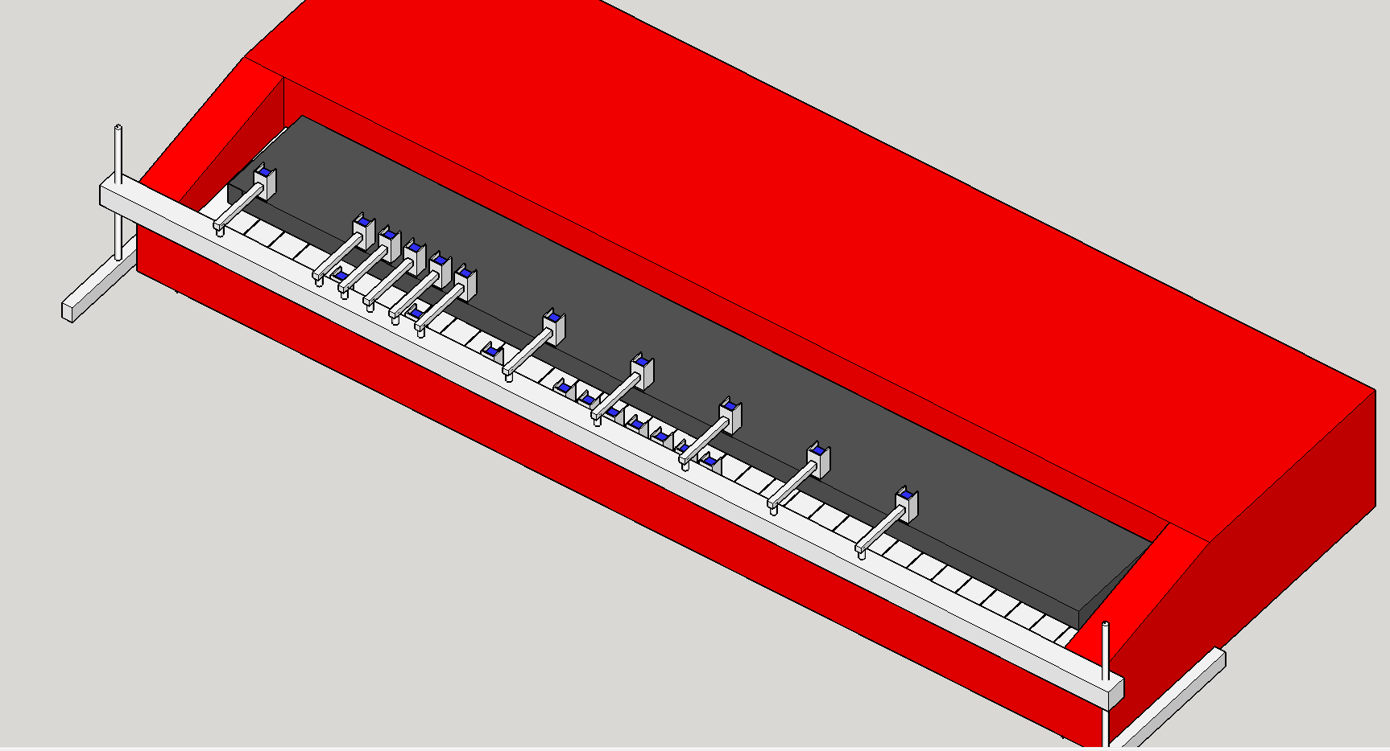It was also decided that the initial model designed (Figure 4.7) would have to be modified in order to make it more adjustable to the height of the keyboard. The previous design had a fixed height for the panels, so, in order to overcome this threaded rod was used in replacement of the metal legs as seen in Figure 4.8. These rods would be fed through a Bosch Bar (Figure 4.9a).

**Figure 4.9b.** T-Slot nut [58].

**Figure 4.9a.** Cross-section of Bosch bar [57].

**Figure 4.8.** New robot keyboard design.

Bosch bar

Threaded rod

The reason for choosing a Bosch bar is largely to do with simplicity of design. From looking at Figure 4.9a it can be seen that the Bosch bar being used has grooves of a specific dimension. T-Slot Nuts can be purchased which fit in to Bosch bar and can slide along the bar. Clamps will be designed for the solenoids which can be screwed in to individual T-Slot nuts which, depending on whether that particular solenoid will be playing a black or white key, will be a specific distance away from the Bosch bar. From Figure 4.8, the solenoids intended to play the black keys are mounted on the top surface of the bar and supported by a bracket. The solenoids playing the white keys are mounted to the front surface.

Also, to simplify the design further, it was found that only 19 notes were needed in order to play both *Eye of the Tiger* and *Californication* so 19 clamps will be designed and fixed to the Bosch bar. The design can be expanded to play all 61 notes by making more clamps for the solenoids and purchasing more T-slot nuts to fix them to the bar.

## Xylophone

The model of the xylophone has 12 keys, where the notes will be programmed so that they can vary between the octaves according to the song that will be played. In addition to this, keys can be reprogrammed to play other sounds.

**Model 1**

In the initial design, the 12 bars were held by two vertical plates, joined together using the friction- tight method, with two square-form bars, each one located at the sides of the xylophone (Figure 4.10). Moreover, piezoelectric sensors were attached at the top middle of the keys which would produce a signal triggering the corresponding sound to be played through the speaker. Finally, a square arch was modeled, which held one solenoid at its top center, and with the aid of wheels would be programmed to travel across the xylophone (Figure 4.10). Transparent Perspex would be used to manufacture the xylophone. This would allow the audience to inspect the interior of the xylophone, which would be fitted with LEDs along with the circuitry needed for the device to function, providing an overall better visual appeal.

The arch was designed in three different sections which would be joined using L-shaped mounting brackets. Additionally, a rod was placed between the parallel plates of the arch as a support, preventing it from toppling as well as guiding it to travel across the xylophone. As for the arch’s locomotion, stepper motors were the preferred method to be used since steppers have more torque than servos [59]. A stepper motor would have been mounted on each side of the arch along with the wheel and controlled using an Arduino in order to move the arch across the xylophone. Overall, two Arduinos would have been used, one to control the two wheels, and therefore the arch; and the other to receive the signals from the piezoelectric sensors and translate them into sounds. The pieces for the xylophone were laser cut and SolidWorks 2016 was used to model them.

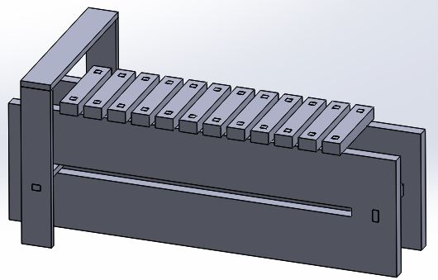

Vertical Plates

Keys

Square form arch

“Guide” Rod

**Figure 4.10.** Model of Xylophone.

**Model 2**

After completing the first design of the xylophone, it was decided that the first model is not feasible within the given time frame as the team wanted to produce a prototype before the end of semester one.

For that reason, the design had to be simplified. The most significant change was the removal of the arch which was replaced by a Bosch bar that was placed across the instrument, and was supported by two threaded rods (at each end of the xylophone). Additionally, with the aid of threaded struts, 12 solenoids were mounted on the bottom side of the Bosch bar, each one assigned to a key (Figure 4.11),which will be programmed to hit the piezoelectric sensors according to the song being played. The last change was to modify the design of the key notes so that they could be similar to the ones found on an actual xylophone. In total, one Arduino will be used, which will control the number of times each solenoid will hit the piezoelectric sensor, according to the song being played.

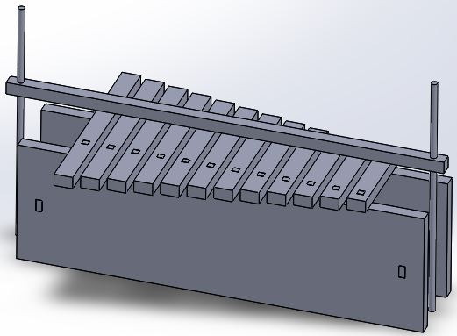

Threaded rods

Bosch Bar

**Figure 4.11.** Model 2 of the xylophone.

Each solenoid which will be used, needs a 5 V DC power supply and requires a current of 1.1 A [60]; the aforementioned was calculated using the following equation:

$P=V*I$ (3)

so $5.5 W[60]=5*I$ → $I=1.1 A$, where the power was taken from the datasheet.

However, the Arduino can only supply a maximum of 40 mA [35] and therefore the use of a Darlington transistor is necessary in order to supply the current through the solenoid. For this reason, a TIP120 NPN transistor was chosen, with a maximum base current of 120 mA. In order to calculate the required base current, the following formula was used found on the TIP120 datasheet [61]:

$I_{c}=250*I_{B}→I_{B}=\frac{I_{C}}{250}$ (4)

where IC = 1.1 A, which is the current required by the solenoid; therefore, IB = 4.4 mA. In order to provide a base current of 4.4 mA, a resistor was placed between the Arduino and the transistor, with a value of 0.94 kΩ. The value of the resistor was calculated by using the formula:

$R=\frac{V_{arduino} - V_{BE}}{I_{B}}=\frac{5 - 0.85}{4.4 *{ 10}^{-3}}=943 Ω$ (5)

A schematic diagram of a solenoid has been created and simulated using the NI Multisim software, which can be seen below in Figure 4.12. On the diagram, the voltage of the Arduino is labeled as “V1”, the 0.94 kΩ resistor as “R1”, the external DC voltage source as “V2” and the transistor as “Q1”. Since the Multisim software does not have a representation of a solenoid, a resistor was used labeled as “R2” with a value of 4.55 Ω since it was assumed that the impedance of the solenoid is $\frac{5 V}{1.1 A }=4.55 Ω$. For simplicity, a free-wheeling diode was omitted from the simulation but will be included in the final design.

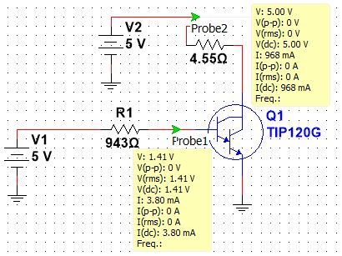At this point, all the components of the xylophone have been received from the mechanical workshop and have been assembled together. The remaining actions that need to be tackled are: to mount the solenoids to the Bosch bar and test them, to attach the piezoelectric sensors on the center of the keys and finally to align the solenoids and the piezoelectric sensors.

**Figure 4.12.** Solenoid Schematic.

## Panpipes

Between the recorder and the panpipes, the panpipes were the preferred choice, since they were more suitable to play the vocals. The video by TeamDare [21] shows one way of making a robot playing panpipes where the mechanism in the video shows the panpipes moving sideways and the nozzle only moving up and down. The decision for the panpipe design was to reverse the moving components and instead make the nozzle move sideways and the panpipes remain stationary. This simplified the design because the panpipes would require a larger and more sophisticated design to be moved whereas the nozzle is much smaller and lighter.

Below, Figure 4.13 shows the initial design for the panpipe setup. The panpipes are held up and fixed and the yellow nozzle constantly blows the air at the pipes with a small servo motor at the end which blocks the airflow to the pipes when needed. The nozzle is on a platform that moves sideways using a stepper motor operated track which will be controlled by a microcontroller such as an Arduino.

**Figure 4.13.** Initial 3D design for the panpipes front (left) and back (right) view.

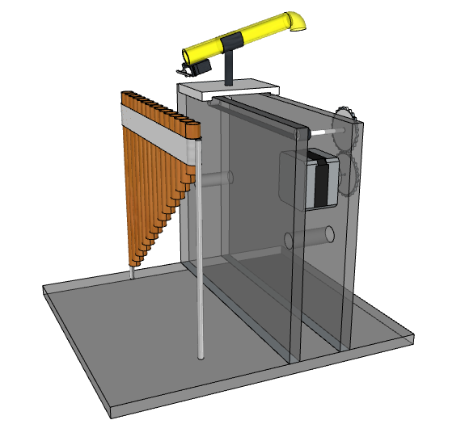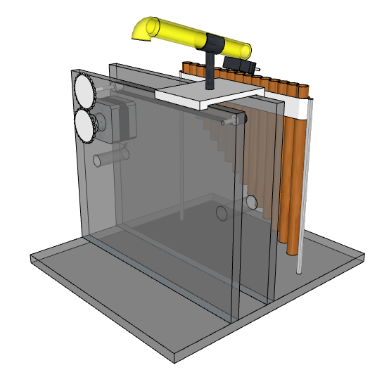

This setup can be broken down into a list of the main components:

* **The panpipes** are 18 cm across with 15 pipes. They came tied together with string forming a slight curve. It is best if the curve is eliminated so that there is no variation in distance between the nozzle and avoiding a curved track. The plan to eliminate the curve is by untying the pipes and making a custom holder for the pipes.
* **The track** will resemble a treadmill and will have the platform with the nozzle attached on top of it. It must be long enough to allow the nozzle platform to go from the first to the last pipe. It was proposed that the track would be driven by a stepper motor which is controlled by an Arduino. This was based off of a previously designed guitar track shown in Appendix D.
* **The nozzle** is going to be mounted on top of the platform which is attached to the track. The air is provided by a mattress air pump which will be constantly on. To block the air in order to hit timed notes, a servo will be attached to the end of the nozzle with a small piece of plastic on the tip, rotating 90 degrees to stop the air and -90 degrees to allow the air to pass again.
* 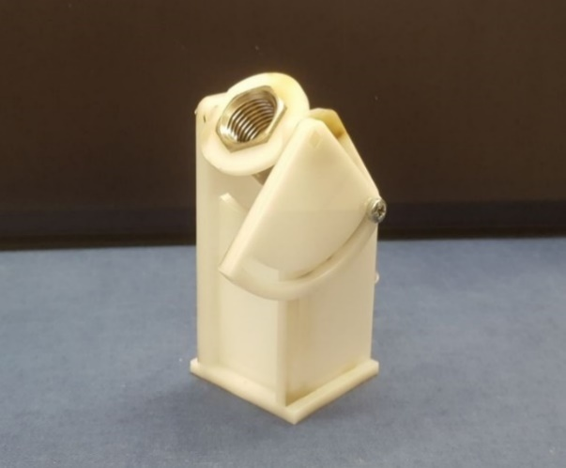**The frame** will be made out of 5mm thick Perspex. It will house the track and the lift up the platform with the nozzle to the required height. The stepper motor will be attached from the side.

**Figure 4.14.** Nozzle which directs the airflow to the panpipes.

From testing and the video [21], it was found that the air needs to hit the tops of the panpipes at a certain angle to provide the best sound, so the mechanical workshop made a support for the nozzle that allows the angle to be adjusted as shown in Figure 4.14.

As this panpipe design has not been completed or tested yet, there will be variations in some components such as the spacing between each pipe of the panpipes, the height of the frame, the distance between the panpipes and the nozzle, and the type of stepper motor that controls the track.

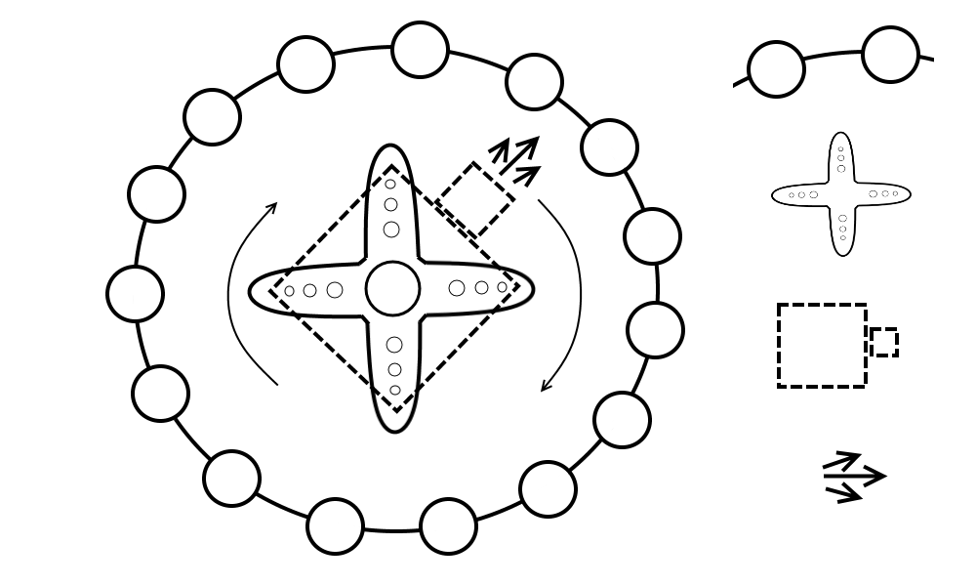A change to the design was proposed where the 15 pipes would be mounted in a circle around the nozzle and the nozzle would rotate in the middle using a servo motor. This would simplify the design by removing the moving platform setup which has a complicated design as well as the stepper motor, making the new setup smaller and requiring fewer components. The new design is showing in Figure 4.15 below.

**Figure 4.15.** New 360-degree panpipe design.

Panpipes

Servo

Nozzle

Airflow

The next step will be the testing of the panpipes sound with the air pump blowing the air. This will determine the feasibility of the panpipes as an instrument and will help determine which design will be easier to implement.

## Tesla Coils

To explore the feasibility of using a Tesla coil as an instrument three Tesla coil kits were bought to test (shown in Figure 4.16). The turns ratio between the primary and secondary coil is 350, as the power supply is 18 V, the maximum voltage over the secondary coil is 6300 V. As the electrical breakdown of air is 3 kV/mm [28], streamers with lengths of $\frac{6300 V}{3000 V/mm}=2.1 mm$ can be expected from the unconnected end of the secondary coil.

**Figure 4.16.** Built Tesla coil.



Transistors with heatsinks

Unconnected end of secondary coil

Secondary coil

Primary coil

To play music through the Tesla coil a smartphone is connected using a 3.5 mm auxiliary input. The Tesla coil was able to produce reasonably high sound quality however, it was quiet so a microphone and speaker would have to be setup if a Tesla coil this size was being used. The volume could also be increased by making the Tesla coil larger (as shown in Figure 3.8 of Section 3.6 [29]) but the sound quality is lower as the interference from the streamers is higher.

To find out more about safety regarding Tesla coils a meeting was arranged with Dr. Vidyadhar Peesapati who is a researcher at the high voltage laboratory at the University of Manchester. The risk surrounding Tesla coils is low as although the voltage is high the current in the coil is very low and a cage could be placed around the coil to mitigate any risk. It could also be arranged to use the high voltage laboratory to test the Tesla coil during development and there would be an opportunity to use the large Tesla coil in the high voltage laboratory for the demonstration day. Currently, a decision is being made on whether to go forward with the panpipes or a Tesla coil. The deadline for this decision is 02/02/2018.

## Stepper motors

### Hardware

For producing the required musical notes, a decision has been made to use the NEMA 17 stepper motor. This is because in the early stages of the project, this type of motor has been bought for testing due to its low price and its specifications which allowed for easy interfacing with inexpensive driver boards (12 V rated voltage and 1.5 A rated current [62]). Further to testing, the motors were considered well suited for the required tasks and decided to keep them for the next prototyping stages.

In order to control the motor, the Allegro A4988 driver board was chosen as it was recommended by multiple sources and according to [63], it could operate with voltages between 8 V and 35 V while supplying a current of up to 2 A. The control algorithm was implemented on an Arduino Uno microcontroller board. Figure 4.17 presents the wiring diagram for the stepper motor control circuit.

As the aim of controlling the motor was to produce various frequencies in the audible range, precise control of the rotation was not required.

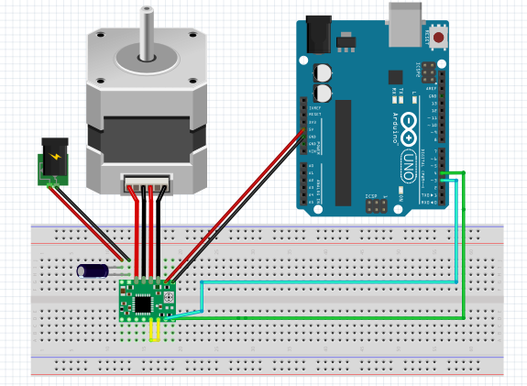

**Figure 4.17.** Stepper motor control circuit.

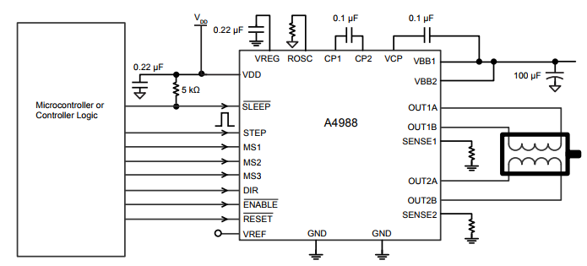As a result, the pins of the driver board that control the step resolution of the motor (full step, half step, etc.) have been left disconnected, leaving the motor to operate in the full step mode. Additionally, the STEP and DIR pins of the driver board have been connected to ports 3 and 4 of the Arduino.

**Figure 4.18.** A4988 Pinout [63].

Figure 4.18 presents the A4988 pinout and its required connections. The STEP pin is used for controlling the movement of the motor with each pulse sent to this pin being converted to a step rotation and the DIR pin is used for controlling the direction in which the motor spins. Additionally, a decoupling 100 µF capacitor has been used as indicated in Figure 4.18 in order to protect the board against voltage irregularities. In setting up the control circuit, the guide presented in [24] has been used for ensuring the wiring was done properly so as not to damage the components.

### Software

The stepper motors are driven by an ATmega328P Arduino microcontroller and an A4988 stepper driver. Outputting a square wave from the Arduino to the stepper driver causes the stepper to rotate. If the frequency of the square wave is matched to that of individual notes, then the sound produced by the stepper matches that of the note. By combining various notes together at different time intervals musical pieces can be played.

**Timers**

For example, the note A4 has a frequency of 440 Hz [64]. The period of a musical note can be calculated by using the following equation:

$T= \frac{1}{f}$ (6)

where T = period (in seconds) and f = frequency (in Hz).

In the case of A4, the period is approximately 2272 µs. In order to generate a square wave of this frequency, the signal can be driven to a logical high for half the period, followed by a logical low for the other half of the period, thus obtaining a PWM signal with a 50% duty cycle. The pseudocode for producing this square wave is presented in Appendix E.

The current version of the stepper motor circuit works by making use of the millis() and delayMicroseconds() functions as presented below. The prototype works well when controlling one or two motors, being able to play simple songs such as “Happy Birthday” or “Frere Jacques”. However, timing errors could become noticeable when increasing the number of motors as the code executes sequentially. A maximum deviation of 10 Hz has been detected which may not be obvious in higher octaves (higher frequencies) but can pose a risk for notes in lower octaves (lower frequencies). Depending on the feasibility of successfully using more motors in the same way, the future circuit could make use of dedicated ICs to generate the required frequencies.

The Arduino Uno microcontroller has a series of pre-defined libraries that are useful for creating accurate delays and implementing timed actions on its GPIO (general purpose input/output) pins. If no additional IC is to be used, the functions delayMicroseconds() and millis() are particularly useful in implementing these timed actions. In the case of the stepper motors, the function delayMicroseconds() is used twice, once after driving the output pin high and once after driving it low, generating thus a square wave with the period determined by the function’s parameter. Additionally, to play each note for a specific amount of time, the function millis() is used to calculate the elapsed time at one instance in the code execution and based on its returning value, decide whether to keep playing the same note or switch to the next note to be played. However, this method has some limitations. If multiple stepper motors are to play a song simultaneously, making use of the delayMicroseconds() function might result in a noticeable delay in the song as the execution of the entire code is paused when this function runs. Additionally, using the millis() function eliminates the option of using the PWM to drive the stepper motors as the function required for using the PWM pins, analogWrite(), can make the millis() function imprecise and thus, lead to a timing error [65].

**555 Timer**

The LM555 timer is an IC capable of generating specific frequencies at various duty ratios by connecting two resistors and two capacitors [66]. Multiple ICs would be used, one for each note and since the IC has an enable pin, the Arduino would be able to turn it on/off with ease. This is a good solution as a lot of the software is now simplified due to the hardware used. However, more hardware is needed making it more expensive to produce. A closer investigation on the components needed to produce some of the frequencies resulted in resistor values in the microohm magnitude. This poses two issues, first, it is hard to procure micro-ohm resistors and most importantly the datasheet recommends resistor values of 1 KΩ to 1 MΩ [66]. This method has therefore been ruled out.

**Digital Signal Synthesizer**

A Digital Signal Synthesizer (DSS) is an IC capable of generating a vast range of frequencies. The DSS considered for this application is the AD9837. The AD9837 is capable of producing frequencies between 0-5 MHz, with a 0.02 Hz resolution making them incredibly accurate [67]. The IC requires no external components (apart from a decoupling capacitor) and the frequency is set by three internal registers. The IC communicates with the microcontroller via SPI [67]. This is advantageous as it can be easily reprogrammed to another frequency, allowing one IC to play multiple notes. As expected the IC is more expensive than the 555 timer. The AD9837 offers a promising solution, and will most probably be used. The breakout board for the AD9837 has been designed and further testing is needed, see Figure 1.1 in Appendix A.

## Guitar

This section was included in the report to show work on the guitar which had been carried out during Semester 1. However, after consideration it was decided not to include the guitar in the robotic orchestra due to the complexity of the design and the limited time available.

Six servos would be placed above the strings along the bottom end of the guitar, where the player’s fingers would normally strike the strings, this would allow the servos to mimic the motion of the hand playing the guitar.

Furthermore, six rods would be placed along the neck of the guitar capable of moving along it. Each rod would be controlled by a stepper motor allowing for accurate control over the rod’s position. The rods would permanently be in contact with the strings, thereby removing the need of an additional system required to lower the rods to press the strings. The aforementioned system would be controlled by an Arduino microcontroller. Figure 10.1 in Appendix Jshows the design of the guitar.

# Progress and Planning

Since this project has a lot of different components an effective and detailed plan was crucial to be successful. The primary method for organising this project has been using a Gantt chart and conducting team progress reviews every 3 weeks.

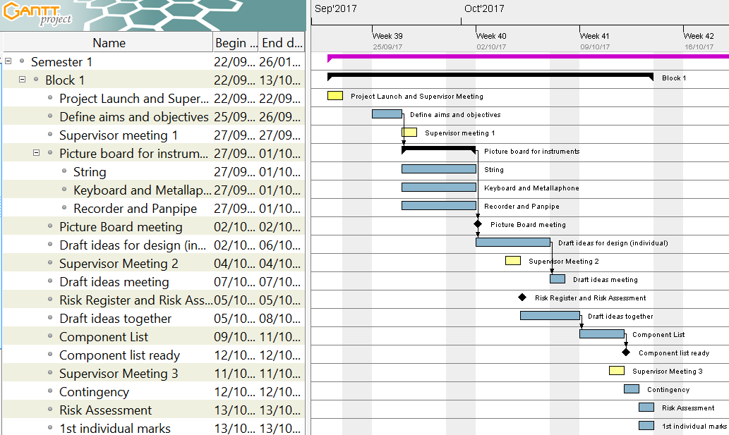One of the things that had to be avoided when organising the schedule for this project is creating all of the instruments and the conductors in a serial manner, i.e. finish one and then create the next. The total allocated time to the project is 17 weeks (85 days, not including weekends) so it crucial to have the instruments being built in parallel to one another. This ensures that if there is a delay in one of the instruments (i.e. some components are taking longer than expected to be delivered) then progress can be made on a different instrument, ensuring that team members are not being underutilised.

**Figure 5.1.** Initial version of the Gantt chart for Project Block 1.

Figure 5.1 shows the initial plan for Project Block 1. The initial stages of the project were open ended so one of the first tasks was to define the aims and objectives of the project, this was followed by defining the different categories of instrument to be designed during this project which helped in narrowing down the criteria for the research period. The research period started on the 27/09/17 through to 01/10/17 (5 days) and culminated in a picture board meeting, which helped in defining the initial four robot instruments that were going to be built: guitar, panpipes, keyboard and xylophone with two backup instruments in the Tesla coil and stepper motors. Deciding on the instruments to be made was a significant step in the project because it now meant more definitive milestones could be set and a more detailed plan could be created to ensure progress.

A milestone was created for the end of the first project block which was to have a *Component list ready* (Figure 5.1). This meant that all necessary electronic components and hardware for the first prototypes of the instruments could be ordered to be worked on in the second project block. Initially, this was going to be the only goal for the end of the first project block. However, specifically after *Supervisor Meeting 2*, it was realised that the instrument designs that were a product of the picture board meeting required many individual steps to be achieved and that starting with simpler designs would be beneficial to the project, these designs could then be adapted to include the additional features from the initial designs. In addition to this, having simpler designs made the *Construct the 4 instruments* (Section 2.2.2) objective more achievable.

The robot guitar was also dropped in favour of a significantly simpler stepper motor design, primarily because the initial designs produced were too complex to be completed within the given timeframe. The panpipe design is currently under debate as to whether it will be progressed, it may be replaced with the Tesla coil. This will be determined after the testing period with the panpipes is over and the feasibility of the robot within the given time frame can be better understood.

In addition to this, one of the objectives was to *Select 2 suitable songs […]* (Section 2.2.2). It was realised that designing the hardware without thought towards the songs that they are being designed to play will make the designs more complicated. Deciding on the songs in the early stages of the project ensured that the designs can be made as simple as possible.

Several new tasks and milestones were added to tackle the issues that were highlighted during the second supervisor meeting, these can be seen in Appendix F. It was decided that the second week should end with both the songs and hardware choices being made meaning that the hardware could be designed with specific song choices (and therefore notes) in mind. This made the design for some of the robots simpler, for example the keyboard was designed to only play 19 different notes instead of the 61 it was capable of. To decide on the song choices a Facebook poll was created where individual team members could vote on different choices, since there are only six members it was easy to get the votes from each member and the poll only had to be live for a day. The advantage of using a Facebook poll for this is that it allows individual members to add their own suggestions as well as easily tracking the number of votes each song achieves. The next day a meeting was held to discuss the most voted song choices and integrate them with the MIDI files of the songs using Anvil Studio. In order to make sure that the *Component list ready* milestone could still be completed on time the songs and instruments needed to be selected by the end of the second week. This is because, in order to create a component list, 3D models were needed which could take a significant amount of time to develop. The milestone for the first project block was achieved and a component list was constructed and ordered which gave 3 weeks for the components to arrive, ready to be used at the start of the next project block.

During the first module block the priorities for the group switched from making significant progress on the project to focusing on individual modules. The work done on the project during this time focused mostly on preparing for the upcoming tasks of the second project block and preparing for the first significant project deadline – *Interim Report.* It was clear that in order to achieve this milestone a significant amount of work would need to be executed. So, in order to pre-empt the workload, and ensure that no time was wasted planning during the second project block, several meetings were held where the approach to achieving the deadline for the interim report was discussed. The first meeting (*Interim Report Meeting – Contents Page)* was used to create a contents page for the report which was used in the next meeting (*Designate Interim Report Roles*) to designate individual sections to individual team members. There was another meeting (*Interim Meeting 3)* which took place two days before the start of the second block. This was deliberately close to the start as it was used to discuss the plan and milestones for the second project block.

The second project block was more complex to schedule because there were more milestones and they often required the same people working on them. The milestones for the end of the second project block were:

* Software for stepper motors created
* Keyboard software simulation created
* Construct the hardware for the xylophone
* Keyboard hardware submitted for manufacture
* Submit the First Interim Report

To make sure that these milestones were achieved several of the tasks were run in parallel. Also, in project block two the team was split in to a hardware team (four members) and software team (2 members). The slight bias towards the hardware team is due to the higher amount of work to be completed on the design and construction of the robot instruments. The reason for choosing the stepper motor software to be created first is because of the low hardware requirements that the stepper motors had, the circuits were quite simple and one could be connected to the Arduino with relative ease. The software development could start from early on in the project block.

Fortunately, all of the components that were ordered in the first project block arrived on time so the drive boards and power supply necessary for the steppers to operate were ready to be used by the software team. Several of the components had been delivered for the keyboard and xylophone so a testing phase began. Each of the testing phases was started with a goal in mind. For example, the *Solenoid Testing for Keyboard* task (Figure 5.2) was created to check whether the solenoids that had been ordered in the first project block were strong enough to push down the keys, if they were not then completing this phase would ensure there was enough time to order more in and still make progress on the keyboard hardware.

Highlighted in blue in Figure 5.2 is the approach towards the interim report. A draft of the report was to be made ready by the start of the last week of the block, 20/11/17 (a week before the deadline). This ensured that there was enough time to conduct a table read and perform any edits. It was debated whether a week may be too long and that the time may be better spent working on the technical progress of the project and having more time to write the report, pushing the deadline for the draft to Wednesday (22/11/17). Due to the size of the report and the amount of time it would take to conduct a table read the initial date was settled on and remained as the deadline for the first draft. This approach worked well, the interim report was submitted on time and there was ample time to edit the document and have it ready. Spacing the editing out over the course of a week resulted in the team still being able to meet the deadlines for modules outside of the project.

**Figure 5.2.** Gantt chart for Second Project Block.

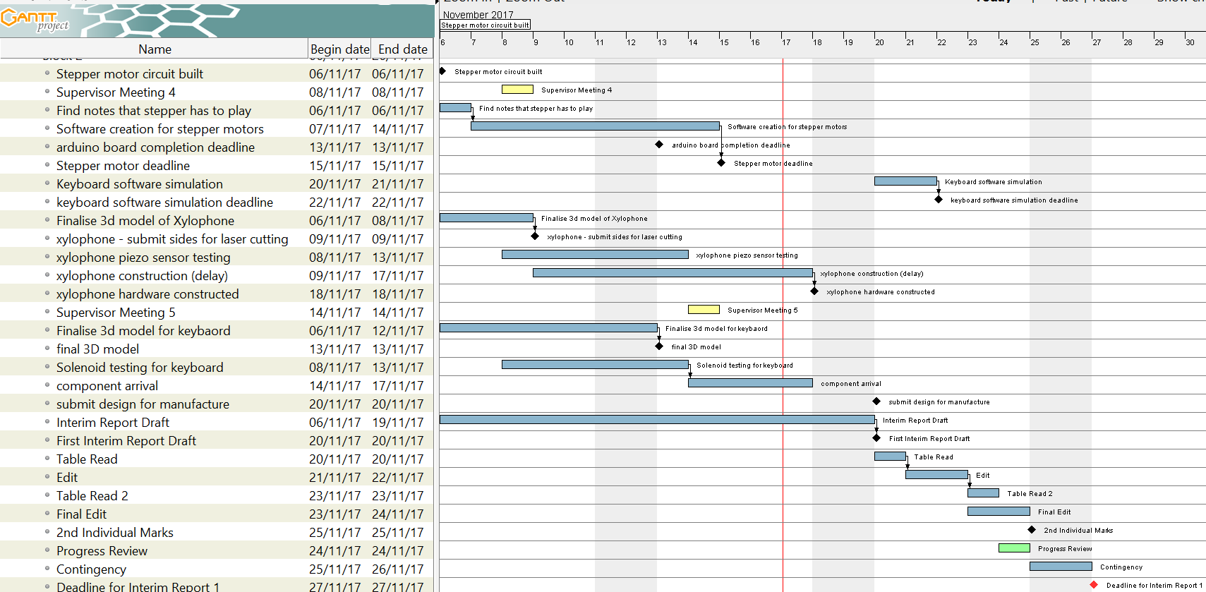

However, the *Keyboard software simulation* milestone (due for 20/11/17) was not completed on time. This was partially due to the interim report taking priority over other workload during the last week and due to the size of the sub teams. In order to address the latter, in the second semester the software and hardware team will contain three members each. This will provide more resources to the software team so that two instruments can be worked on at the same time, instead of one.

## Approach towards 2nd Semester

As discussed in Section 5, both the hardware and software teams will be evened out in the second semester which should help to achieve both the hardware and software goals in the upcoming project blocks. Below is a summary of the remaining tasks for each of the instruments. The Gantt charts for the blocks in semester 2 can be seen in Appendix G**.**

**Keyboard:** The software simulation for the keyboard will take significant amount of time to complete so will form the main part of the third project block. It is worth spending a significant amount of time on this section because both the Xylophone and Keyboard will use very similar software – so building the keyboard software with this in mind will reduce the amount of time spent on the Xylophone. The Keyboard simulation software will start development at the beginning of the second week of project block 3. It is currently scheduled to be completed by 12/02/18 (week three of the third project block). By this time the hardware for the keyboard will also be constructed so the remainder of the block will be spent on integrating the software simulation with the hardware.

**Xylophone:** The hardware for the Xylophone has now been delivered and constructed. The next stage would be to write the software and integrate it with the hardware. As mentioned in Section 4.4 the hardware was given a new design which was significantly simpler than the previous design. This also has the added benefit of the software between the Xylophone and Keyboard now being very similar in structure. Because of this, finalising the Xylophone should not be a very long task once the Keyboard instrument is completed. Adapting the software of the Keyboard to suit the needs of the Xylophone hardware will take place at the start of the fourth project block.

**Panpipes and Tesla Coil:** The plug for the air pump used on the panpipe was delayed by a week which has delayed the testing to the start of the next project block. The Tesla Coil currently looks like it would make a good addition to the orchestra, however more research needs to be conducted in order to determine how the Tesla Coil will be scaled up, since the volume of the off-the-shelf kit purchased was not high enough. In Figure 7.1 of Appendix G, there are tasks to perform some preliminary tests on the panpipes with the air pump and do some research on scaling the Tesla Coil up to operate at a higher voltage. These are scheduled to be completed partway through the second week of the third project block (07/02/18), by the end of the third project a block a decision will be made whether to move forward with the Tesla coil or the robot panpipes.

**Stepper Motors:** The current software iteration of the software allows for one stepper motor to be controlled and play a song. However, the initial design involved having four stepper motors synchronised with each other. This is now being explored by researching various timers. Before the start of the third project block a decision will be made on what method will be best suited for achieving multiple stepper motors at once. The beginning of the third project block (30/01/18 – 06/02/18) has been dedicated towards achieving the *Multiple Stepper Motor Software Deadline* (06/02/18). It was found that the noise from the steppers was amplified when fixed on to a wood surface. To capitalise on this, a wooden speaker box will be designed in the first week of the third project block and be fixed to the stepper in the third week. The entire stepper motor instrument has a completion date of 14/02/18 (third week of project block three).

**Conductor Design:** The main task to be completed with the conductor is to decide the method of communication between the Raspberry Pi and the four robot instruments. A deadline has been set for the end of the third project block (15/02/18) to make this decision. Once this has been a step-by-step will be created to create the conductor by the end of the fourth project block. By the end of the first week in the fourth project block the hardware for the instruments should be complete, this means that more resources can be applied to designing and constructing the conductor.

## Risk Management

In order to identify the potential risks that project faces a risk register was established, which allowed some mitigations to be put in place. The full risk register can be seen in Appendix H**.**

Risks 1, 5 and 9 (Appendix H) are not from direct action of the team and have to be mitigated. One of the ways in doing this is to add contingency time at the end of each block. From Figure 5.2 and Appendices F and G, it can be seen that this was done, giving two days at the end of each block for tasks to overrun. During the second project block the testing phase for the panpipes was supposed to begin at the start of the second week, so that the feasibility of the panpipes could be determined. However, since the plug that was needed to power the air pump was delayed until the end of the second week the testing phase was delayed.

The contingency time attached to the end of the second project block had to be used to compensate for the delay, giving two additional days to work on the testing for the panpipe. Risk 5 should not be much of an issue (shown by its *Probability being equated to 1*) since a locked cupboard has been provided, all built equipment shall be stored in there and the key is removed from the room.

Risk 2 (Appendix H) has the potential to cause significant setbacks in the project, especially since the team has been split into two teams which have a focus on either software or hardware. However, the risk is somewhat reduced by having several members in each team and more than one person on each task. This ensures that more than one person is familiar with each task that is currently ongoing with the project so if someone was to become unavailable then another member will be able to pick up from the last member that left it. Also, the team has weekly meetings where the whole team is present (this is in addition to the supervisor meetings).

The primary goal of these meetings is to check on progress made in the previous week but they also allow members to update each other on specific tasks. This means that if another member has to pick up the work of another there is only, at the maximum, a five-day gap in the workload.

Risk 4 is reduced by using Google Drive. Since Google Drive is a completely online file storage system every file can be accessed by each individual member. This acts as a good back up to the local files stored on individual laptops.

Risk 7 is due to none of the team members having previously used a MyRIO (Table 2.1). In order to mitigate this risk two actions were taken. Firstly, the National Instruments Student Scholarship was applied for, where one of the benefits is being provided with a National Instruments Engineer. Then a training session was organised with a National Instruments Engineer to provide an introduction to the MyRIO and to demonstrate its capability. In order to further reduce this risk all members of the team will be present at the training session so that everyone can be assumed to be at the same level for the MyRIO after. This ensures that individual team members can provide support to others should there be problems using it.

Risk 8 is mitigated by constructing components lists before ordering a significant amount of components (such as at the end of the first project block). This gives the opportunity to review the items being ordered and ensure that they are within budget, it also gives time to look for alternatives to the products ordered. Some may be cheaper if factors such as delivery time are more flexible. For example, at the end of the first project block there was a three-week period that the items could be delivered in so cheaper alternatives for the solenoids could be selected. These were exactly the same solenoids that were going to be ordered but because they had a longer delivery time the total cost per solenoid was cheaper.

Risk 10 is in regards to only one member of the team having skills in one particular element of the project. For example, only one member of the team has previous experience in using the Raspberry Pi, which means that should a person become unavailable it may be heard to keep progressing on any tasks relating to the RPi. In order to mitigate this, any task involving the RPi will involve more than one member of the team, ensuring that each member is able to use the RPi for this project.

## Minutes and agendas

A project meeting is held each week with the team and project supervisors Danielle George and William McGenn. For the meeting an agenda is produced by the Secretary and is distributed a day before the meeting. Before it is sent out it is reviewed by the team to make sure everyone’s work for that week has been included so all progress made can be presented effectively.

Minutes are taken during the meeting which are typed up and uploaded to the shared drive within two days so the team can look at the actions required for that week. The minutes include an ongoing actions list, a section detailing actions from the previous week (confirming if they had been completed or not) and a section containing a summary of the topics discussed detailing the actions that the meeting produced.

## Logistics

WhatsApp was chosen as the communication platform and two groups were set up with one with the team and one with the team and supervisors. Meetings were arranged either using the WhatsApp group or at the end of a previous meeting. The storage platform that is to be used for sharing and saving document was chosen to be google drive as all members of the team had access to it.

The project group was split up into two with a hardware side and a software side. In the hardware group was Joyanto, Josh, Anton and Theodore and on the software side was Andrei and Francesco. Joyanto as initially in the software group but it was realised that initially more work on hardware was needed to get the robots built ready for programming.

## Procurement

The team has an allocated budget of £1500 and so far, £506 have been spent on musical instruments, electronic components and building materials. The full expenditure record is presented in Appendix I. Although this represents approximately a third of the budget, it is worth mentioning that a substantial amount was spent in the beginning on buying the musical instruments (keyboard, stepper motors, etc.) and the components required to set them up (ex: power sources). These expenses accounted for approximately £250 and a key aspect to be taken into account is that these were nonrecurring expenses, thus reducing the risk of a future budget exceeding.

The current financial plan leaves £200 to be used as a reserve for unexpected expenses that accounts for possible component failures or improper equipment being bought during the prototyping stages, leaving a current usable balance of approximately £800. In terms of future expenses, the biggest pressure on the budget is posed by the solenoids used for pushing the keys of the keyboard as these are expensive components and a large number is required for the project. A solenoid costs approximately £10 per piece and it is estimated that 25 will have to be bought in the next stages, thus running a cost of £250. To minimise this risk, single solenoids will be tested in advance to ensure that the large order will meet the project requirements. Another large expected expense is that of the building materials necessary for constructing the mechanical ensemble of the robots, the cost being estimated at £200. Considering the available balance, the cash reserve and the future large expected expenditures, approximately £350 are left to be used for electronic components. As these have a generally low price, the project is expected to be finished within the allocated budget.

## Conclusion

This report outlines the progress that has been made towards constructing a new core the Manchester Robot Orchestra. Currently three instruments are confirmed to contribute to the four with the last being decided. The stepper motor design involves having four stepper motors synchronised together to play MIDI files. They spin at specific frequencies to mimic notes being played. The keyboard utilises a Bosch bar held up by threaded rods, a row of solenoids will be fitted in to the bar and will be used to press down on the keys. The xylophone utilises a similar design to the keyboard, some solenoids will be mounted on to a Bosch bar which is supported by two threaded rods. The solenoids will hit piezoelectric sensors which will trigger a sound to be played from the speaker. This is quite a unique instrument because the sound being played can be changed according to the song as well as the type of instrument being played.

The fourth instrument is being decided between a Tesla coil and robot panpipes. The panpipes are still in their preliminary stage; the testing phase has been delayed due to a plug for the air pump arriving late. This has since arrived so the testing phase will begin in the third project block. The Tesla coil is a recent addition and is currently being researched to better understand the feasibility of making it one of the four instruments. Once the testing phase for the panpipes is complete and the design for the Tesla coil is researched further, a decision will be made by the end of the second week of the third project block regarding which design will be progressed.

The third project block should see the completion of two of the instruments – the keyboard and the stepper motors. The xylophone should be completed shortly after in the fourth project block since it shares similar software traits to the keyboard. The construction for the conductor will begin in the third project block, a decision will be made regarding the type of communication that is needed between the conductor and instruments.

# References

|  |  |
| --- | --- |
| [1] | The University of Manchester, “European City of Science | The University of Manchester | Science and Engineering,” The University of Manchester, May 2016. [Online]. Available: <http://www.se.manchester.ac.uk/about-us/ecos/> [Accessed November 2017]. |
| [2] | BBC, “BBC Radio 1 - Can a robot replace Ed Sheeran?,” BBC, 3 March 2017. [Online]. Available: <http://www.bbc.co.uk/programmes/p04sxvgw> [Accessed October 2017]. |
| [3] | L. Mather, “Glock o Bot,” YouTube, 13 June 2016. [Online]. Available: <https://www.youtube.com/watch?v=4toW8Tc9GPI> [Accessed October 2017]. |
| [4] | National Instruments, “Student Project Sponsorship - National Instruments United Kingdom,” National Instruments, 12 August 2017. [Online]. Available: <http://uk.ni.com/studentsponsorship> [Accessed November 2017]. |
| [5] | J. Shauw, “Dream wedding played by piano robot,” YouTube, 7 November 2010. [Online]. Available: <https://www.youtube.com/watch?v=IwuiOwZrzCM> [Accessed October 2017]. |
| [6] | Teotronica, “robot playing piano,” YouTube, 14 September 2009. [Online]. Available: <https://www.youtube.com/watch?v=HHcgTbs7_Os> [Accessed October 2017]. |
| [7] | Bowles, E.A. and Marcuse, S. (2017). *Percussion Instrument*. [online] Available at: <https://www.britannica.com/art/percussion-instrument> [Accessed November 2017]. |
| [8] | The editors of Encyclopedia Britannica. (2012). *Idiophone*. [online] Available at: <https://www.britannica.com/art/idiophone> [Accessed November 2017]. |
| [9] | Estrella, E. (2017). *What is a Chromatic Scale?* [online] Available at: <https://www.thoughtco.com/what-is-a-chromatic-scale-2456561> [Accessed November 2017]. |
| [10] | Jenna deBoisblanc, " Arduino: how to build an electronic MIDI xylophone", 3 May 2011. [Online]. Available: <https://www.youtube.com/watch?v=92VIEDtQKVI> [Accessed November 2017]. |
| [11] | Deboisblanc, J.(n.d.). *Xylophone.* [online] Available at: <http://jdeboi.com/xylophone/> [Accessed November 2017]. |
| [12] | Cambridge Dictionary. (n.d.). *String Instrument*. [online] Available at: <https://dictionary.cambridge.org/dictionary/english/string-instrument> [Accessed November 2017]. |
| [13] | Halfpenny, E. and Grame, T. (2017). *Stringed Instrument*. [online] Available at: <https://www.britannica.com/art/stringed-instrument> [Accessed November 2017]. |
| [14] | Learnitonlinetoday, "How to Play Trumpet- Lesson #1 Beginner," Learnitonlinetoday, 9 January 2010. [Online]. Available: <https://www.youtube.com/watch?v=2SjH0qhQpoU> [Accessed November 2017]. |
| [15] | WikiHow, "wikiHow to Play the Trumpet," WikiHow, [Online]. Available: <https://www.wikihow.com/Play-the-Trumpet> [Accessed November 2017]. |
| [16] | A. Lim, "Toyota Trumpet Robot (Subtitles in English and Japanese)," 4 January 2010. [Online]. Available: <https://www.youtube.com/watch?v=6fctULDctuA&t=107s> [Accessed Novemeber 2017]. |
| [17] | BotJunkie, "Waseda Flutist Robot," 1 November 2008. [Online]. Available: <https://www.youtube.com/watch?v=jx8U1FgILCE> [Accessed November 2017]. |
| [18] | WikiHow, "wikiHow to Play the Panpipe or Pan Flute," [Online]. Available: <https://www.wikihow.com/Play-the-Panpipe-or-Pan-Flute> [Accessed November 2017]. |
| [19] | "how to play the recorder," arta recorder, [Online]. Available: <http://www.arta-recorder.org/> [Accessed November 2017]. |
| [20] | Cu cselab, " recorder12\_1.wmv",Computer Engineering CUHK, 5 Mar 2012. [Online]. Available: <https://www.youtube.com/watch?v=Bi6ShZp7poM> [Accessed November 2017]. |
| [21] | T. Dare, "TeamDARE's robot band plays 'Rolling in the deep'," TeamDare, 27 August 2011. [Online]. Available: <https://www.youtube.com/watch?v=RKpKygGX2Nk> [Accessed November 2017]. |
| [22] | O. Engineering, "What is a stepper motor? - Principles, types and controllers", *Omega.co.uk*, 2017. [Online]. Available: <https://www.omega.co.uk/prodinfo/stepper_motors.html> [Accessed November 2017]. |
| [23] | "Stepper Motors | NEMA Stepper Motors & Controllers", *Circuitspecialists.com*, 2017. [Online]. Available: <https://www.circuitspecialists.com/stepper-motor> [Accessed November 2017]. |
| [24] | Stepper Motor - How It Works – “HowToMechatronics", *HowToMechatronics*, 2017. [Online]. Available: <http://howtomechatronics.com/how-it-works/electrical-engineering/stepper-motor/> [Accessed November 2017]. |
| [25] | "How do stepper motors work?", *Explain that Stuff*, 2017. [Online]. Available: <http://www.explainthatstuff.com/how-stepper-motors-work.html> [Accessed November 2017]. |
| [26] | M. Pilhofer and H. Day, Music theory for dummies. |
| [27] | TheHomebrewGuru, "Build and Code a Musical Tesla Coil With a Microcontroller," instructables, [Online]. Available: <http://www.instructables.com/id/Build-a-Musical-Tesla-Coil-like-a-Pro/> [Accessed November 2017]. |
| [28] | Admin, "Breakdown voltage/Dielectric strength (Breakdown of Insulator)," The Physics Fact book, 15 September 2014. [Online]. Available: <https://electronicspani.com/breakdown-voltagedielectric-strength/> [Accessed November 2017]. |
| [29] | E. Goodchild, ""In the Hall of the Mountain King" - Played on Musical Tesla Coils," Youtube, [Online]. Available: <https://www.youtube.com/watch?v=8LAhKkPUo_A> [Accessed November 2017]. |
| [30] | "The musical tesla coils," physics central- phisics buzz blog, [Online]. Available: <http://physicsbuzz.physicscentral.com/2007/11/musical-tesla-coils.html> [Accessed November 2017]. |
| [31] | “www.raspberrypi.org,” Raspberry Pi Foundation, [Online]. Available: <https://www.raspberrypi.org/downloads/raspbian/> [Accessed November 2017]. |
| [32] | “Raspberry Pi Foundation,” [Online]. Available: <https://www.raspberrypi.org/products/raspberry-pi-3-model-b/> [Accessed November 2017]. |
| [33] | “Sparkfun.com,” [Online]. Available: <https://learn.sparkfun.com/tutorials/what-is-an-arduino> [Accessed November 2017]. |
| [34] | “Arduino.com,” [Online]. Available: <https://store.arduino.cc/usa/arduino-uno-rev3> [Accessed November 2017]. |
| [35] | “Atmel,” [Online]. Available: <http://www.atmel.com/images/Atmel-8271-8-bit-AVR-Microcontroller-ATmega48A-48PA-88A-88PA-168A-168PA-328-328P_datasheet_Complete.pdf> [Accessed November 2017]. |
| [36] | “Atmel,” [Online]. Available: <http://www.atmel.com/Images/Atmel-2521-AVR-Hardware-Design-Considerations_ApplicationNote_AVR042.pdf> [Accessed November 2017]. |
| [37] | “Arduino,” [Online]. Available: <https://www.arduino.cc/en/uploads/Main/ArduinoNano30Schematic.pdf> [Accessed November 2017]. |
| [38] | “ftdichip.com,” 2015. [Online]. Available: <http://www.ftdichip.com/Support/Documents/DataSheets/ICs/DS_FT232R.pdf> [Accessed November 2017]. |
| [39] | “National Instrument,” [Online]. Available: <https://www.ni.com/en-gb/shop/select/myrio-student-embedded-device> [Accessed November 2017]. |
| [40] | “Nordic Semiconductors,” [Online]. Available: <https://www.nordicsemi.com/eng/Products/2.4GHz-RF/nRF24L01P> [Accessed November 2017]. |
| [41] | “midi.org,” MIDI Organisation, [Online]. Available: ttps://www.midi.org/specifications/item/the-midi-1-0-specification [Accessed November 2017]. |
| [42] | J. Gibson, “Indiana.edu,” Indiana University, 2013. [Online]. Available: <http://www.indiana.edu/~emusic/361/midi.htm> [Accessed November 2017]. |
| [43] | T. M. Association, “midi.org,” MIDI Organisation, [Online]. Available: <https://www.midi.org/articles/an-intro-to-midi> [Accessed November 2017]. |
| [44] | S. Richard, “Petesqbsite,” [Online]. Available: <http://www.petesqbsite.com/sections/express/issue18/midifilespart1.html> [Accessed November 2017]. |
| [45] | “CSIE.ntu.edu.tw,” [Online]. Available: <https://www.csie.ntu.edu.tw/~r92092/ref/midi/> [Accessed November 2017]. |
| [46] | “electronics.dit.ie,” [Online]. Available: <http://www.electronics.dit.ie/staff/tscarff/Music_technology/midi/midi_note_numbers_for_octaves.htm> [Accessed November 2017]. |
| [47] | C. O. 2. Jarrod Hart (Los Olivos, "Musical Notes Explaned Simply," theprovincialscientist, 25 October 2011. [Online]. Available: <http://theprovincialscientist.com/?p=1576> [Accessed Novemeber 2017]. |
| [48] | "MIDI numbering, the Helmholtz Pitch Notation System,," theoretically correct, [Online]. Available: http://www.theoreticallycorrect.com/Helmholtz-Pitch-Numbering/. [Accessed November 2017]. |
| [49] | “Anvil Studio,” Willow Software, [Online]. Available: <https://www.anvilstudio.com/> [Accessed November 2017]. |
| [50] | A. Sweigart, in AUTOMATE THE BORING STUFF WITH PYTHON, San Francisco, No Starch Press, 2015. |
| [51] | O. M. Bjørndalen, “mido.reathedocs.io,” [Online]. Available: <https://mido.readthedocs.io/en/latest/> [Accessed November 2017]. |
| [52] | Society of Robots, “Actuators - Solenoids,” Soceity of Robots, 9 August 2006. [Online]. Available: <http://www.societyofrobots.com/actuators_solenoids.shtml> [Accessed October 2017]. |
| [53] | BICRON Electronics Company, “Standard & Customer Solenoids for OEM Application,” BICRON Electronics Company, Connecticut, 2011. Available: <http://www.bicronusa.com/pdfs/BICRON_DC_Solenoids.pdf> [Accessed October 2017]. |
| [54] | H. A. Radi and J. O. Rasmussen, Principles of Physics For Scientists and Engineers, Berkley, CA, USA: Springer, Berlin, Heidelberg, 2013. |
| [55] | BICRON Electronics Company, “Standard & Customer Solenoids for OEM Application,” BICRON, 2011. [Online]. Available: <http://www.bicronusa.com/pdfs/BICRON_DC_Solenoids.pdf> [Accessed October 2017]. |
| [56] | multicomp, “MCSMO-0630S12STD Technical Data Sheet,” Farnell, Leeds, 2011. |
| [57] | R. Components, “3842992888/3000 Bosch Rexroth Aluminium Strut 20 x 20 mm, 6mm Groove , 3000mm L,” Rexroth Bosch Group, Germany. |
| [58] | R. Components, “3842523135 Bosch Rexroth Strut Profile T-Slot Nut, , M4 Thread strut profile 20 mm, Groove Size 6mm,” RS Components, Lohr Am Main. |
| [59] | Burris, M. (2017). Stepper Motor vs. Servo Motors- Selecting a Motor. [online] Available at: <https://www.lifewire.com/stepper-motor-vs-servo-motors-selecting-a-motor-818841> [Accessed November 2017]. |
| [60] | Shenzhen Zonhen Electric Appliances. (n.d.). Specification. [online]. Available at:http://www.robotshop.com/media/files/pdf2/zho-0420s-05a4.5\_specification.pdf. |
| [61] | Semiconductor Components Industries. (2014). Plastic Medium- Power Complementary Silicon Transistors. [online] Available at: <https://www.onsemi.com/pub/Collateral/TIP120-D.PDF> [Accessed November 2017]. |
| [62] | "NEMA17 Stepper Motor - 34mm", SPOOL3D, 2017. [Online]. Available: <https://spool3d.ca/nema17-stepper-motor-34mm/> [Accessed November 2017]. |
| [63] | Allegro MicroSystems, “DMOS Microstepping Driver with Translator and Overcurrent Protection””, A4988 datasheet, 2014. |
| [64] | Frequencies of Musical Notes, A4 = 440 Hz", Pages.mtu.edu, 2017. [Online]. Available: <https://pages.mtu.edu/~suits/notefreqs.html> [Accessed November 2017]. |
| [65] | "analogWrite()", Arduino.cc, 2017. [Online]. Available: <https://www.arduino.cc/reference/en/language/functions/analog-io/analogwrite/> [Accessed November 2017]. |
| [66] | “Texas Instruments Website,” 2015. [Online]. Available: <http://www.ti.com/lit/ds/symlink/lm555.pdf> [Accessed November 2017]. |
| [67] | “Analog Devices Website,” [Online]. Available: <http://www.analog.com/media/en/technical-documentation/data-sheets/AD9837.PDF> [Accessed November 2017]. |
|  |  |

# Appendix D

|  |  |  |  |  |
| --- | --- | --- | --- | --- |
| **Notes Requird** | | |  |  |
| **Califonication** | **Eye of Tiger** | **Game of Thrones** | **Note count** | **Type of Key** |
| 40 | 40 | 40 | 1 | w |
| 41 | 41 | 41 | 2 | w |
| 43 | 43 | 43 | 3 | w |
|  | 44 |  | 4 | b |
| 45 |  | 45 | 5 | w |
|  | 46 |  | 6 | b |
| 47 |  | 47 | 7 | w |
| 48 | 48 | 48 | 8 | w |
| 50 | 50 | 50 | 9 | w |
|  | 51 |  | 10 | b |
| 52 | 52 | 52 | 11 | w |
| 53 | 53 | 53 | 12 | w |
| 55 | 55 | 55 | 13 | w |
|  | 56 |  | 14 | b |
| 57 |  | 57 | 15 | w |
|  | 58 |  | 16 | b |
| 59 |  | 59 | 17 | w |
| 60 | 60 | 60 | 18 | w |
| 61 |  | 61 | 19 | b |
| 62 | 62 | 62 | 20 | w |
|  | 63 |  | 21 | b |
| 64 |  | 64 | 22 | w |
| 65 | 65 | 65 | 23 | w |
| 67 | 67 | 67 | 24 | w |
| 69 |  | 69 | 25 | w |

Table 1. Type of keys needed to play the 3 songs.

# Appendix E

|  |  |
| --- | --- |
| **Mass (g)** | **Did the key play?** |
| 5 | No |
| 10 | No |
| 20 | No |
| 30 | No |
| 40 | No |
| 50 | No |
| 60 | No |
| 70 | Yes |
| 80 | Yes |
| 90 | Yes |
| 100 | Yes |

Table 2. Amount of force required to play a key.

# Appendix H

|  |  |  |
| --- | --- | --- |
| **Key** | **Did it produce a note?** | |
| **1** | **2** |
| 40 | Yes |  |
| 41 | Yes |  |
| 43 | Yes |  |
| 44 | Yes |  |
| 45 | Yes |  |
| 46 | No | Yes |
| 47 | Yes |  |
| 48 | Yes |  |
| 50 | Yes |  |
| 51 | Yes |  |
| 52 | Yes |  |
| 53 | Yes |  |
| 55 | Yes |  |
| 56 | Yes |  |
| 57 | Yes |  |
| 58 | Yes |  |
| 59 | Yes |  |
| 60 | No | Yes |
| 61 | Yes |  |
| 62 | Yes |  |
| 63 | Yes |  |
| 64 | Yes |  |
| 65 | Yes |  |
| 67 | No | Yes |
| 69 | Yes |  |

Table 3. Keyboard testing

# Appendix I

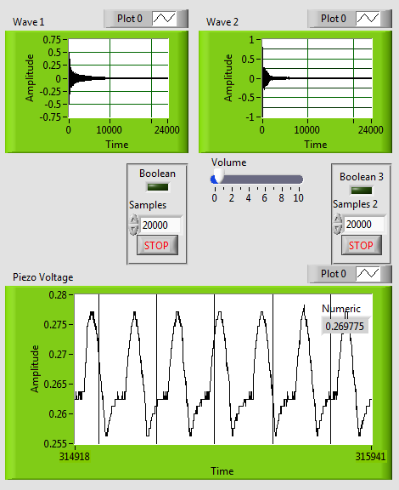

Figure . Front Panel of LabView Code when testing piezo sensors.

Wave 1 shows the sound waveform of the first piezo (one being tested through the analog pin)

Wave 2 shows the sound waveform of the second piezo (being tested through digital pin)

Piezo voltage shows the voltage produced by the piezo which is tested through the analog pin.

# Appendix J

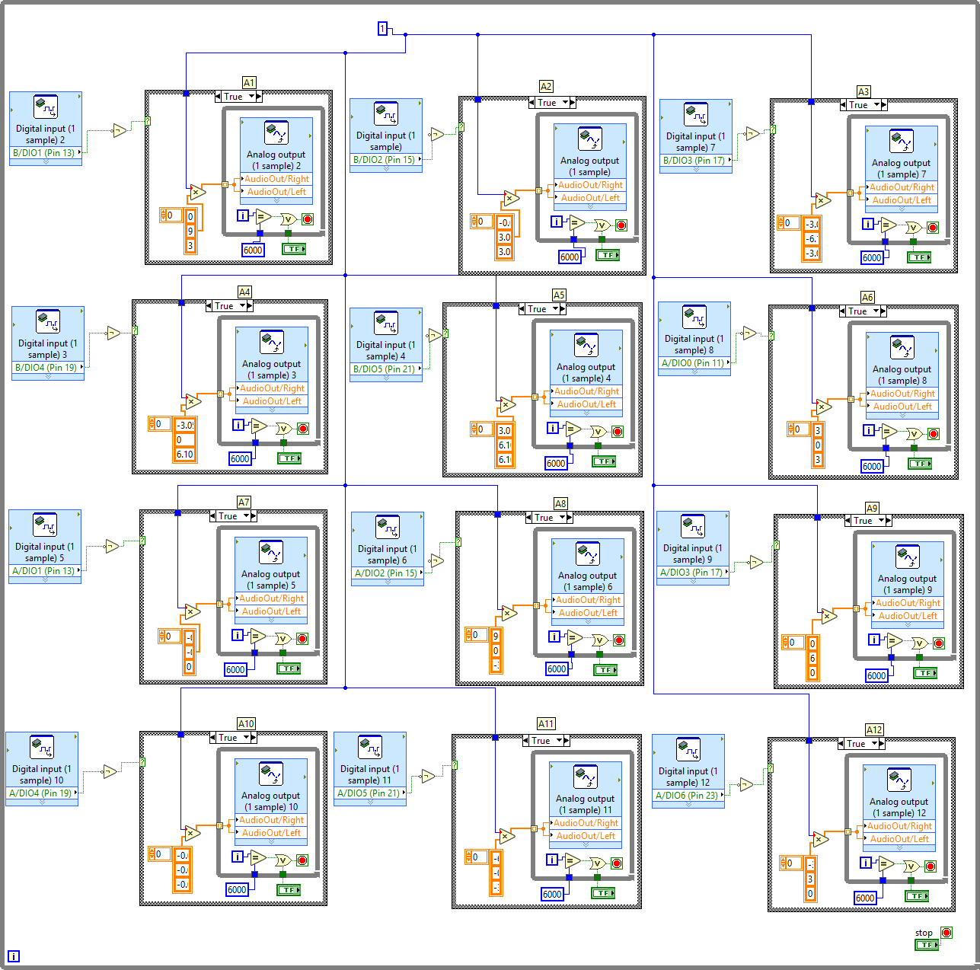

Figure . Code for 12 keys to produce 12 notes.

# Appendix K

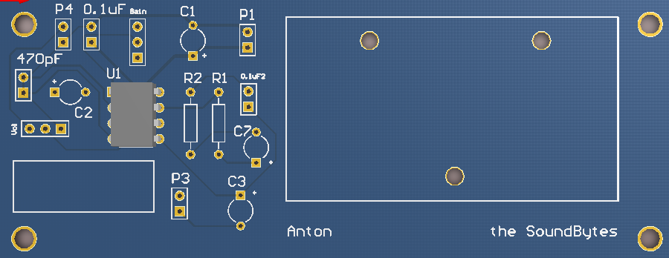

Figure . PCB of the audio amplifier circuit

# Appendix N

